*Florida International University*

*School of Computing and Information Sciences*

Software Engineering Focus

Feature Document

User Story #1313

**Name:** Steve Hirabayashi

**Team Member(s):** Leon Liang, Dale Keith, Andres Moser, Steve Hirabayashi, Adam Levy

**Project:** V.I.P. Website 7.0

**Product Owner(s)**: Francisco Ortega, Masoud Sadjadi

**Mentor(s)**: Jose Ponce

**Instructor**: Masoud Sadjadi

**User Story Name: Manage Projects in Admin Panel**

* As a PI/CoPI, I would like to be able to make changes to a project’s properties, so that I can easily modify/update the information of projects.

Acceptance Criteria

* After selecting the option to change the project’s properties and entering the new properties for the project, the project’s updated information will be displayed to the user.
* Needs to have ability to change the semester of projects so that PI/CoPI can move pending and proposed projects to a better time frame.
* Merge the Admin Panel UI for searching and filtering with the ability to modify the project’s properties.

**Use Cases**

* Name: Administrator edits a project’s properties
* Actor: Pi/CoPi
* Preconditions: Admin must be logged in with administrative rights, admin must be at the admin panel page - project maintenance tab.
* Description:

1. Pi/CoPi selects the ‘edit project’ button
2. Vip.fiu.edu responds by prompting Pi/CoPi with the edit project dialog
3. Pi/CoPi modifies project information and selects ‘save changes’ button.
4. Vip.fiu.edu responds by either displaying a failure message with the specific occured error or displaying a confirmation message that the project has been updated in the system.

* Name: Administrator adds/removes users from a project
* Actor: Pi/CoPi
* Preconditions: Admin must be logged in with administrative rights, admin must be at the admin panel page - project maintenance tab.
* Description:

1. Pi/CoPi selects the ‘add/remove users’ button
2. Vip.fiu.edu responds by prompting Pi/CoPi with the add/remove users dialog
3. Pi/CoPi modifies user information and selects ‘save changes’ button.
4. Vip.fiu.edu responds by either displaying a failure message with the specific occured error or displaying a confirmation message that the project has been updated in the system.

* Name: Administrator deletes a project
* Actor: Pi/CoPi
* Preconditions: Admin must be logged in with administrative rights, admin must be at the admin panel page - project maintenance tab.
* Description:

1. Pi/CoPi selects the ‘delete project’ button
2. Vip.fiu.edu responds by requesting confirmation to to delete project
3. Pi/CoPi selects ‘Yes’ button.
4. Vip.fiu.edu responds by either displaying a failure message with the specific occured error or displaying a confirmation message that the project has been deleted from the system.

**Use Case Diagram**

[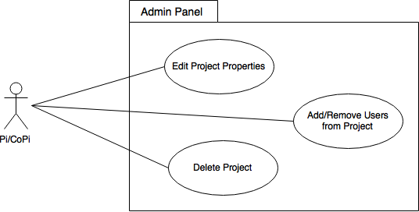](https://www.draw.io/#G0B_dj3TRYcWPaNm9yNmpsRVRvZjQ)

**Sequence Diagrams**

Edit Project Properties

[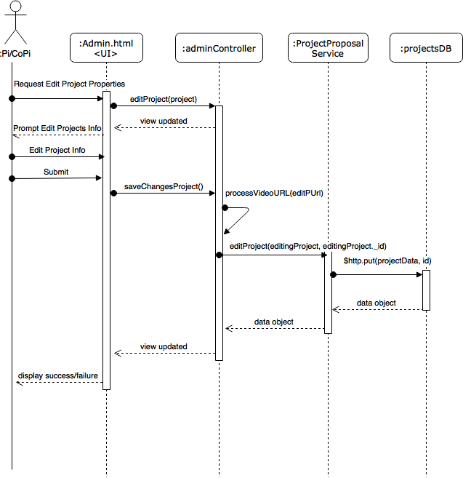](https://www.draw.io/#G0B_dj3TRYcWPaTEt4dWQzeDR3cDg)

Add/Remove Users from Project

[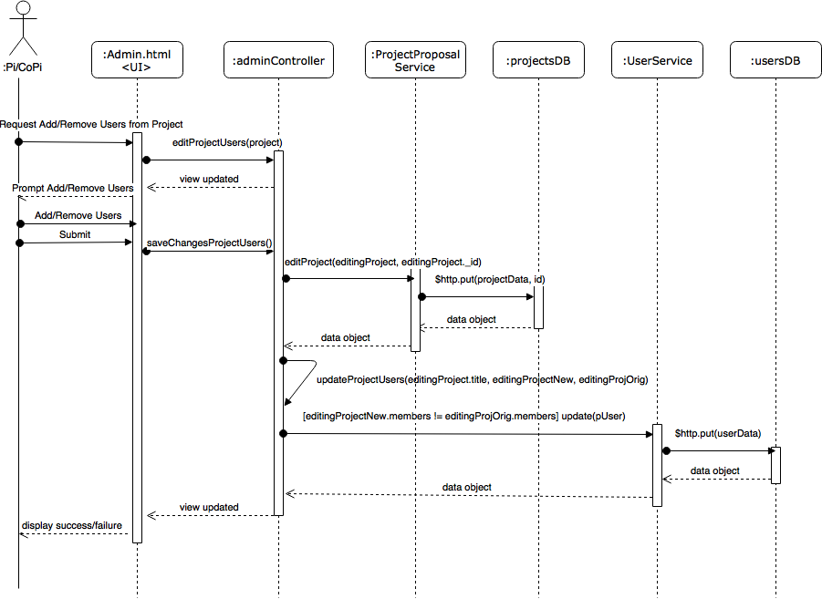](https://www.draw.io/#G0B_dj3TRYcWPaYlBaTy1DSU9Sa1U)

Remove Project

[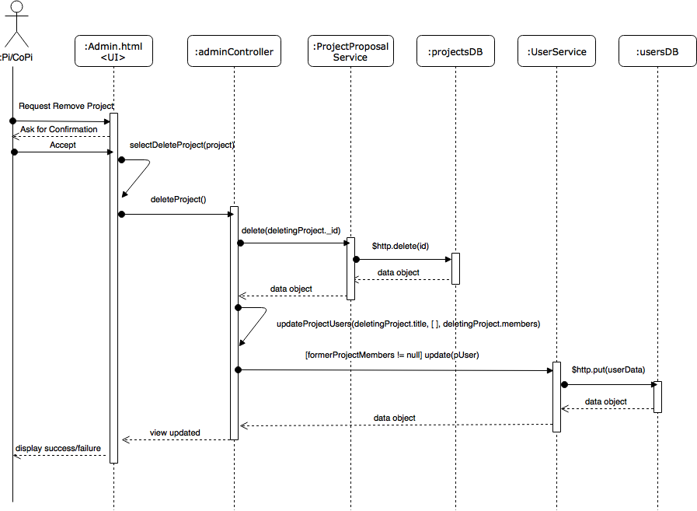](https://www.draw.io/#G0B_dj3TRYcWPaXzR3UFBxQU9FQkk)

**Class Diagram**

[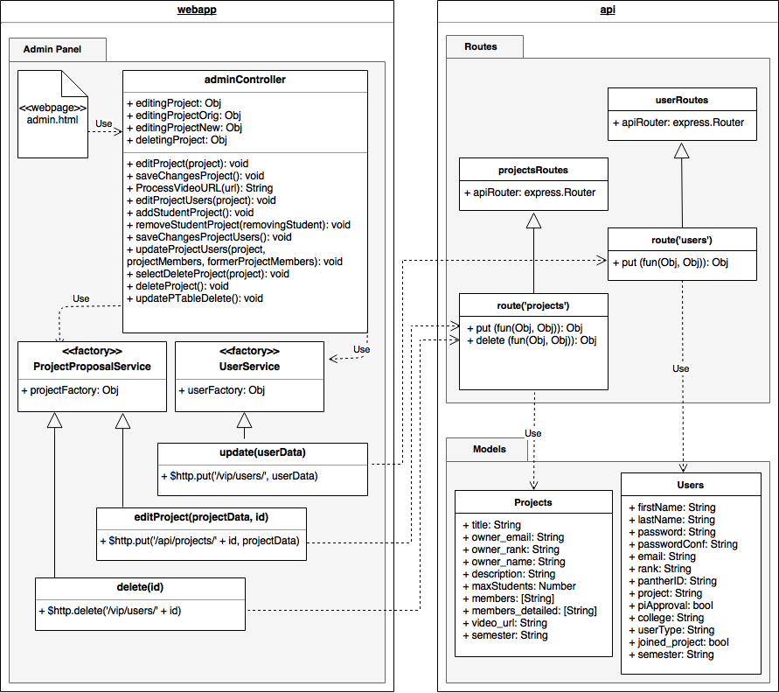](https://www.draw.io/#G0B_dj3TRYcWPaVXNGTUQzZzdwb3M)

**Unit Tests**

* Test case ID: VIP-1313-U1
* Description: Admin edits project properties (Sunny Day Scenario)
* Summary of Test:

1. Tester selects ‘edit project properties’ button
2. Tester modifies project with project data into edit project dialog
3. Tester selects ‘save changes’ button

* Test Data:
* Project Title: Test Project
* Description: desc
* Max Students: 10
* Status: Active
* Pre-Condition:

1. User with Pi/CoPi privileges has logged into the VIP website
2. User is at the admin panel page - project maintenance tab

* Expected Results:

1. Project will be updated in the database
2. Projects panel table will be updated
3. Tester will be notified of success

* Actual Result:

1. Project will be updated in the database
2. Projects panel table will be updated
3. Tester will be notified of success

* Status (Fail/Pass): PASS
* Test case ID: VIP-1313-U2
* Description: Admin edits project properties (Rainy Day Scenario)
* Summary of Test:

1. Tester selects ‘edit project properties’ button
2. Tester modifies project with project data into edit project dialog
3. Tester selects ‘save changes’ button

* Test Data:
* Project Title: (empty)
* Description: desc
* Max Students: -1
* Status: Active
* Pre-Condition:

1. User with Pi/CoPi privileges has logged into the VIP website
2. User is at the admin panel page - project maintenance tab

* Expected Results:

1. Project will not be updated in the database
2. Projects panel table will not be updated
3. Tester will be notified of error

* Actual Result:

1. Project will not be updated in the database
2. Projects panel table will not be updated
3. Tester will be notified of error

* Status (Fail/Pass): PASS
* Test case ID: VIP-1313-U3
* Description: Admin adds/removes project’s users (Sunny Day Scenario)
* Summary of Test:

1. Tester selects ‘add/remove users’ button
2. Tester finds and selects user ‘testF’ in add user
3. Tester selects ‘add user’ button
4. Tester selects ‘remove user’ button for a user other than ‘testF’
5. Tester selects ‘save changes’ button

* Pre-Condition:

1. User with Pi/CoPi privileges has logged into the VIP website
2. User is at the admin panel page - project maintenance tab
3. Project selected already has users assigned to it as current members
4. Test VIP-1300-U1 has been executed

* Expected Results:

1. Project will be updated in the database
2. Projects panel table will be updated
3. Users will be updated in the database
4. Users panel table will be updated
5. Tester will be notified of success

* Actual Result:

1. Project will be updated in the database
2. Projects panel table will be updated
3. Users will be updated in the database
4. Users panel table will be updated
5. Tester will be notified of success

* Status (Fail/Pass): PASS
* Test case ID: VIP-1313-U4
* Description: Admin removes project (Sunny Day Scenario)
* Summary of Test:

1. Tester selects ‘remove project’ button for project
2. Tester selects ‘Yes’ button

* Pre-Condition:

1. User with Pi/CoPi privileges has logged into the VIP website
2. User is at the admin panel page - project maintenance tab

* Expected Results:

1. Project will be removed from the database
2. Projects panel table will be updated with project removed from it
3. Tester will be notified of success

* Actual Result:

1. Project will be removed from the database
2. Projects panel table will be updated with project removed from it
3. Tester will be notified of success

* Status (Fail/Pass): PASS

**Integration Test**

* Test case ID: VIP-1313-G1
* Description: User and Admin Email will be notified when user is removed from project by Add/Remove Users from Project Dialog
* Summary of Test:

1. Tester enters a test admin email into the admin email input
2. Tester selects the entered admin email and selects the ‘change’ button
3. Tester selects the project maintenance tab
4. Tester selects ‘add/remove users’ button for a project with current members in it
5. Tester selects ‘remove user’ button next to a current member
6. Tester selects ‘save changes’ button, which toggles an automated message sent to the admin email and the user’s email.

* Pre-condition:

1. User with Pi/CoPi privileges has logged into the VIP website
2. User is at the admin panel page - admin maintenance tab
3. There exists a project that already has users assigned to it

* Expected Results:

1. Project will be updated to have the user removed from member list
2. Both user and admin email will receive an email notification

* Actual Result:

1. Project will be updated to have the user removed from member list
2. Both user and admin email will receive an email notification

* Status (Fail/Pass): PASS

**Visual User Guide**

