*Florida International University*

*School of Computing and Information Sciences*

Software Engineering Focus

Feature Document

User Story #1363

**Name:** Leon Liang

**Team Member(s):** Leon Liang, Dale Keith, Andres Moser, Steve Hirabayashi, Adam Levy

**Project:** V.I.P. Website 7.0

**Product Owner(s)**: Francisco Ortega, Masoud Sadjadi

**Mentor(s)**: Jose Ponce

**Instructor**: Masoud Sadjadi

**User Story Name: Sort tables by column header**

* As an user, I want to be able to sort any tables by table headers in order to find the  
   information I need more efficiently and group similar entries together

Acceptance Criteria

1. User can click on table header to sort the columns by descending or ascending
2. Table should contain same information as non-sorted table

**Use Cases**

* Name: Admin sorts review student table
* Actor: Pi/CoPi
* Preconditions:
* Admin must be logged in with administrative rights
* Admin must be at the admin panel page - student maintenance tab
* Description:

1. Pi/CoPi clicks on the First Name header of the table
2. Table repopulates displaying the first entry being lexicographically largest last name
3. First name table header displays with a descending triangle to indicate table is being sorted in descending order

**Use Case Diagram**

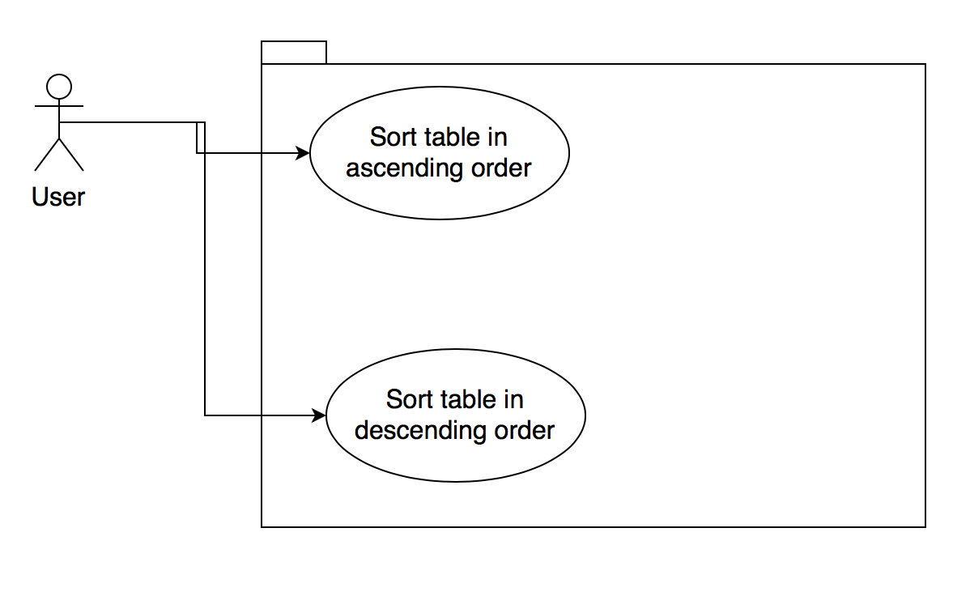

**Sequence Diagram**

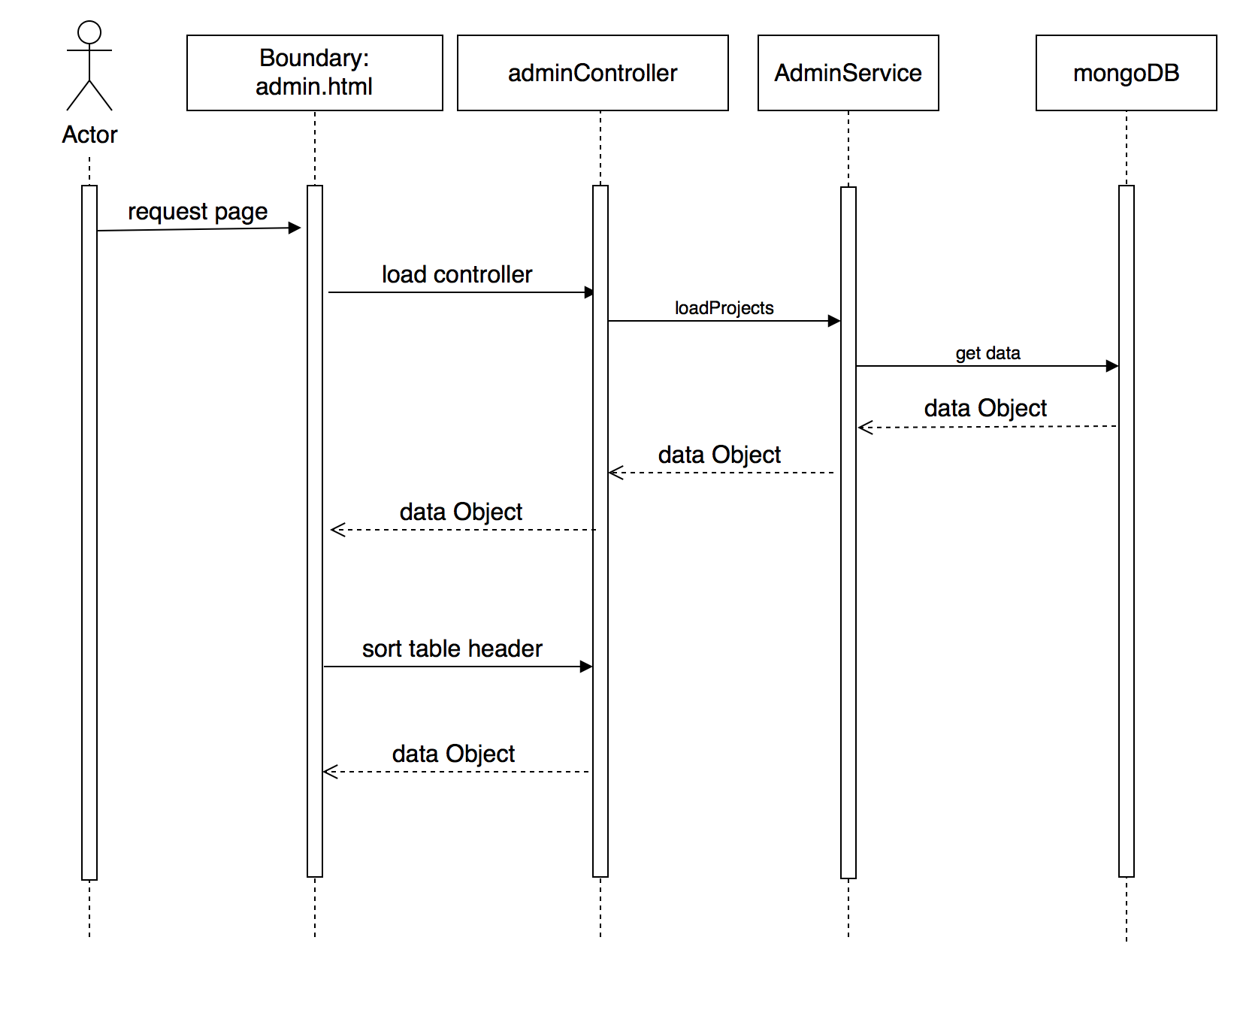

**Class Diagram**

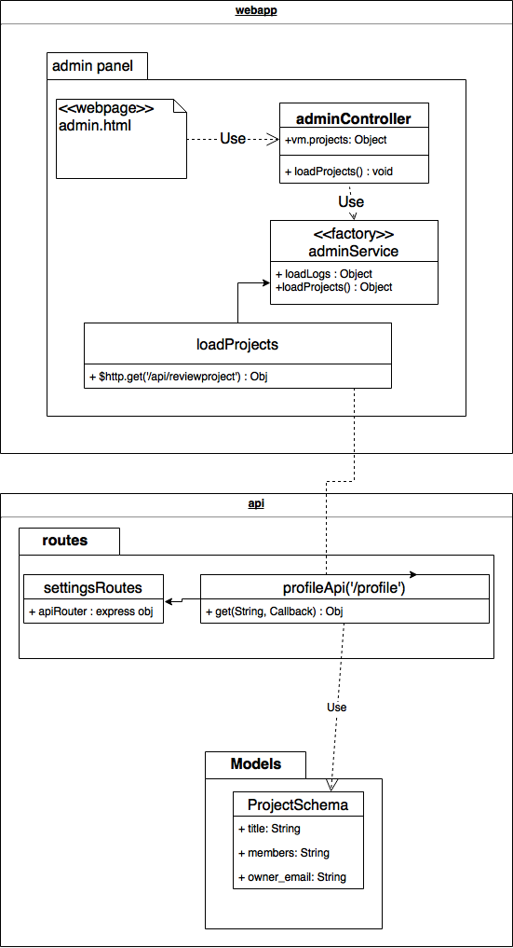

**Unit Test**

* Test case ID: VIP-1363-U1
* Description: Admin sort review student by first name
* Summary of Test:

1. Tester selects on first name table header
2. Tester reclick on first name table header

* Pre-Conditions:

1. Admin with Pi/CoPi privileges has logged into the VIP website
2. Admin is at the admin panel page - student maintenance tab
3. Database contains multiple users

* Expected Results:

1. Table will be initially unsorted
2. Table will then sort on first name in descending order
3. Table will sort again on second click by descending order

* Actual Result:

1. Course will be updated in the database
2. Course maintenance page will be updated with new course

* Status (Fail/Pass): PASS

**Integration Test**

* Test case ID: VIP-1363-G1
* Description: Admin sort review student by first name
* Summary of Test:

1. Tester selects on first name table header
2. Tester reclick on first name table header

* Pre-Conditions:

1. Admin with Pi/CoPi privileges has logged into the VIP website
2. Admin is at the admin panel page - student maintenance tab
3. Database contains multiple users

* Expected Results:

1. Table will be initially unsorted
2. Table will then sort on first name in descending order
3. Table will sort again on second click by descending order

* Actual Result:

1. Course will be updated in the database
2. Course maintenance page will be updated with new course

* Status (Fail/Pass): PASS

**Visual User Guide** 