*Florida International University*

*School of Computing and Information Sciences*

Software Engineering Focus

Feature Document

[vip/#1264]

**Name:** Dafna Steinberg

**Team Member(s):** Jose Ponce Diaz

**Project:** VIP Website 6.0

**Product Owner(s)**: Francisco Ortega, Masoud Sadjadi

**Mentor(s)**: Leila Zahedi

**Instructor**: Masoud Sadjadi

**Allow admin to modify email notification settings:**

**Description**

* As a PI, I would like the ability to change the default admin address used in notifications to another email address of my choice. I would like to be able to make these modifications via the admin panel.
* This story will allow the PI to easily make changes to the admin email without having to modify the source code.

**Acceptance Criteria**

1. The following “Admin Email” settings can be **viewed,** **modified,** and **saved** via the admin panel:
   1. The current / active email address
   2. A list of alternate, user-defined email addresses to select from
2. User must have EXACTLY one (1) *active* e-mail address to save settings.
3. Admin email settings are retrieved from and saved to a “settings” collection on the data base.
4. VIP website retrieves and uses the active email address whenever an automated message is sent to the admin.

**Use Case**

* Name: Adding new, active email address to email settings.
* Actor: Admin / Pi
* Preconditions:

1. User with Pi privileges has logged into VIP website

* Description <Flow of events>:
* User accesses admin panel page. Using the provided input form, the user adds a new entry to the “Admin Email” list. Active e-mail is toggled by selecting (clicking) the desired e-mail address on the list. User commits changes by pressing the “Change” button.

**Use Case Diagram**

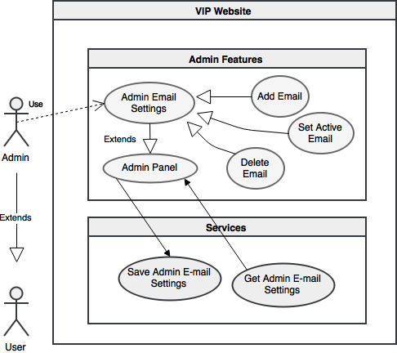

**Sequence Diagram**

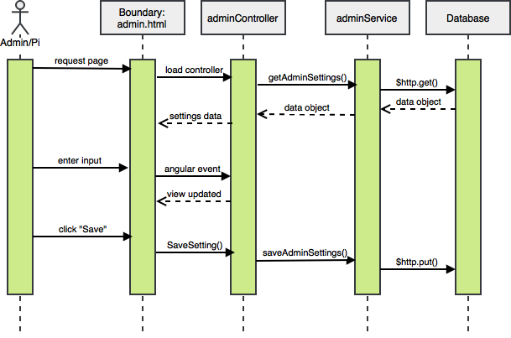

**Class Diagram**

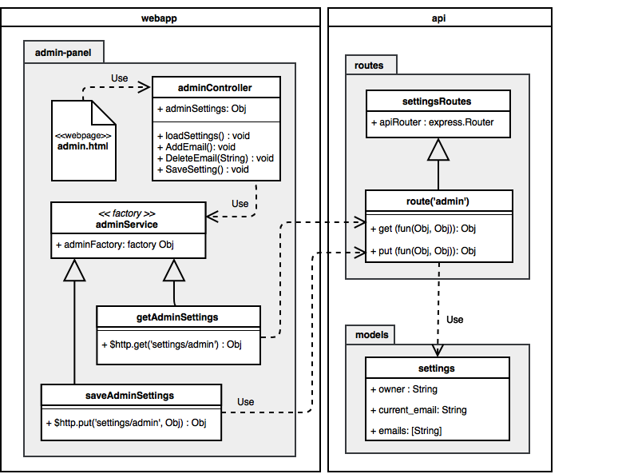

**Unit Tests**

* **Test case ID:** VIP-1264-U1
* **Description/Summary of Test:**
* Enter the input email@email.com into the text area
* Click the [Add New] button to append email to list.
* Click the [Change] button to commit changes.
* P**re-condition:**
* User with Pi privileges has logged into the VIP website.
* Web browser is open to the admin panel page
* **Expected Results:**
* New entry []email@email.com persists after refreshing the admin panel or navigating off the page.
* **Actual Result:**
* New entry []email@email.com persists after refreshing the admin panel or navigating off the page.
* **Status:** PASS
* **Test case ID:** VIP-1264-U2
* **Description/Summary of Test:**
* Change active email-address to ‘email@email.com’ by selecting the entry

[]email@email.com from the list.

* Click the [Change]button to commit changes.
* P**re-condition:**
* User with Pi privileges has logged into the VIP website.
* []email@email.com entry has been previously added to the email list
* Email list contains at least one other entry. Exactly one (1) of these email

addresses should be selected as the “active” e-mail [x]any@any.com

* Web browser is open to the admin panel page
* **Expected Results:**
* The entry [x]email@email.com remains marked as active after refreshing the admin panel or navigating off the page.
* **Actual Result:**
* The entry [x]email@email.com remains marked as active after refreshing the admin panel or navigating off the page.
* **Status:** PASS

**Integration Test**

* **Test case ID:** VIP-1264-G1
* **Description/Summary of Test**:
* Tester modifies admin email settings to use an e-mail address of their choosing. (We

will refer to this address as any@any.com ).

* User submits project edit form, which toggles an automated message sent to the

e-mail address any@any.com.

* **Pre-condition:**
* User with Pi privileges has logged into the VIP website.
* User has ownership of at least one active project.
* Tester has access to inbox of email address used during testing.
* **Expected Results:**
* Tester receives email regarding a project edit proposal at the address any@any.com
* **Actual Result:**
* Tester receives email regarding a project edit proposal at the address any@any.com
* **Status (Fail/Pass):** PASS

**Visual User Guide**

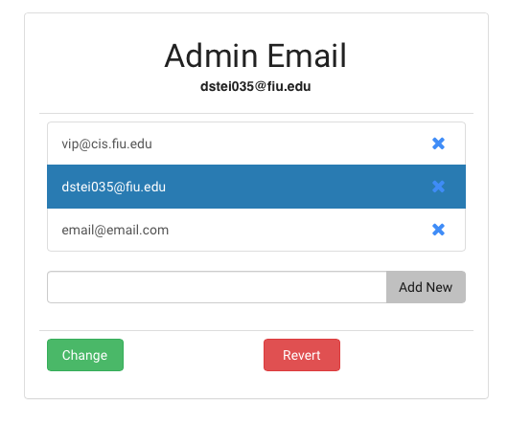

*[vip#1264]: Relevant portion of web page “/#/adminpanel”*