*Florida International University*

*School of Computing and Information Sciences*

CIS 4911 - Senior Capstone Project

Software Engineering Focus

Feature Document

User Story ID #1262

**Name: Jose Ponce**

**Team Member(s): Dafna Steinberg**

**Project: VIP web 6.0**

**Product Owner(s)**: Masoud Sadjadi, Francisco Ortega

**Mentor(s)**: None

**Instructor**: Masoud Sadjadi

# Notify users about new projects added since last notification**:**

* Description: As a user(any user) of the vip website, i would like to be notified daily of any new projects available in the website. I would also like to be able to opt-out of receiving this emails.

Acceptance Criteria

* As a user, i should receive a daily email with a list of(and links to) all new projects created in the vip website since the previous day.
* I will not receive an email if there are no new projects.
* When i click on any of the links from the email it should take me to the project details page for that specific project.
* I will see in every notification email an explanation of how to unsubscribe from this emails.
* When i go to my profile page(after login) and uncheck the “allow notifications” checkbox and click update, i will no longer receive this project notification emails.

**Use Case**

* Name: Daily project notifications.
* Actor: any user(Student, Faculty-Staff, Pi-CoPi)
* Preconditions: user has registered with the vip website
* Description:

1. An event is triggered by the system in the morning each day.
2. The system will send every user that hasn’t opted out of notifications an email with a list of new projects created(approved) since the last time the notifications were sent if there are new projects, else, no email is sent.
3. User receives email and clicks in one of the project links.
4. System presents the user with the detailed project description page.

**Use Case Diagram**

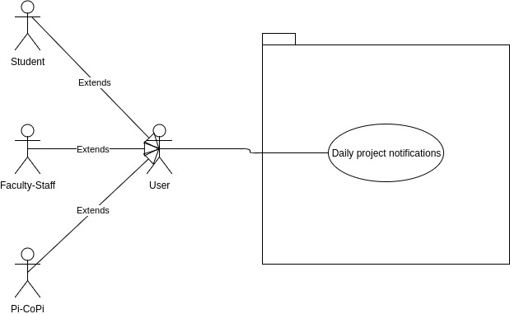

**Sequence Diagram**

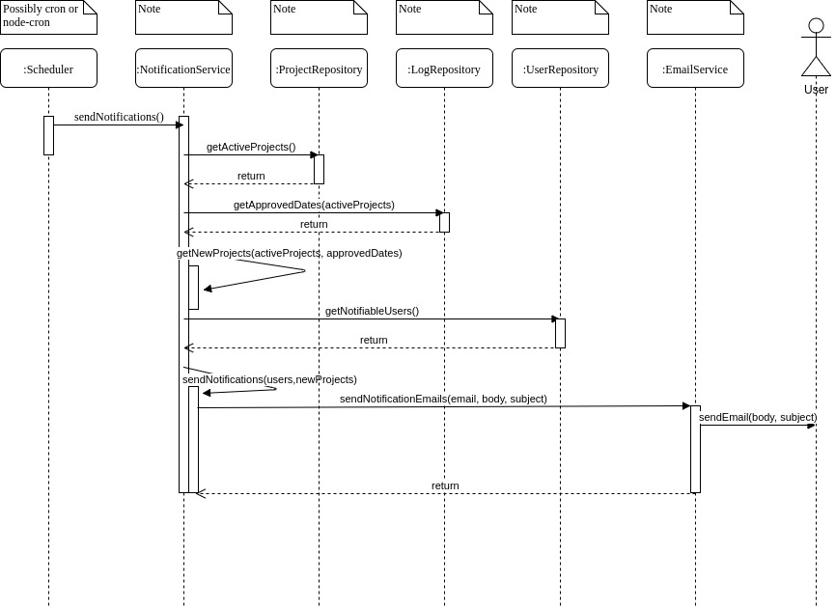

**Class Diagram**

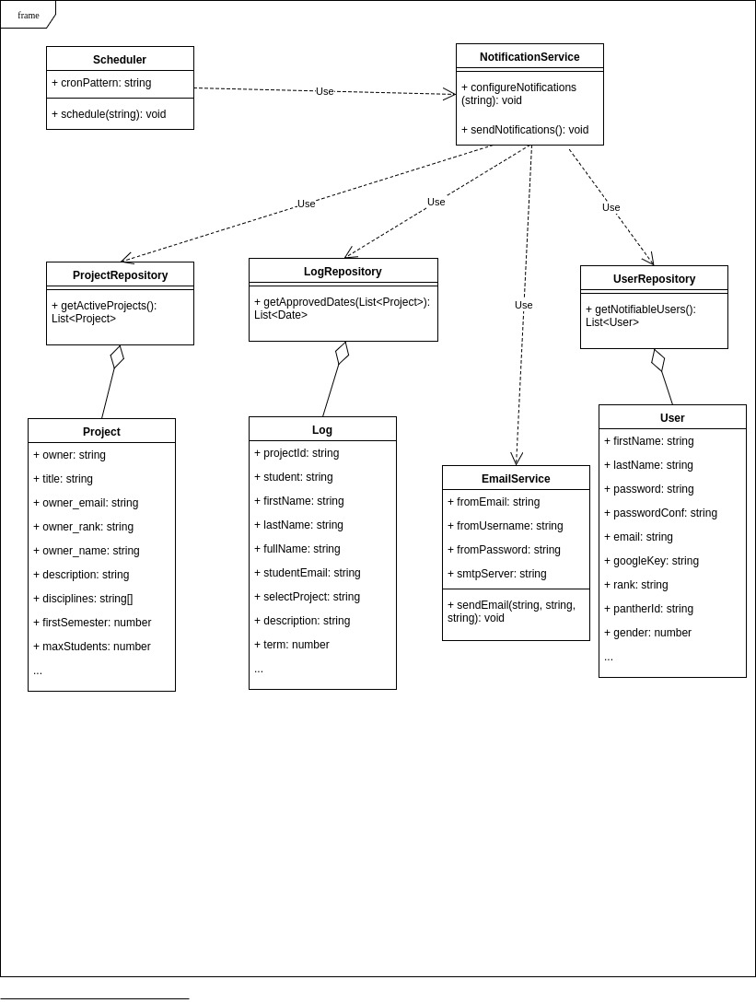

**Unit Test**

* Test case ID: Sunny day scenario
* Description/Summary of Test: There is one new project(approved yesterday) and a user who has not opted out of notifications and then the sendNotifications method of the notificationService is triggered and this will cause an email to be sent to the user with a link to the project specified above.
* Pre-condition:
  + There is a project approved with date of yesterday in the database.
  + There is a user who hasn’t opted out of notifications in the database.
  + The notificationService’s sendNotifications method is triggered.
* Expected Results:
  + An email will be sent to the user specified above.
  + The email sent to the user will contain a link to the project details page of the project specified above.
* Actual Result:
  + An email will be sent to the user specified above.
  + The email sent to the user will contain a link to the project details page of the project specified above.
* Status (Fail/Pass): Pass

**Integration Test**

* Test case ID: No email is sent when there are no new projects
* Description/Summary of Test: There are no new project(approved yesterday) and there is at least one user who has not opted out of notifications and then the sendNotifications method of the notificationService is triggered and no emails should be sent since there are no projects to notify users about.
* Pre-condition:
  + There are no projects approved with date of yesterday in the database.
  + There is at least one user who hasn’t opted out of notifications in the database.
  + The notificationService’s sendNotifications method is triggered.
* Expected Results:
  + No emails will be sent in response to the sendNotifications method being called.
* Actual Result:
  + No emails were sent.
* Status (Fail/Pass): Pass

**Visual User Guide**

