*Florida International University*

*School of Computing and Information Sciences*

Software Engineering Focus

Feature Document

[vip/#1272]

**Name:** Dafna Steinberg

**Team Member(s):** Jose Ponce Diaz

**Project:** VIP Website 6.0

**Product Owner(s)**: Francisco Ortega, Masoud Sadjadi

**Mentor(s)**: Leila Zahedi

**Instructor**: Masoud Sadjadi

**Enhance alert / to-do management system:**

**Description**

* As an Admin/Faculty, I would like a more efficient way to address, dismiss or delete alerts (to-dos). Currently, to-dos are only marked as “done” if the task is accessed via the to-do panel. I would like a “smart” to-do system that automatically senses when an alert has been handled, and updates the to-do panel appropriately. This will help prevent hundreds of alerts from accumulating, and make new alerts more meaningful.

**Acceptance Criteria**

1. To-dos are retrieved from the database on a per-user basis. Website should only retrieve to-dos containing the owner ID of the current user.
   1. Pi/CoPi to-dos are not associated with any particular user ID and are viewable by all Pi/Copi users on the system.
2. (All) Users are able to clear to-dos from their inbox en-masse. Users are given the option to:
   1. delete ALL to-dos in their inbox
   2. delete to-dos aged one week (7 days) and older
   3. delete to-dos aged one month (30 days) and older
3. Pi/CoPi to-dos regarding project proposals and/or student applications are automatically detected and removed from the inbox whenever the proposal / application request is handled.

**Use Cases**

* Name: Indirectly dismissing to-do messages via project review page
* Actor: Admin / Pi
* Preconditions:
* User with admin / Pi privileges is logged into the VIP website
* There exists at least one (1) project pending approval visible on the “Review Project Proposals” page.
* Pi/CoPi to-do message corresponding to above project proposal is visible on the to-do page, and has not yet been marked as read.
* Description <Flow of events>:
* Pi/Copi navigates to the “Review Projects Proposals” page. Pi/Copi can either accept or reject the desired project. Upon accept / reject, system will automatically detect the correct “to-do” and remove it from the PiCopi’s to-do inbox.
* Name: Bulk deleting to-do messages
* Actor: Any registered user (Student, Faculty, Pi/Copi)
* Preconditions:
* User is logged into the VIP website
* There exists at least one (1) to-do available to the user in the to-do inbox.
* Description <Flow of events>:
* User navigates to the to-do inbox by clicking on the notification icon on the page header. The user proceeds to clear to-do messages by clicking the button with the trash icon. The to-dos should be correctly cleared based on the criteria selected.

**Use Case Diagram**

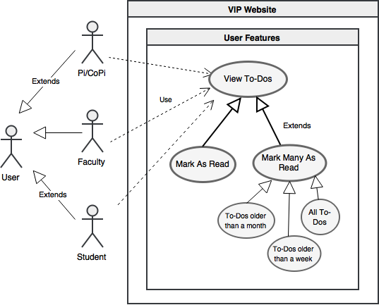

**Sequence Diagram**

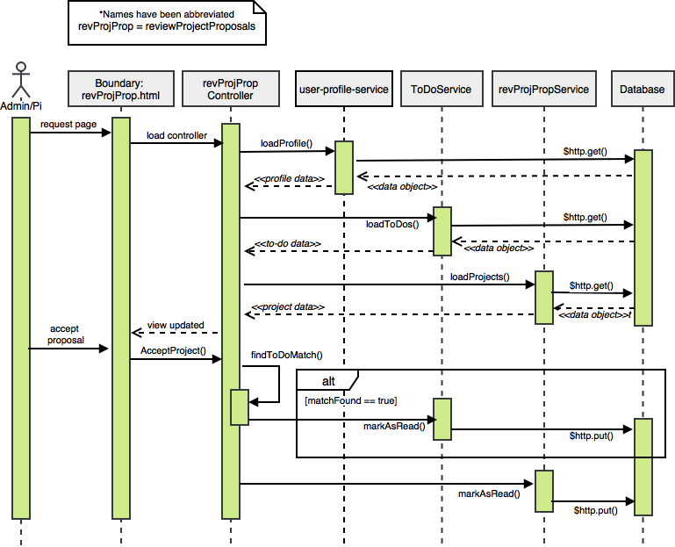

**Class Diagram**

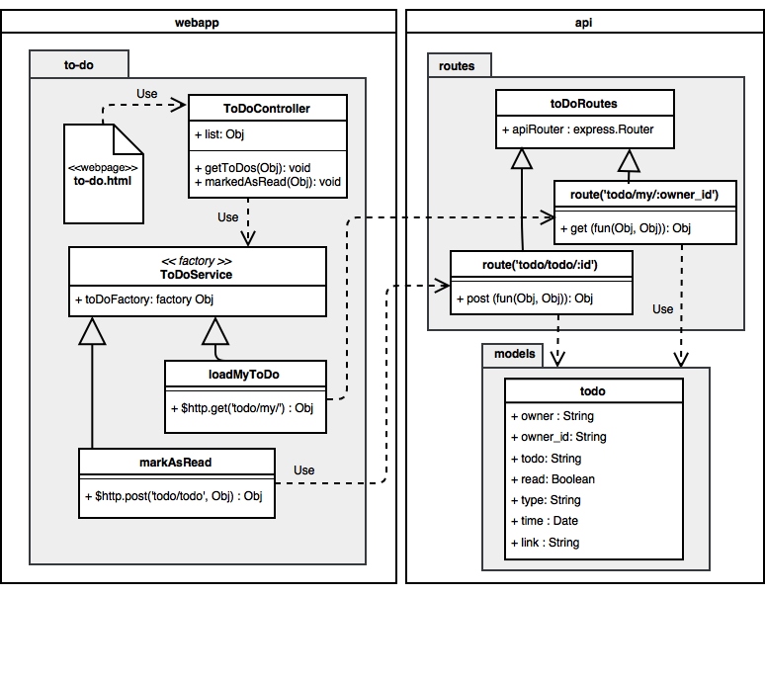

**Unit Tests**

* **Test case ID:** VIP-1272-U1 (Sunny Day)
* **Description/Summary of Test:**
* Deleting to-do notifications older than one week of age.
* P**re-condition:**
* User is logged into VIP website
* There exists at least one (1) to-do belonging to the user and visible in the to-do inbox.
* At least one (1) of these to-dos is seven (7) days or older.
* **Expected Results:**
* All to-dos aged seven (7) days and older from the selected category are removed from the to-do inbox. Deletion persists when the to-do inbox is refreshed.
* **Actual Result:**
* All to-dos aged seven (7) days and older from the selected category are removed from the to-do inbox. Deletion persists when the to-do inbox is refreshed.
* **Status:** PASS

**Integration Test**

* **Test case ID:** VIP-1272-G1 - Matching and removal of todos
* **Description/Summary of Test**: User accepts or rejects a project on the project proposal interface. System matches selected project to a “to-do” by using the project title, proposer’s name and a timestamp. Corresponding to-do task is then automatically removed from the user’s inbox.
* **Pre-condition:**
* User with admin / Pi privileges is logged into the VIP website
* There exists at least one (1) project pending approval visible on the “Review Project Proposals” page.
* **Expected Results:**
* The correct to-do is removed from the user’s inbox. All other to-dos should remain intact and unaltered.
* **Actual Result:**
* The correct to-do is removed from the user’s inbox. All other to-dos should remain intact and unaltered.
* **Status (Fail/Pass):** PASS
* **Test case ID:** VIP-1272-G2 - Matching and removal of todos related to identically-named projects
* **Description/Summary of Test**: User accepts (or rejects) one of two projects with identical project names. System matches the selected project to a “todo” by using the project status, the proposer’s name, and a timestamp.
* **Pre-condition:**
* User with admin / Pi privileges is logged into the VIP website
* There exists at least two (2) projects pending approval visible on the “Review Project Proposals” page. These two projects share an identical project name.
* **Expected Results:**
* The correct to-do is removed from the Pi’s to-do inbox. The other to-do correlated to the similarly named project should remain intact. All other unrelated to-dos should also remain unaltered.
* **Actual Result:**
* The correct to-do is removed from the Pi’s to-do inbox. The other to-do correlated to the similarly named project should remain intact. All other unrelated to-dos should also remain unaltered.
* **Status (Fail/Pass):** PASS

**Visual User Guide**

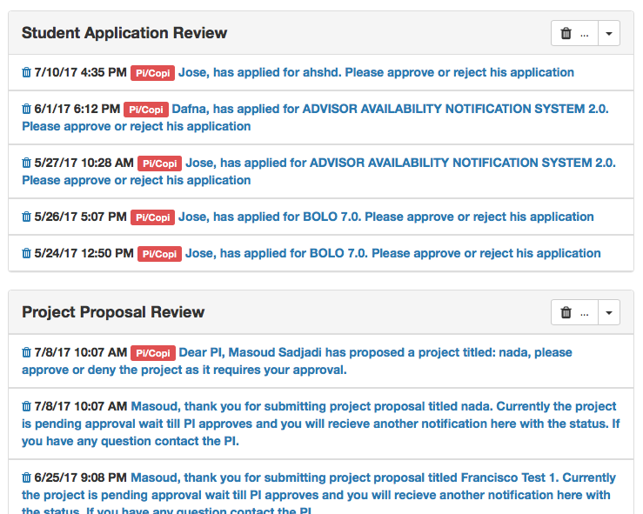

*[vip#1262]: Red tags have been added on to-dos that require Pi/CoPi activity. New ‘trash’ button has been added on the header of every to-do section and provides a way for to-dos to be cleared in bulk.*

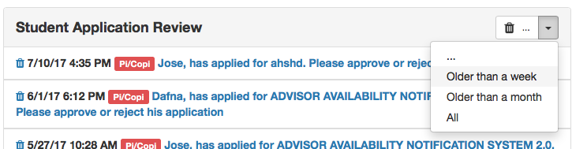

*[vip#1262]: Drop-down options showing options for to-do deletion criteria.*