*Florida International University*

*School of Computing and Information Sciences*

Software Engineering Focus

Feature Document

User Story ID #1393

**Name:** Sergio Hernandez Padron

**Team Member(s):** David Venta and Sergio Hernandez Padron

**Project:** VIP Website 8.0

**Product Owner(s)**: Dr. Masoud Sadjadi, Dr. Francisco Ortega

**Mentor(s)**:

**Instructor**: Masoud Sadjadi

**User Story Name:** Data consistency test/script

Description:

* As developer I would like to implement a data consistency test/script that we can run to detect inconsistencies in the database, this will greatly improve the debugging and testing process. The data is not always entered consistently because there are several ways to create/update users, projects and courses. This script should be easy to update with new consistency rules.

Acceptance Criteria:

* Check for mandatory fields that are empty on all tables
* Users that are students should all be enrolled in a course, project, semester that exist
* A course should have at least one student, if not deleted
* A project should always have an owner, owner email, existing semester.
* This could eventually be added to the Admin Maintenance section to show all discrepancies found.

**Use Case**

* Name: Data consistency test/script
* Actor: Admin
* Preconditions:
* Admin must be logged in with administrative rights
* Admin must be at the admin panel page - admin maintenance tab
* Description:
* Admin will see the discrepancies in red on the site summary on admin maint. tab

**Use Case Diagram:**

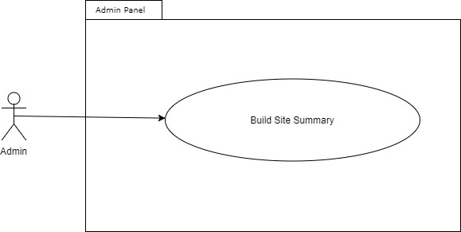

**Sequence Diagram:**

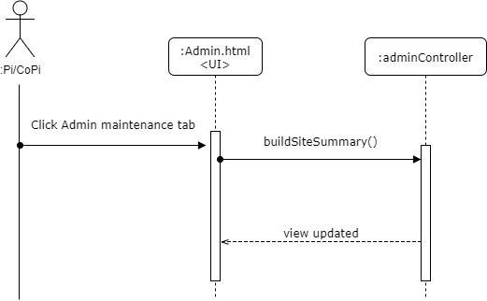

**Class Diagram:**

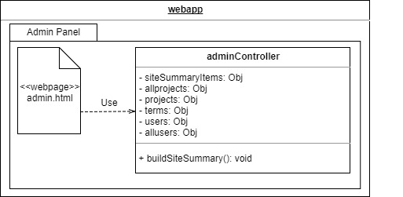

**Unit Test:**

* Test case ID: VIP-1393-U1
* Description: Chek summary totals match actual values
* Summary of Test:

1. Compare summary totals with actual totals

* Test Data:
* Pre-Conditions:

1. Admin with Pi/CoPi privileges has logged into the VIP website
2. Admin is at the admin panel page - admin maintenance tab

* Status (Fail/Pass): PASS

**Integration Test:**

**Visual User Guide:**

