*Florida International University*

*School of Computing and Information Sciences*

Software Engineering Focus

Feature Document

User Story ID #1422

**Name:** David Venta

**Team Member(s):** David Venta and Sergio Hernandez Padron

**Project:** VIP Website 8.0

**Product Owner(s)**: Dr. Masoud Sadjadi, Dr. Francisco Ortega

**Mentor(s)**:

**Instructor**: Masoud Sadjadi

**User Story Name:** Email for user validation redirects to wrong page.

* Description: As an **admin**, I **would like** to be redirected to the admin panel after following the link form email, **so that** I am able to confirm the user.

Acceptance Criteria

* When admin receives a confirmation email after a new user registers, it contains a link; which should redirect to admin panel instead of home page, so that admin is able to validate/delete user.

**Use Case**

* Name:Email for user validation redirects to wrong page.
* Actor: Admin
* Preconditions:
* Admin must have administrative rights
* Admin must have access to email
* Admin must follow link sent on confirmation email
* Description:
* New user registers to VIP website
* Admin receives an automated email with a link to follow
* Admin follows link and gets redirected to admin panel
* Admin validate/rejects user in admin panel

**Use Case Diagram:**

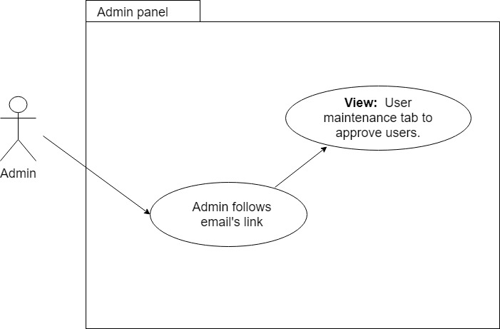

**Sequence Diagram:**

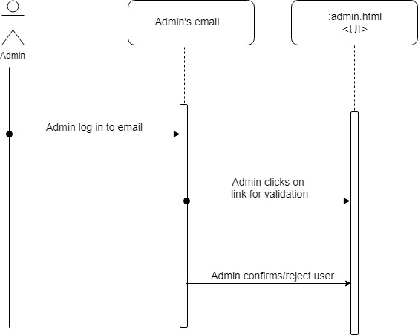

**Class Diagram:**

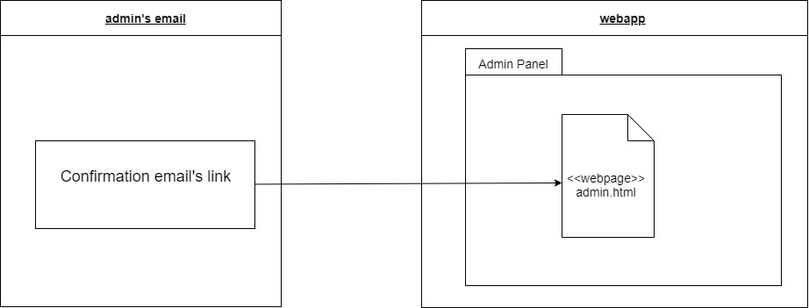

**Unit Test**

* Test case ID: VIP-1422-U1
* Description/Summary of Test:
* Admin receives email with confirmation of new user registered
* Link redirects to admin panel.
* Pre-condition:
* Admin must have administrative rights.
* Admin must have access to email.
* Admin must follow link sent on confirmation email.
* Expected Results:
* Admin receives email with confirmation of new user registered
* Link redirects to admin panel.
* Actual Result:
* Same as expected results
* Status (Fail/Pass): PASS

**Visual User Guide:**



