*Florida International University*

*School of Computing and Information Sciences*

Software Engineering Focus

Feature Document

User Story ID #1415

**Name:** David Venta

**Team Member(s):** David Venta and Sergio Hernandez Padron

**Project:** VIP Website 8.0

**Product Owner(s)**: Dr. Masoud Sadjadi, Dr. Francisco Ortega

**Mentor(s)**:

**Instructor**: Masoud Sadjadi

**User Story Name:** Admin should not be able to add members to a project if that specific member is already registered for one.

* Description: **As an** admin. **I would like** to know which user is already assigned to a project, **so that** I am not able to add that user to more than one project. Also, It is not clear for admin whether the users are approved or not.

Acceptance Criteria

* Drop down of project members should only show members who are not assigned/registered to a project. This will make sure Admin is not able to add that student to another project.
* Added a text to let admin know when the user is not approved to that specific project.
* Added tooltip to button to let the user know the meaning of each button.

**Use Case**

* Name: Admin should not be able to add members to a project if that specific member is already registered for one.
* Actor: Admin
* Preconditions:
* User must have admin rights
* Description
* User must login as an admin.
* User must navigate to admin panel.
* User must select project maintenance tab.
* User clicks on edit users button
* Admin tries to add users to projects.

**Use Case Diagram:**

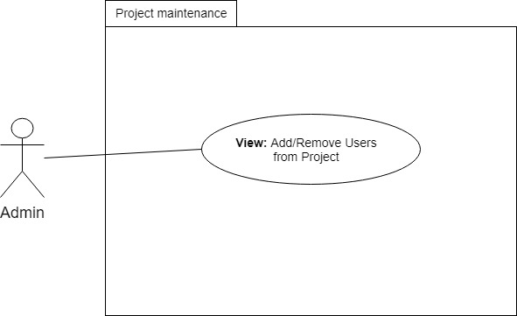

**Sequence Diagram:**

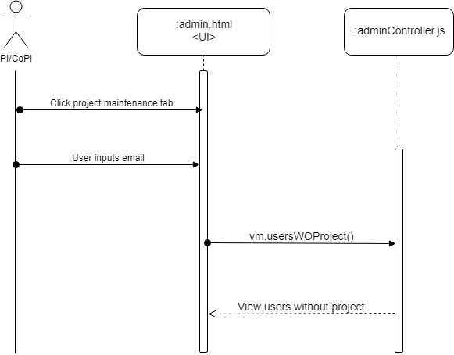

**Class Diagram:**

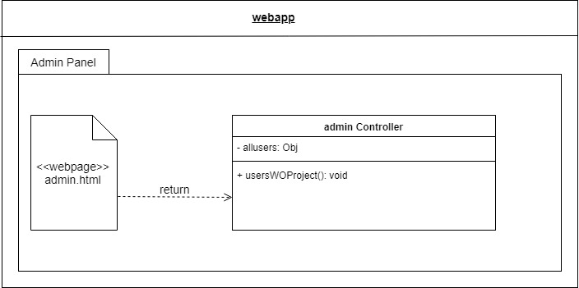

**Unit Test**

* Test case ID: VIP-1415-U1
* Description/Summary of Test:
* Drop down should only have students without a project
* Pre-condition:
* User must have admin rights
* Admin navigates to admin panel by clicking on the tool icon
* Admin navigates to project maintenance tab
* Expected Results:
* Only students with no projects assigned must show in dropdown to avoid admin from registering that user to another project.
* Actual Result:
* Admin only sees students without any projects assigned
* Admin is presented with information on which user is not approved to that project
* Status (Fail/Pass): PASS

**Integration Test(Not needed)**

**Visual User Guide:**

