*Florida International University*

*School of Computing and Information Sciences*

Software Engineering Focus

Feature Document

User Story ID #1392

**Name:** Sergio Hernandez Padron

**Team Member(s):** David Venta and Sergio Hernandez Padron

**Project:** VIP Website 8.0

**Product Owner(s)**: Dr. Masoud Sadjadi, Dr. Francisco Ortega

**Mentor(s)**:

**Instructor**: Masoud Sadjadi

**User Story Name:** Update Upload Course Data feature

Description:

* As a Admin, I would like to be able to import students into the system, so that the system can have the list of new students in the current semester registered in different courses.

Acceptance Criteria:

* Upload Course Data feature will import from a .txt file which has the following format:

userloginname::PID::FirstName MiddleInitial LastName

* email will be set to userloignname@fiu.edu
* semester will be set to current semester
* course will be set to the one selected on the drop-down list.
* user type will be set to student
* Generate each part of the name by using the structure of the email address to distinguish what goes into each section of the name. As name can have more than two parts, it is hard to distinguish what is first, middle, and last name. Using the email address, which is in this format, first initial then first part of last name and then some numbers, you can better guess what part of the name text is first name, what is middle name, if any, what is last name, and whether the last name has more than one word. For example, for ssadj001@fiu.edu::1234567:seyed masoud sadjadi vala", you would know that Seyed is the first name, Masoud is the middle name...
* pantherID will be set to PID.

**Use Case**

* Name: Upload Course Data feature
* Actor: Admin
* Preconditions:
* Admin must be logged in with administrative rights
* Admin must be at the admin panel page - course maintenance tab
* Description:
* Admin selects a course file (.txt)
* Admin selects the ‘add course file’ button
* Admin selects the ‘sync database’ button
* Admin will see the update of the users of the course in the system

**Use Case Diagram:**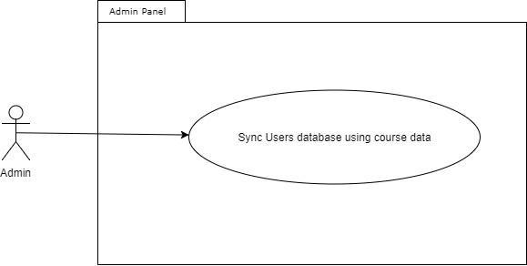

**Sequence Diagram:**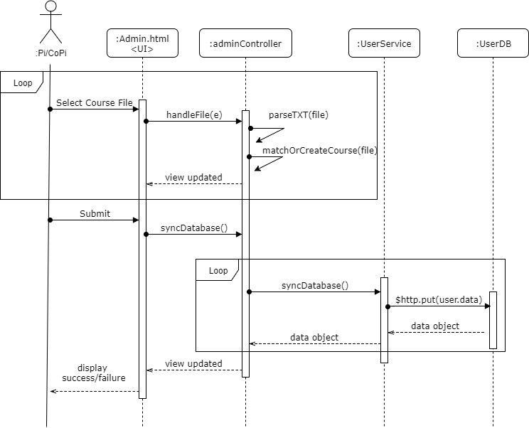

**Class Diagram:**

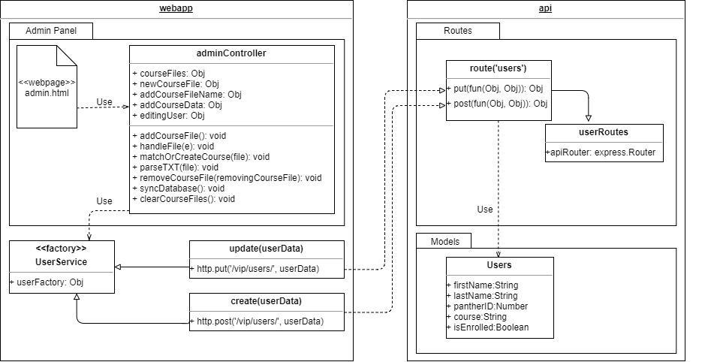

**Unit Test:**

* Test case ID: VIP-1346-U1
* Description: Admin syncs Users database using course data for a course registered in the system
* Summary of Test:

1. Tester selects ‘Sync Database’ button
2. Tester selects ‘choose file’ button
3. Vip.fiu.edu responds by presenting a file dialog
4. Tester selects xls file ‘TST 1234-U01’ in file dialog
5. Vip.fiu.edu responds by updating course combo box with matching course ‘TST 1234-U01’
6. Tester selects ‘add course file’ button
7. Tester selects ‘Sync Database’ button
8. Vip.fiu.edu responds with notification of success or failure

* Test Data:
* XLS File Name: TST 1234-U01
* User: Test User

- panther ID: 0000001

- email: t@u.edu

- name: User, Test

* User: Q W

- panther ID: 0000002

- email: q@w.edu

- name: W, Q

* User: first1 last1 last2

- panther ID: 0000003

- email: f@l.edu

- name: last1 last2, first1

* Pre-Conditions:

1. Admin with Pi/CoPi privileges has logged into the VIP website
2. Admin is at the admin panel page - course maintenance tab
3. Users ‘Test User’, ‘Q W’, ‘first1 last1 last2’ are present in the Users Database
4. Course ‘TST 1234-U01’ is present in the Courses Database

* Expected Results:

1. Users ‘Test User’, ‘Q W’, ‘first1 last1 last2’ will be updated to be enrolled in course ‘TST 1234-U01’
2. Users panel will be updated with users course changes

* Actual Result:

1. Users ‘Test User’, ‘Q W’, ‘first1 last1 last2’ is updated to be enrolled in course ‘TST 1234-U01’
2. Users panel is updated with users course changes

* Status (Fail/Pass): PASS

**Integration Test:**

* Test case ID: VIP-1346-G1
* Description: Admin syncs Users database using course data for a course not registered in the system
* Summary of Test:

1. Tester selects ‘Sync Database’ button
2. Tester selects ‘choose file’ button
3. Vip.fiu.edu responds by presenting a file dialog
4. Tester selects xls file ‘NEW 1000-U01’ in file dialog
5. Vip.fiu.edu responds by asking the user to confirm the creation of course ‘NEW 1000-U01’
6. Tester selects ‘add course’ button
7. Tester selects ‘add course file’ button
8. Tester selects ‘Sync Database’ button
9. Vip.fiu.edu responds with notification of success or failure

* Test Data:
* XLS File Name: NEW 1000-U01
* User: Test User

- panther ID: 0000001

- email: t@u.edu

- name: User, Test

* Pre-Conditions:

1. Admin with Pi/CoPi privileges has logged into the VIP website
2. Admin is at the admin panel page - course maintenance tab
3. User ‘Test User’ is present in the Users Database
4. Course ‘NEW 1000-U01’ is not present in the Courses Database

* Expected Results:

1. User ‘Test User’ will be updated to be enrolled in course ‘NEW 1000-U01’
2. Users panel will be updated with users course changes
3. Courses panel will be updated with new course ‘NEW 1000-U01’ shown

* Actual Result:

1. User ‘Test User’ will be updated to be enrolled in course ‘NEW 1000-U01’
2. Users panel will be updated with users course changes
3. Courses panel will be updated with new course ‘NEW 1000-U01’ shown

* Status (Fail/Pass): PASS
* Test case ID: VIP-1346-G2
* Description: Finding a user in the course data being synced that is not currently in the Users database should create a new user in the Users database
* Summary of Test:

1. Tester selects ‘Sync Database’ button
2. Tester selects ‘choose file’ button
3. Vip.fiu.edu responds by presenting a file dialog
4. Tester selects xls file ‘TST 1234-U01’ in file dialog
5. Vip.fiu.edu responds by updating course combo box with matching course ‘TST 1234-U01’
6. Tester selects ‘add course file’ button
7. Tester selects ‘Sync Database’ button
8. Vip.fiu.edu responds with notification of success or failure
9. Test selects ‘User maintenance’ tab and searches for added user: ‘New User’

* Test Data:
* XLS File Name: TST 1234-U01
* User: New User

- panther ID: 0000004

- email: n@u.edu

- name: User, New

* Pre-conditions:

1. Admin with Pi/CoPi privileges has logged into the VIP website
2. Admin is at the admin panel page - course maintenance tab
3. User ‘New User’ is not present in the Users Database
4. Course ‘TST 1234-U01’ is present in the Courses Database

* Expected Results:

1. User ‘New User’ will be added to the database, enrolled in course ‘TST 1234-U01’
2. Users panel will be updated with new user ‘New User’

* Actual Result:

1. User ‘New User’ was added to the database, enrolled in course ‘TST 1234-U01’
2. Users panel was updated with new user ‘New User’

Status (Fail/Pass): PASS

**Visual User Guide:** 