*Florida International University*

*School of Computing and Information Sciences*

Software Engineering Focus

Feature Document

User Story ID #1382

**Name:** David Venta

**Team Member(s):** David Venta and Sergio Hernandez Padron

**Project:** VIP Website 8.0

**Product Owner(s)**: Dr. Masoud Sadjadi, Dr. Francisco Ortega

**Mentor(s)**:

**Instructor**: Masoud Sadjadi

**User Story Name:** Product owner dropdown not functional

* Description: **As an** Admin **I would like** to navigate to the project maintenance tab **so that** I am able to view the owner tab, **which** shows by default one value and does not filter the project’s owner table

Acceptance Criteria

* As an admin, I would like to be able to filter by owner by selecting one from the owner’s dropdown list.
* As an admin, I would like to navigate to the Projects where all filters should be blank by default

**Use Case**

* Name: In project maintenance the owner dropdown does not filters
* Actor: PI/CoPI
* Preconditions:
* User must have admin rights
* User must navigate to project maintenance tab
* Description:
* As an admin, the user should be able to filter by owner. This is done by selecting one project owner from the owner’s dropdown list.
* As an admin, the user should be able to navigate to the Projects where all filters should be blank by default.

**Use Case Diagram:**

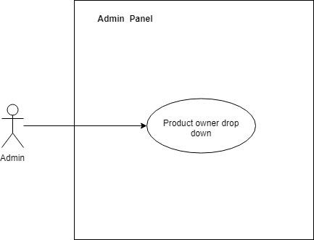

**Sequence Diagram:**

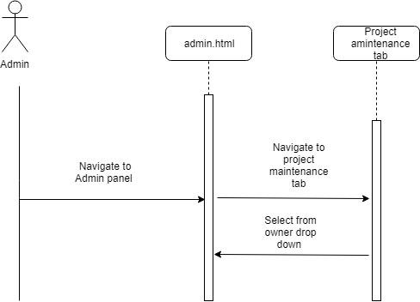

**Class Diagram(Not needed)**

**Unit Test(Not needed)**

* Test case ID:
* Description/Summary of Test:
* Pre-condition:
* Expected Results:
* Actual Result:
* Status (Fail/Pass):

**Integration Test(Not needed)**

**Visual User Guide**

