*Florida International University*

*School of Computing and Information Sciences*

Software Engineering Focus

Feature Document

User Story ID #1419

**Name:** David Venta

**Team Member(s):** David Venta and Sergio Hernandez Padron

**Project:** VIP Website 8.0

**Product Owner(s)**: Dr. Masoud Sadjadi, Dr. Francisco Ortega

**Mentor(s)**:

**Instructor**: Masoud Sadjadi

**User Story Name:** Create a way to confirm/verify any user's email from the admin panel.

* Description: As an admin I would like to confirm/verify the user's email on the admin panel, so that the user does not have to register multiple times.

Acceptance Criteria

* Admin must be able to confirm and edit the email of the registered user
* User does not need to register multiple times if wrong email was typed when registering
* A drop down that verifies user email should be available to admin

**Use Case**

* Name: Create a way to confirm/verify any user's email from the admin panel.
* Actor: Admin
* Preconditions:
* Admin must be logged in with administrative rights
* Admin must be at the admin panel page - user maintenance tab
* Description:
* Admin logs in to account
* Admin navigates to admin panel - user maintenance tab
* Admin selects user to be verified and clicks on edit user
* Admin verifies user and save changes

**Use Case Diagram:**

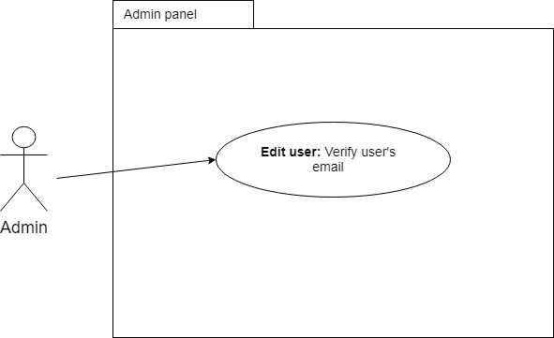

**Sequence Diagram:**

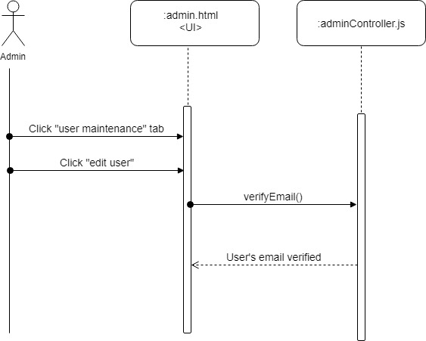

**Class Diagram:**

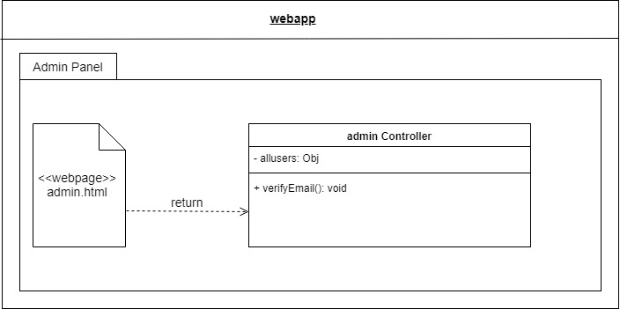

**Unit Test**

* Test case ID: VIP-1419-U1
* Description/Summary of Test:
* Selected a user with an unverified email
* Selected a user with a verified email
* Pre-condition:
* User must have admin privileges
* Admin must be in user maintenance and edit user panel
* Expected Results:
* Setting value of verify email to true makes the user’s email verified
* Setting value of verify email to false makes the user’s email unverified
* Actual Result: Same as expected result
* Status (Fail/Pass): Pass

**Visual User Guide:**

