*Florida International University*

*School of Computing and Information Sciences*

Software Engineering Focus

Feature Document

User Story ID #1421

**Name:** David Venta

**Team Member(s):** David Venta and Sergio Hernandez Padron

**Project:** VIP Website 8.0

**Product Owner(s)**: Dr. Masoud Sadjadi, Dr. Francisco Ortega

**Mentor(s)**:

**Instructor**: Masoud Sadjadi

**User Story Name:** Re-design filters in admin panel.

* As an admin, I would like to have useful filtering options, so that the entire panel is shown and not cut off. As well as having one filtering bar instead of two.

Acceptance Criteria

* Show only useful filters on the admin panel such as first name, last name, email, role and semester
* Re design repeated filters to have consistent drop down and combo box filters.

**Use Case**

* Name: Re-design filters in admin panel.
* Actor: Admin
* Preconditions:
* Admin must be logged in with administrative rights.
* Admin must be at the admin panel page - user maintenance tab.
* Description:
* Admin is presented with useful filtering options
* All filters are accessible to admin.
* No need to scroll to the sides to see filters

**Use Case Diagram:**

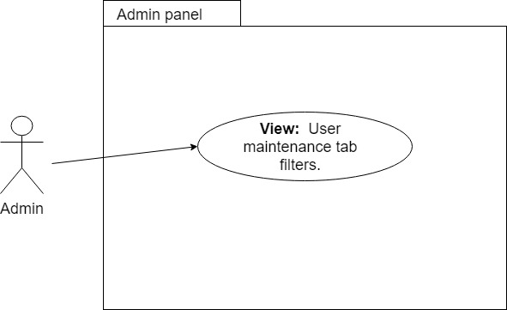

**Sequence Diagram:**

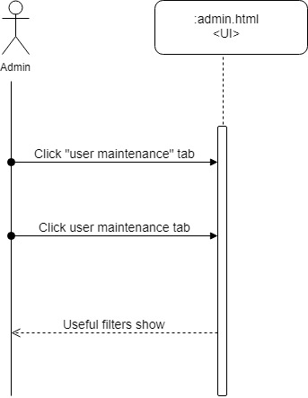

**Class Diagram:**

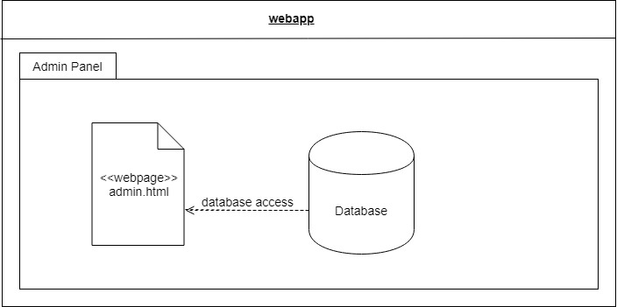

**Unit Test**

* Test case ID: VIP-1421-U1
* Description/Summary of Test:
* Filters show filtering options.
* Filters are organized for user visibility.
* Pre-condition:
* Admin must be logged in with administrative rights
* Admin must be at the admin panel page - user maintenance tab
* Expected Results:
* All tabs are visible
* Actual Result:
* Same as
* Status (Fail/Pass): PASS

**Visual User Guide:**

