*Florida International University*

*School of Computing and Information Sciences*

Software Engineering Focus

Feature Document

User Story ID #725

**Name:** Sergio Hernandez Padron

**Team Member(s):** David Venta and Sergio Hernandez Padron

**Project:** Mobile Judge 10

**Product Owner(s)**: Dr. Masoud Sadjadi, Dr. Francisco Ortega

**Mentor(s)**:

**Instructor**: Masoud Sadjadi

**User Story Name:** Implement questioning depending on course

Description:

* As Admin, I would like to have a course field on the questions, so that judges get questions for students depending on what course are they on.

Acceptance Criteria:

* Show an editable course column on term questions to enter the questions to be asked for that course
* Restructure students questioning to include only the question for his course

**Use Case**

* Name: Implement questioning depending on course
* Actor: Admin
* Preconditions:
* Admin must be logged in with administrative rights
* Admin must be on the settings page on the questions tab
* Description:
* Admin enter a course name exactly as the course on the students list
* When the Judge get its students assigned, only the questions for the course of the student will show

**Use Case Diagram:**

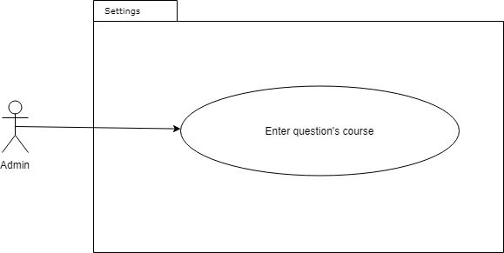

**Sequence Diagram:**

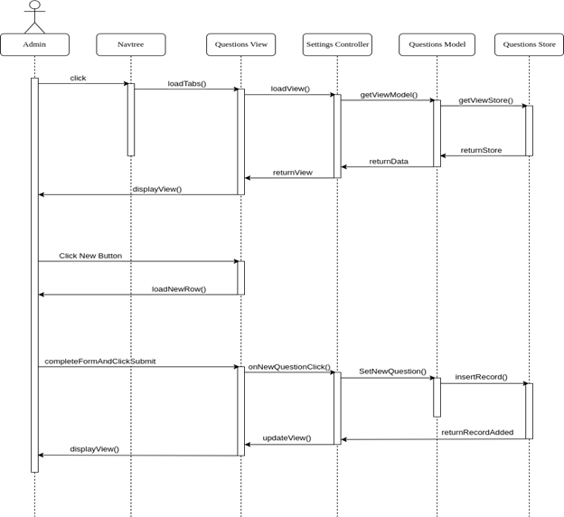

**Class Diagram:**

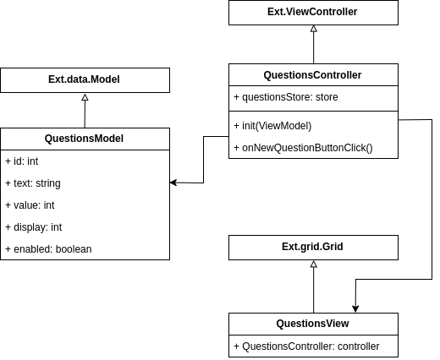

**Unit Test:**

**Test case ID:** 725-01

**Description/Summary of Test:** Create a new questions with course and see it being displayed in grid

**Pre-condition:** Administrator is logged in and on the settings page, terms tab. The question to be added does not exist in the system.

**Expected Results:** New question can be seen in the grid with its course.

**Actual Result:** New question can be seen in the grid with its course.

**Status (Fail/Pass):** Pass

**Integration Test:**

**Visual User Guide:**

