*Florida International University*

*School of Computing and Information Sciences*

Software Engineering Focus

Feature Document

User Story ID #1416

**Name:** David Venta

**Team Member(s):** David Venta and Sergio Hernandez Padron

**Project:** VIP Website 8.0

**Product Owner(s)**: Dr. Masoud Sadjadi, Dr. Francisco Ortega

**Mentor(s)**:

**Instructor**: Masoud Sadjadi

**User Story Name:** Implement date restriction to join and drop projects

Description:

* As an Admin, I would like to restrict the joining and dropping of students in projects based on a range of dates

Acceptance Criteria:

* Provide an input form for setting start and end date
* Restrict joining a project outside deadline range.
* Restrict dropping a project outside deadline range.

**Use Case**

* Name: Implement date restriction to join and drop projects
* Actor: Admin
* Preconditions:
* Admin must be logged in with administrative rights
* Admin must be at the admin panel page - projects maintenance tab
* Description:
* Admin will be able to set the projects join/leave deadline dates on projects maint. tab

**Use Case Diagram:**

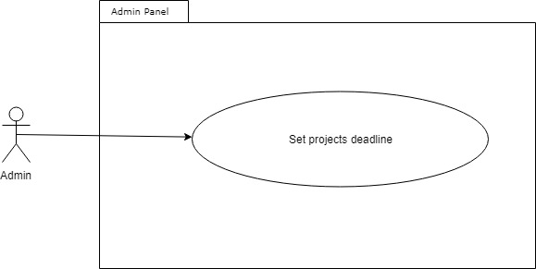

**Sequence Diagram:**

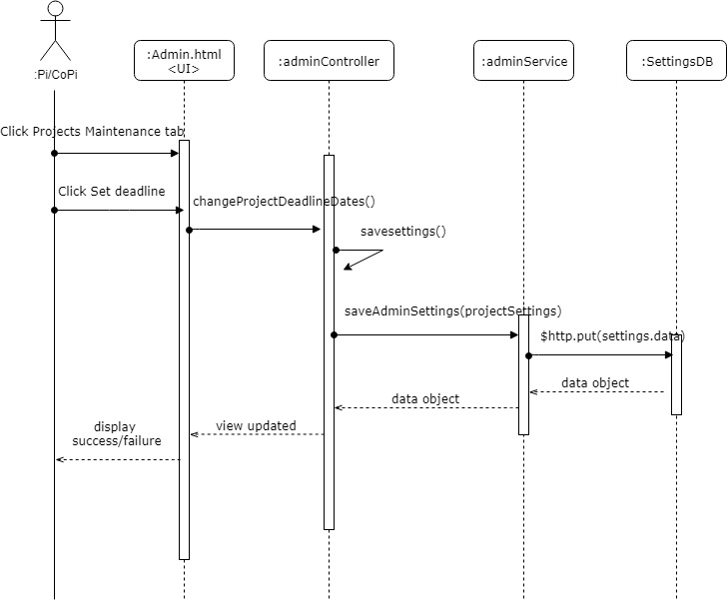

**Class Diagram:**

**Unit Test:**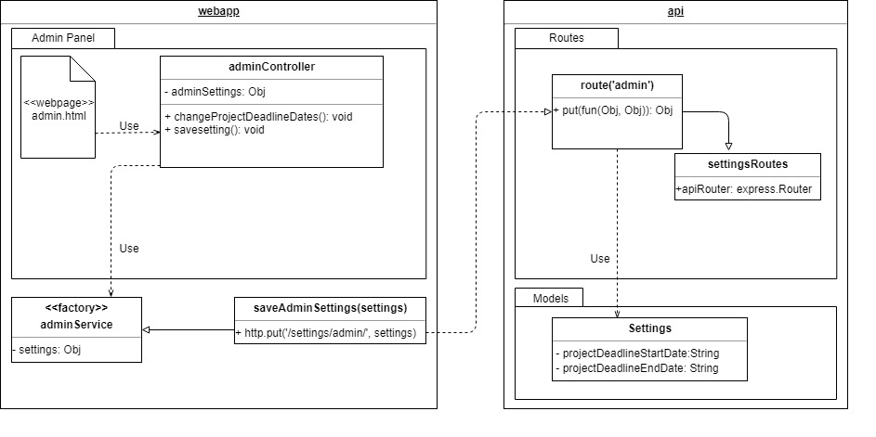

**Integration Test:**

**Visual User Guide:**

