*Florida International University*

*School of Computing and Information Sciences*

Software Engineering Focus

Feature Document

User Story ID #1423

**Name:** David Venta

**Team Member(s):** David Venta and Sergio Hernandez Padron

**Project:** VIP Website 8.0

**Product Owner(s)**: Dr. Masoud Sadjadi, Dr. Francisco Ortega

**Mentor(s)**:

**Instructor**: Masoud Sadjadi

**User Story Name:** Upload course/student data automation.

**Description:**

* As an admin, I would like to have all the data from courses and students populated automatically from the server, so that I am able to sync the students into the courses without having to do it manually.

**Acceptance Criteria:**

* Read “panthersoft” files from root directory and populate onto “upload course” feature screen.
* Populate course list with the files of the format reg-ABC-1234.txt or reg-ABC-1234-INC.txt (incomplete students from previous semesters).
* User will be imported to the system with the first letter capitalized.
* Users with space in their last name shall be imported to the VIP website.
* Users with a last name with less than 4 characters shall be imported to the VIP website.
* Warning messages shall be displayed for files with wrong data format. Details about file name and row number shall be displayed to user for reference.

**Use Case**

* Name:Upload course/student data automation
* Actor: Admin
* Preconditions:
* Admin must be logged in with administrative rights
* Admin must be at the admin panel page - course maintenance tab
* Description:
* Admin clicks on server download button.
* Files with course data get populated from the server.
* Admin clicks on sync database button.
* Admin will see the update of the users of the course in the system.

**Use Case Diagram:**

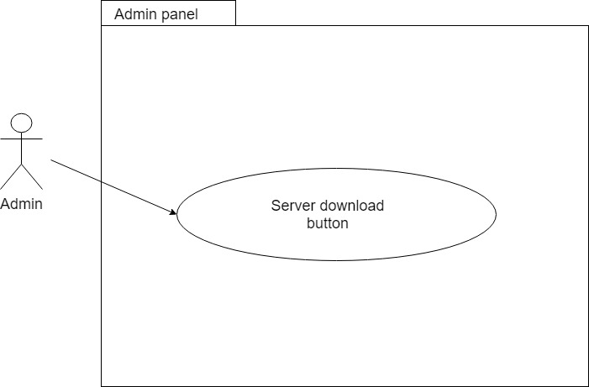

**Sequence Diagram:**

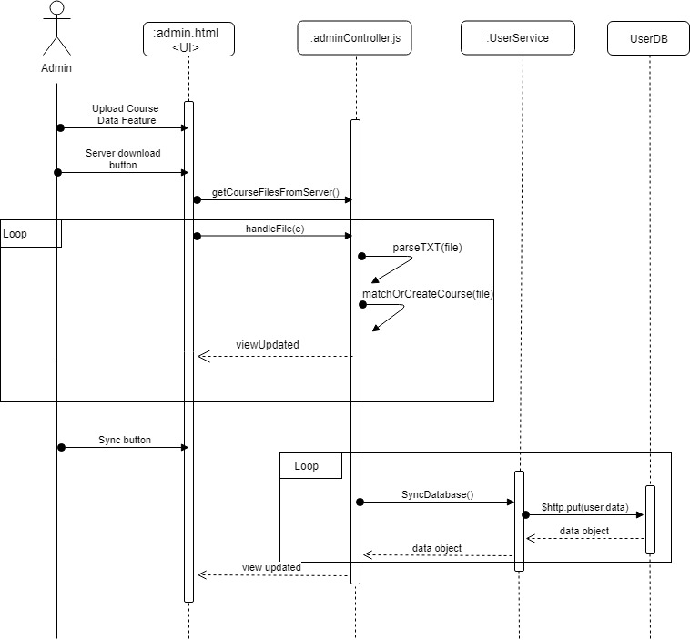

**Class Diagram:**

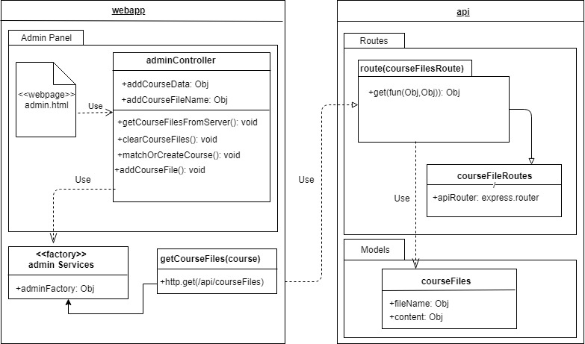

**Unit Test**

* Test case ID: VIP-1423-U1
* Summary of Test: Admin tries to up download files to be synced to VIP website. He/she clicks on “download from server” button. Then, all files are populated from the server to the “Upload Course Data” feature. Finally, admin syncs the data and receives all the statistics of the data being imported to the system.
* Pre-condition:
* Admin has to be logged in to the system
* Admin needs to be at the course maintenance tab
* Admi must click on “Upload Course Data” button
* Expected Results: All files are populated from server and upload screen shows all the statistics
* Status of test (Fail/Pass): Pass

**Visual User Guide:**

