*Florida International University*

*School of Computing and Information Sciences*

CIS 4911 - Senior Capstone Project

Software Engineering Focus

Feature Document

User Story #846

**Team Member:**

Miguel Conde

**Product Owner(s)**:

Masoud Sadjadi

**Mentor(s)**:

Masoud Sadjadi

**Instructor**: Masoud Sadjadi

# 

# 

# 

# **Apply for Existing Projects**

### **Description:**

* As a student i would like to be able to apply to a VIP Project so that I may be able to participate in VIP projects.

### **Acceptance Criteria:**

1. If student not logged in -> log in.
2. Once logged in the system will show the content of the student status to confirm its updated.
3. Notification is sent via Email to the VIP PI and Coordinator, add link to email to redirect to application.
4. Once they log into the system the application will appear in the VIP PI and Coordinator.

## **Use Case**

**Use Case ID:(VIP-846 ) Apply for Existing Project**



Details:

Actor: Student

Pre-conditions:

1. User has to be on application Page

Description:

1. Use case begins when user clicks on Apply button on Apply tab
2. VIP will fetch user information and all projects in database
3. VIP will display form with current user information and projects
4. Student will select project and update any of his information if needed
5. User will click Save&Submit button
6. VIP will update user model
7. VIP will send email notification about application

Post-conditions:

1. User will be notified that his application has been submitted and navigated to home page

Alternative Courses of Action:

1. User clicks on apply to project on project page
2. VIP will populate project dropdown input field with project selected by Student

Exceptions:

N/A

Related Uses Case:

1. US #848 - View my VIP project page
2. US #745 - View login Page

Decision Support:

Frequency: Low. Estimated average of one addition per application execution.

Criticality: High. Allows the student to apply to VIP project.

Risk: Low. Implementing this use case employs standard web-based technology.

Constraints:

1. Usability:
   1. No training time  required.
   2. User guide should provide more in-depth information on Docker if necessary.
2. Reliability:
   1. Mean time to Failure – 5% failures for every twenty four hours of operation is acceptable.
   2. Availability – Down time for Login Back-up 30 minutes in a 24 hour period.
3. Performance:
   1. Web Page should be loaded on a broadband connection (>5Mbps) in 1 second or less
4. Supportability:
   1. Should work with current versions of most popular browsers.

Modification History:

Owner: Miguel Conde.

Initiation date: 03/28/2016

Date last modified: 04/01/2016

**Sequence Diagram**

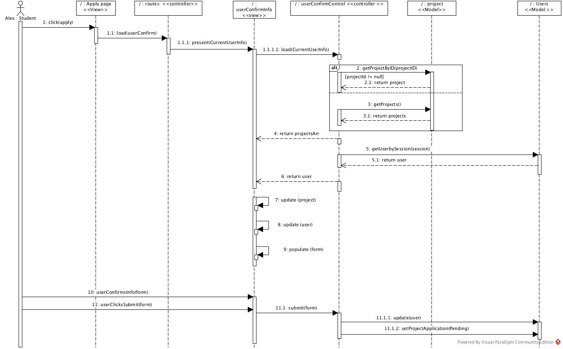

**Class Diagram**



**State Chart Diagram**

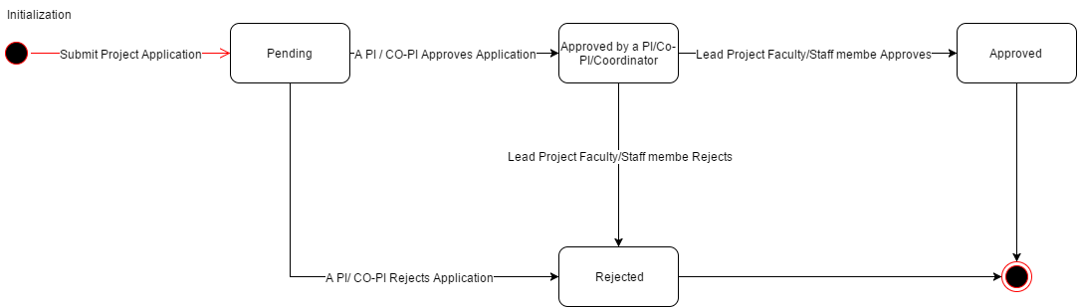

**Unit & Integration Tests**

**Test Case 1 (Sunny Day)**

**ID: VIP-SD-846-01**

**Purpose**

* Ensure Student can apply to VIP project

**Precondition**

* Student has reached the VIP site and reached project application form

**Input**

* Student inputs data into form
* Student clicks submit

**Expected Result**

* Student project application is created

**Actual Result**

* Student project application is created

**Test Case 2 (Sunny Day)**

**ID: VIP-SD-846-02**

**Purpose**

* Ensure when student chooses to apply to a specific project the project is automatically selected in the application form

**Precondition**

* User has reached the VIP
* User has reached a project page

**Input**

* Student clicks apply button

**Expected Result**

* Project is automatically selected in the application form on the Project drop down tab

**Actual Result**

* Project is automatically selected in the application form on the Project drop down tab

**Test Case 3 (Rainy Day)**

**ID: VIP-RD-846-03**

**Purpose**

* Ensure project application must contain valid data for all required fields

**Precondition**

* Student has reached the VIP site and reached project application form

**Input**

* Student leaves a required field blank or inputs invalid data

**Expected Result**

* Submit button becomes disabled

**Actual Result**

* Submit button becomes disabled

## **User Guide**

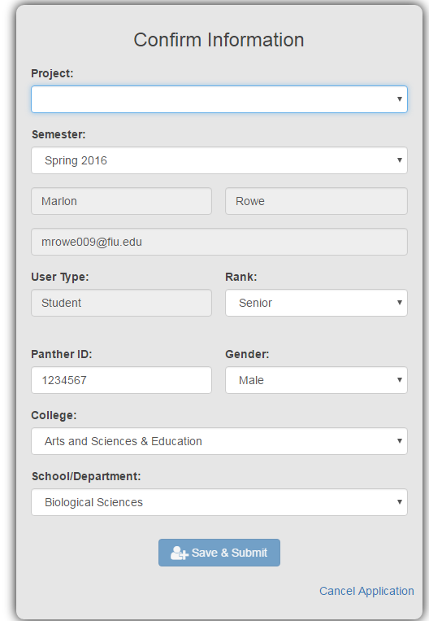

Selected the project to apply to. First name, Last name and email are automatically populated by the information returned by google authentication and cannot be modified. Confirm all other information is correct and click the Save & Submit button. To cancel the application click the “Cancel Application” link which will return you to home page.