*Florida International University*

*School of Computing and Information Sciences*

CIS 4911 - Senior Capstone Project

Software Engineering Focus

Feature Document

User Story #848

**Team Member:**

Rodolfo Viant

**Product Owner(s)**:

Masoud Sadjadi

**Instructor**: Masoud Sadjadi

# User Story

# 848 Review My Projects

### Description:

* As a staff, I would like to view my VIP Teams/Projects page so that I can see all of the projects that have been accepted into the VIP platform.

### Acceptance Criteria:

1. Main content should have a list of all accepted projects in VIP.
2. Each project should have a Name, Picture, and one sentence description associated with it. (Note, the plus sign is to be removed and the default should be Name, Picture, and Sentence).
3. Each project also has a hidden tag associated with it that relates to the tags on the left sidebar.

## Use Case

Use Case ID:(VIP-848-1) - Guest access Teams page

**Details**:

**Actor**: User John Smith

**Pre-conditions**:

1. User is logged in.
2. User is registered to at least one team.
3. User is in website.

**Description**:

1. Use case begins when user clicks on the TEAMs link in the nav bar.
2. The system shall then redirect the user to the TEAMs page.
3. The system shall verify the user and request all the teams the user is registered to.
4. The system shall present the user with a list of all the teams the user is registered to.
5. The use case ends when the user is page has been loaded with the teams the user is registered to.

**Post-conditions**: N/A

**Alternative Course of Action**:

1. The user clicks on a different link
2. The system shall then display the new page.

**Exceptions**: N/A

**Related Use Case**: N/A

**Decision Support**

**Frequency**: Used seldom to check the teams the user is registered to.

**Criticality**: Low allows users to see the teams they registered to.

**Risk**: Low. It uses simple authentication and data fetch operations.

**Constraints**

**Usability**:

1. No training required. It should take less than a minute to access the page.

**Reliability**:

1. System should be able to authenticate the user and request the data in a timely manner

**Performance**:

1. System should be able to gather information and load the response in one minute max.

**Supportability**

**Adaptability**:

1. Should work on devices of multiple screen sizes.

**Maintainability**:

1. Changes to the use case should be easy to perform and should be reflected on all the devices supported.

**Modification History**:

*Owner*: Rodolfo Viant Rodriguez

*Initiation Date*: 01/28/2016.

*Termination Date*: 02/1/2016.

## Sequence Diagram

Sequence Diagram User Story 848.png

## Class Diagram

Class Diagram User Story 848.png

## 

## 

## 

## 

## Use Case Diagram

Use Case Diagram.png

## Unit & Integration Test

**Test Case 1 (Sunny Day)**

**ID: VIP-SD-848**

**Purpose**

* To ensure the correct contact information is displayed when user clicks Teams

**Precondition**

* User has VIP webpage loaded.

**Input**

* User clicks TEAMS on nav bar.

**Expected Result**

* A page with all the Teams should be displayed.

**Actual Result**

* A page with all the Teams should be displayed.

**Test Case 2 (Rainy Day)**

**ID: VIP-SD-848**

**Purpose**

* Teams page is clicked with no Teams in the Database

**Precondition**

* User has VIP webpage loaded.
* Database has no data stored for Teams

**Input**

* User clicks TEAMS on nav bar.

**Expected Result**

* A page with no Teams should be displayed.

**Actual Result**

* A page with no Teams should be displayed.

## User Guide

* Click Teams on the navbar

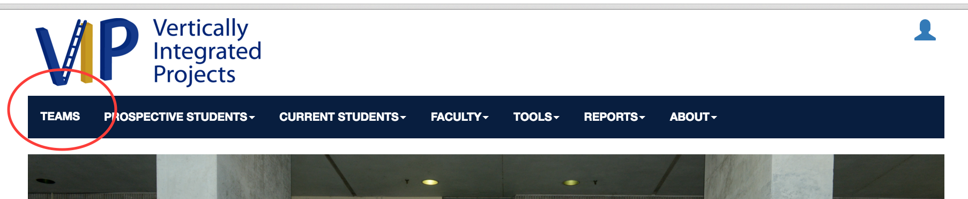

* This will then load the TEAMS page.

