*Florida International University*

*School of Computing and Information Sciences*

CIS 4911 - Senior Capstone Project

Software Engineering Focus

Feature Document

User Story #914

**Team Member:**

Steven Rowe

**Product Owner(s)**:

Masoud Sadjadi

**Mentor(s)**:

Frank Hernandez

**Instructor**: Masoud Sadjadi

# User Story

Description: View ToDo List

As a User, I would like to view my ToDo List so that I am aware of the status of my tasks.

### Acceptance Criteria:

1. After registered user logs in they should get a popup in the top right corner that notifies user of any tasks that has not been seen yet.
2. If the user clicks on todo notification, they should be able to see the list of all of tasks of that particular user. Unread (Bold) and read (not bold). If user clicks on notification, it should send them to the corresponding page.
3. PI, Co-PI, or Faculty is logged into the system
4. If one PI, Co-PI, or Faculty accepts or rejects a particular project or student, then the TODO gets removed for all users involved with that particular story.
5. After being accepted or rejected, All related users get an email notification.
6. Review User Registration Requests (Accept/Reject)
7. Project Proposal → Proposal detail page with edit form and Accept/Reject at the bottom. Should look exactly like the proposal page.

## Use Case Diagram

## 

## Use Case

**Use Case ID: VIP914 - View ToDo list**

Details:

Actor: User

Pre-conditions:

1. User has logged in
2. User is either Pi, CoPi or Faculty

Description:

1. Use case begins when the user signs in
2. The user is able to see on the top right how many tasks he/she must complete.
3. Clicking on the tasks icon, will take the user to a page that is categorized based upon the type of task needs to be done. For example, all student applications will be together, project proposals will be together, etc.
4. The user will be able to click on the task and will direct them to the corresponding page to take action.
5. Use case ends whenever the user logs out.

Post-conditions:

1. n/a

Alternative Courses of Action:

1. n/a

Decision Support:

Frequency: Low. Estimated average of one addition per application execution.

Criticality: Low. Allows the Member to add/edit data into existing app function.

Risk: Low. Implementing this use case requires Member to know Angular, HTML, CSS

Constraints:

1. Usability:
   1. No training time required.
2. Reliability:
   1. Mean time to Failure – 1% failure is acceptable.
   2. Availability – Always available.
3. Performance:
   1. Response time - system should react to a user input within 100ms - 500ms.
   2. Throughput - the system should accomplish the work within 50ms.
   3. Availability - always available unless the system is down for maintenance.
4. Supportability:
   1. Feature must appear on mobile and non-mobile devices.

Modification History:

Owner: Marlon Rowe

Initiation date: 03/10/2015

Date last modified: 04/04/2015

## Sequence Diagram



**Class Diagram**

## 

## Unit & Integration Test

**Test Case 1 (Sunny Day)**

**ID: VIP-SD-914-01**

**Purpose**

* Test if user is able to see if all unread todos get populated

**Precondition**

* User is signed into VIP
* User is of faculty/PI/CoPI
* User is add todo page

**Expected Result**

* User sees all unread todos

**Actual Result**

* User sees all unread todos

**Test Case 1 (Rainy Day)**

**ID: VIP-RD-914-01**

**Purpose**

* Test if any user, including guest and students, can read todos

**Precondition**

* Guest or student is on the site

**Expected Result**

* Guest and student can not see todos

**Actual Result**

* Guest and student can see todos

## User Guide

As soon as the user enters the todo page, he is presented with the page like so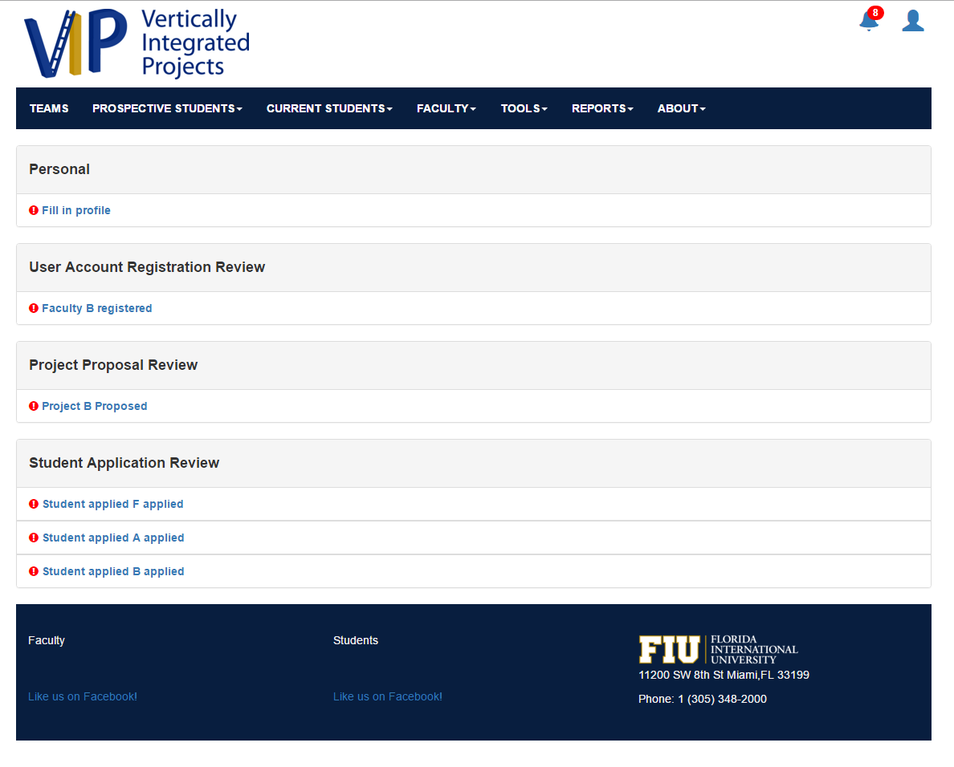

Here the user can see which task he/she must complete Upon selecting a todo, they will be directed to the corresponding application/review.

The todos are grouped by type. Once the last one in the group is read, the panel will disappear

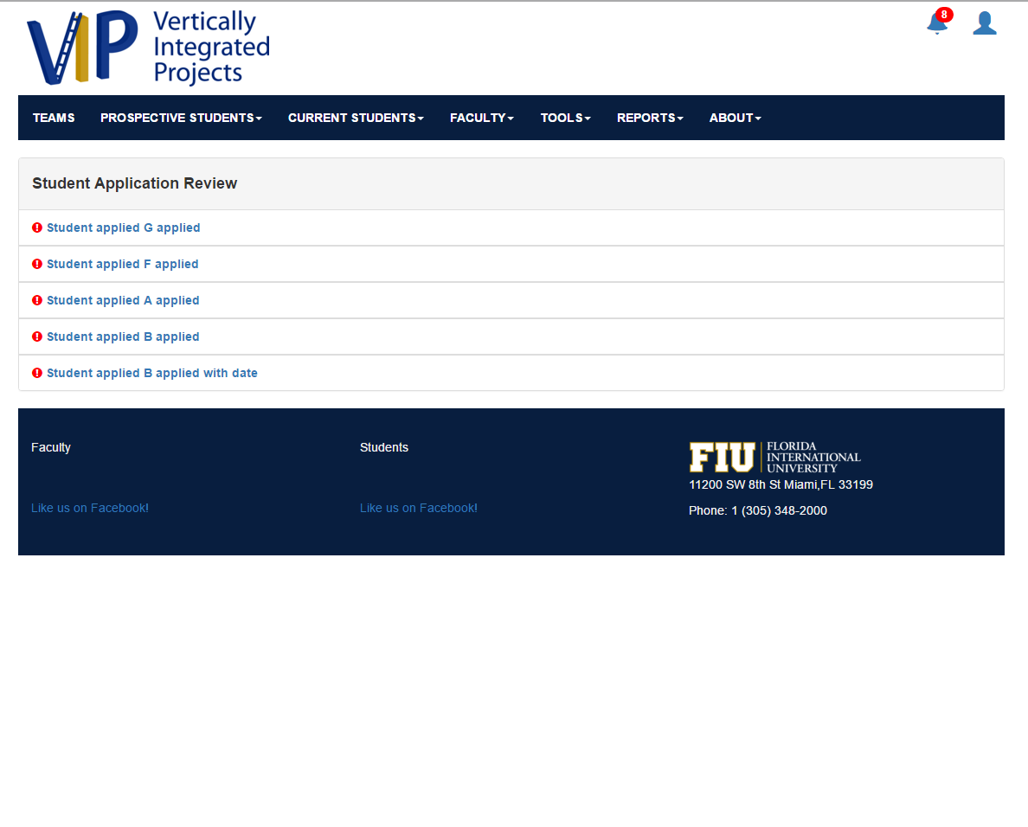

Once the user clicks the last todo in its category, the panel will go away. Once all the todos have been cleared, this panel will appear saying there is no more todos left.

