*Florida International University*

*School of Computing and Information Sciences*

CIS 4911 - Senior Capstone Project

Software Engineering Focus

INSTALLATION GUIDE

User Story #856

**Team Member:**

Miguel Conde

**Product Owner(s)**:

Masoud Sadjadi

**Mentor(s)**:

Masoud Sadjadi

**Instructor**: Masoud Sadjadi

# 

# 

# **User Story**

### **Description:**

* As a developer, I would like to install the software architecture stack onto the development server, so that developers have a server to add accepted user stories to.

### **Acceptance Criteria:**

1. MEAN stack
2. System Diagram
3. Installation Guide

**Development stack:**

The development stack that was chosen for this product was the MEAN (Mongo, Express, Angular, Node) stack. This uses lightweight frameworks such as Angular and Node and is currently one of the leading stacks used in the industry for website development. It relies almost exclusively one open-source contributions from the community, which provides the team and abundance of resources to use while developing this product at no extra cost. Due to it’s popularity, it is also one of the most widely discussed stacks on open forums, which enables us as developers to seek help from the community when we are blocked on a specific problem.

Angular also provides us with the tools needed to make this application dynamic. With frameworks such as bootstrap and other angular libraries, that transition from desktop, mobile and tablet is extremely easy to implement, which removes having to do double the work (write code for mobile and desktop separately).

These frameworks also come with a plethora of testing frameworks that we can use to automate our tests. Karma, Jasmine, and Protractor are great examples of frameworks that can be used with the mean stack to perform unit and E2E testing.

**Deployment Diagram:**

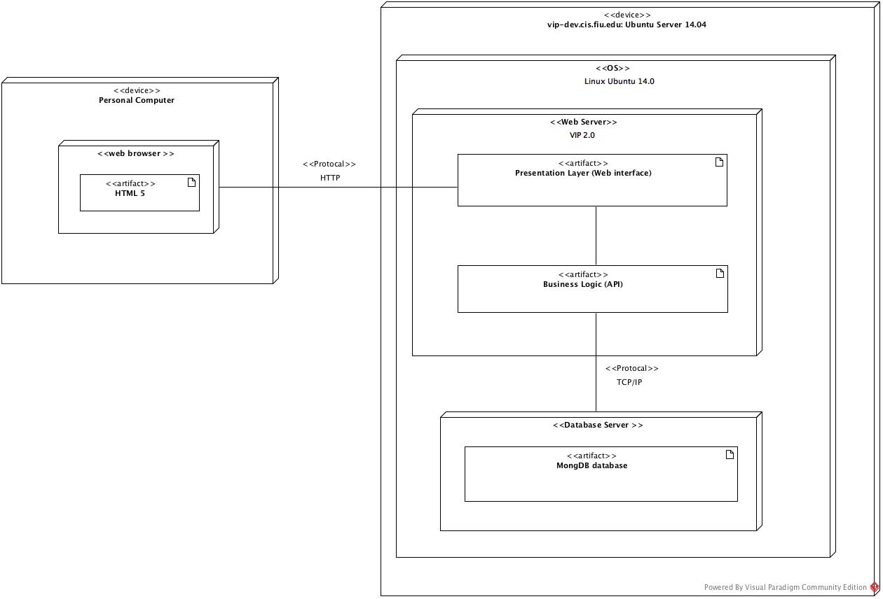

**Package Diagram:**

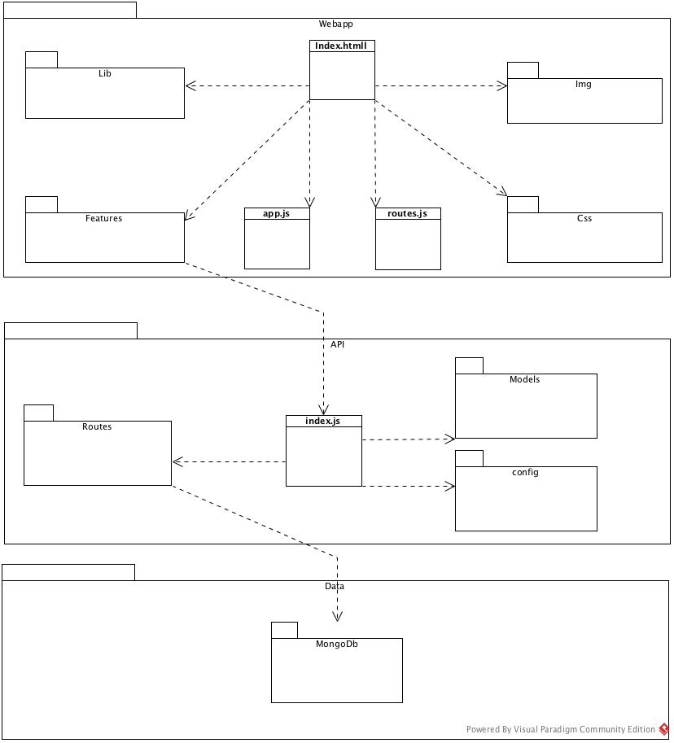

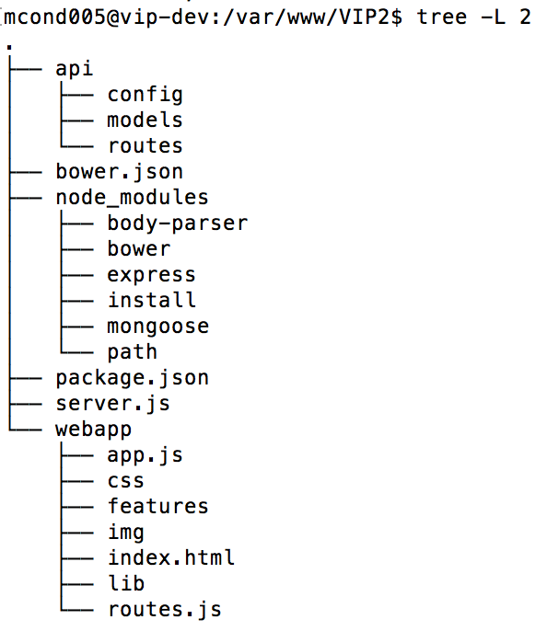

Tree display of VIP structure on server

**Installation Guide:**

The following instructions are written for the Linux Ubuntu 14.04 operation system:

**Install Git:**

1. Run the following command in terminal to install git: **Sudo apt-get install git**
2. After the installation is done run the **git --version** command to confirm it has installed properly



**Install MongoDB:**

1. Run the command  **sudo apt-key adv --keyserver hkp://keyserver.ubuntu.com:80 --recv EA312927**
2. Create a list file for MongoDB: **echo "deb http://repo.mongodb.org/apt/ubuntu trusty/mongodb-org/3.2 multiverse" | sudo tee /etc/apt/sources.list.d/mongodb-org-3.2.list**
3. Reload local package database: **sudo apt-get update**
4. Install MongoDb packages: **sudo apt-get install -y mongodb-org**
5. Start MongoDB: **sudo service mongod start**
6. Verify that MongoDB has started by opening /var/log/mongodb/mongod.log a look for a line that states: **[initandlisten] waiting for connection on port <port>** where <port> is the port configured in /etc/mongod.conf, 27017 is default.



**Create VIP database**

1. Run **sudo** **mongo** command to run mongoDB in shell
2. While in mongo run **use VIP** to create VIP database

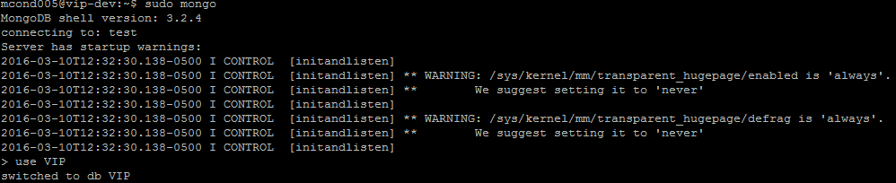

**Installing Node:**

1. Run the command **curl -sL https://deb.nodesource.com/setup_4.x | sudo -E bash -**
2. Run the command **sudo apt-get install -y nodejs**
3. Run the command **sudo apt-get install -y build-essential**
4. Run the command **node -v & npm vim**

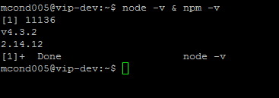

**Route port 80 to 3000**

1. Run the command: **sudo iptables -t nat -A PREROUTING -i eth0 -p tcp --dport 80 -j REDIRECT --to-port 3000**

**Deployment:** (to do once deployment process has been finalized)