*Florida International University*

*School of Computing and Information Sciences*

CIS 4911 - Senior Capstone Project

Software Engineering Focus

Feature Document

User Story #672

**Team Member:**

Victoriano Vega

**Product Owner(s)**:

Masoud Sadjadi

**Mentor(s)**:

Masoud Sadjadi

**Instructor: Masoud Sadjadi**

# **User Story**

# Receive Project Proposal Notification

* As a developer, I would like to be enable the email system when a new project is proposed and submitted.
* Faculty and staff should be able to propose new projects.

## **Use Case**

**Use Case ID:(VIP-672) Receive Project Proposal Notification**

Details:

Actor: Faculty and Staff

Pre-conditions:

1. Faculty and staff have navigated to <http://vip-dev.cis.fiu.edu/#/project-proposal>
2. Faculty and staff have fill out correctly the “Team Proposal Form”

Description:

1. Use case begins when user clicks on “SUBMIT” button
2. The submit button will send a notification email to the PI about this new project proposed.

Post-conditions:

1. Detailed information of the project is sent to the PI as a notification email.

Constraints:

1. Usability:
   1. No training time  required.
   2. The user should be able to use this case easily.
2. Reliability:
   1. Mean time to Failure – 5% failures for every twenty four hours of operation is acceptable.
   2. Availability – Down time for Login Back-up 30 minutes in a 24 hour period.
3. Performance:
   1. Request for sending notificatons should be done immediately after being requested.
   2. The system should be able to handle as many email requests as the faculty and staff need.
4. Supportability:
   1. The notification email will be corrected display in Chrome, IE, Firefox.

Modification History:

Owner: Victoriano Vega.

Initiation date: 04/16/2016

Date last modified: 04/17/2016

## 

## **Sequence Diagram**

C:\Users\Vituchin\Documents\FIU\spr2016\senior\VIP\nodemailer\Untitled Diagram.png

## **Class Diagram**



**Use Case Diagram**



**Unit & Integration Tests**

**Test Case 1 (Sunny Day)**

**ID: VIP-SD-672-01**

**Purpose**

* To test if the notification can be sent properly when the user creates a new project.

**Precondition**

* Faculty and staff have navigated to <http://vip-dev.cis.fiu.edu/#/project-proposal>
* Faculty and staff have filled out correctly the “Team Proposal Form”

**Input**

* User clicks on “Submit” button.

**Expected Result**

* An email notification is sent to the PI.

**Actual Result**

* An email notification is sent to the PI.

**Test Case 2 (Rainy Day)**

**ID: VIP-RD-672-01**

**Purpose**

* To test if the notification can be sent properly when the user creates a new project.

**Precondition**

* Faculty and staff have navigated to <http://vip-dev.cis.fiu.edu/#/project-proposal>
* Faculty and staff have filled out correctly the “Team Proposal Form”

**Input**

* User clicks on “Submit” button.

**Expected Result**

* An email notification is sent to the PI.

**Actual Result**

* The email notification will not be sent because the mail server did not recognize the email of the PI.

## 

## **User Guide**

1. The confirmation of the email sent will be shown

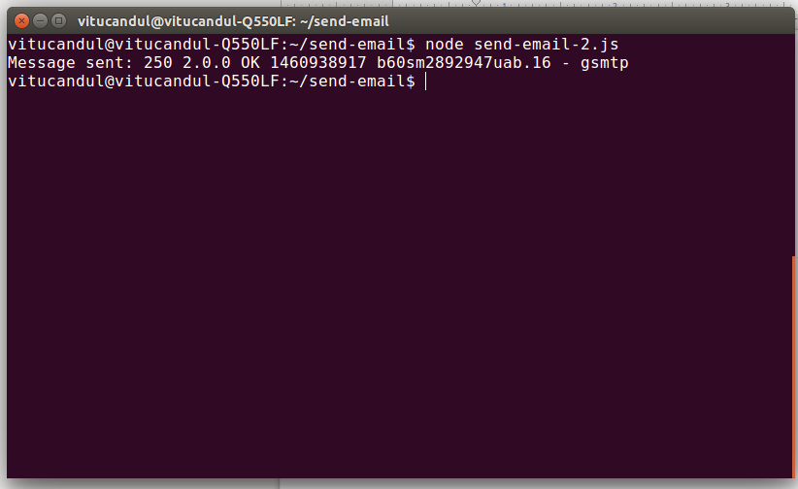

2. Open the email and check the notification.

