*Florida International University*

*School of Computing and Information Sciences*

CIS 4911 - Senior Capstone Project

Software Engineering Focus

Feature Document

User Story #693

**Team Member:**

Andres Villa

**Product Owner(s)**:

Masoud Sadjadi

**Mentor(s)**:

Masoud Sadjadi

**Instructor**: Masoud Sadjadi

# 

# **User Story**

* As a staff or faculty member I would like to be able to submit a new project proposal so that it can be reviewed, accepted, and rejected.

## **Use Case**

**Use Case ID:(VIP-693) Implement Project Proposal**

Details:

Actor: User

Pre-conditions:

1. User has navigated to VIP website

Description:

1. Use case begins when user clicks faculty/propose project
2. User will be returned a form containing required and optional fields for a project
3. Docker will pull the repository using the latest commit

Post-conditions:

1. Project proposal is created

Alternative Courses of Action:

1. User clicks edit on a project detailed page
2. Project proposal form is returned with data pre-filled from selected project
3. Certain fields cannot be changed when editing a project(Title)

Exceptions:

N/A

Related Uses Case:

N/A

Decision Support:

Frequency: Low. Estimated average of one addition per application execution.

Criticality: Medium. Allows the Member to add data into the social aspect integration features.

Risk: Low. Implementing this use case employs standard web-based technology.

Constraints:

1. Usability:
   1. No training time  required.
   2. User guide should provide more in-depth information on Docker if necessary.
2. Reliability:
   1. Mean time to Failure – 5% failures for every twenty four hours of operation is acceptable.
   2. Availability – Down time for Login Back-up 30 minutes in a 24 hour period.
3. Performance:
   1. The build should be triggered within 20 seconds
4. Supportability:
   1. The docker build should support any branch on the repository

Modification History:

Owner: Andres Villa.

Initiation date: 03/09/2016

Date last modified: 03/09/2016

## 

## 

## 

## 

## 

## **Sequence Diagram**

## projectProposalSequence (1).png

## 

## 

## 

## **Class Diagram**

projectProposalClass (1).png

**Unit & Integration Tests**

**Test Case 1 (Sunny Day)**

**ID: VIP-SD-693-01**

**Purpose**

* Ensure User can create a new project

**Precondition**

* User has reached the VIP and reached project form

**Input**

* User inputs data into form
* User clicks submit

**Expected Result**

* Project proposal is created

**Actual Result**

* Project proposal is created

**Test Case 2 (Sunny Day)**

**ID: VIP-SD-693-02**

**Purpose**

* Ensure User can edit a story

**Precondition**

* User has reached the VIP
* User has clicked edit project

**Input**

* User updates form
* User clicks submit

**Expected Result**

* Project proposal is created

**Actual Result**

* n/a (failing)

**Test Case 3 (Rainy Day)**

**ID: VIP-RD-693-03**

**Purpose**

* Ensure Project must contain data for all required fields

**Precondition**

* User has reached the VIP and reached project form

**Input**

* User leaves title field blank

**Expected Result**

* Form notifies user that title field is required

**Actual Result**

* Form notifies user that title field is required

**Test Case 4 (Sunny Day)**

**ID: VIP-SD-854-01**

**Purpose**

* Ensure Project cannot have the same name as another Project

**Precondition**

* User has reached the VIP and reached project form

**Input**

* User inputs data into form
* Title matches a name of another project

**Expected Result**

* Project proposal fails

**Actual Result**

* n/a(failing)

## 

## 

## **User Guide**

1. Click the faculty/Propose Project (fields with a star are required)

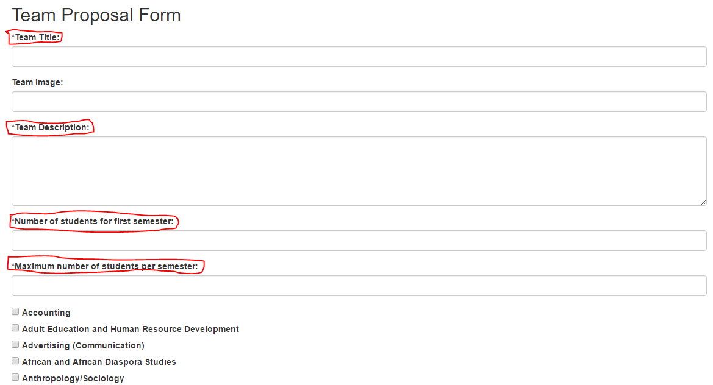

1. After filling out required fields and any other fields, click submit

