*Florida International University*

*School of Computing and Information Sciences*

CIS 4911 - Senior Capstone Project

Software Engineering Focus

Feature Document

User Story #717

Register User

**Team Member:**

Tiago Moore

**Product Owner(s)**:

Masoud Sadjadi

**Mentor(s)**:

Masoud Sadjadi

**Instructor**: Masoud Sadjadi

# 

# **User Story - Register User**

* As a Guest User I would like to be able to register so I can use the VIP web app.

## **Use Case**

**Use Case ID:(VIP-717) Register User**

Details:

Actor: User

Pre-conditions:

1. User has navigated to VIP website

Description:

1. Use case begins when user clicks Login button.
2. Login page will have create account button.
3. User will click on button and register for an account.

Post-conditions:

1. User is on registration page.
2. User does not have a previous account .

Alternative Courses of Action:

N/A

Exceptions:

N/A

Related Uses Case:

N/A

Decision Support:

Frequency: Low. Estimated average of one addition per application execution.

Criticality: Medium. Allows the Member to add data into the social aspect integration features.

Risk: Low. Implementing this

Constraints:

1. Usability:
   1. No training time  required.
   2. User guide should provide more in-depth information on Docker if necessary.
2. Reliability:
   1. Mean time to Failure – 5% failures for every twenty four hours of operation is acceptable.
   2. Availability – Down time for Login Back-up 30 minutes in a 24 hour period.
3. Performance:
   1. The build should be triggered within 20 seconds
4. Supportability:
   1. The docker build should support any branch on the repository

Modification History:

Owner: Tiago Moore.

Initiation date: 03/20/2016

Date last modified: 4/11/2016

## **Sequence Diagram**

## 

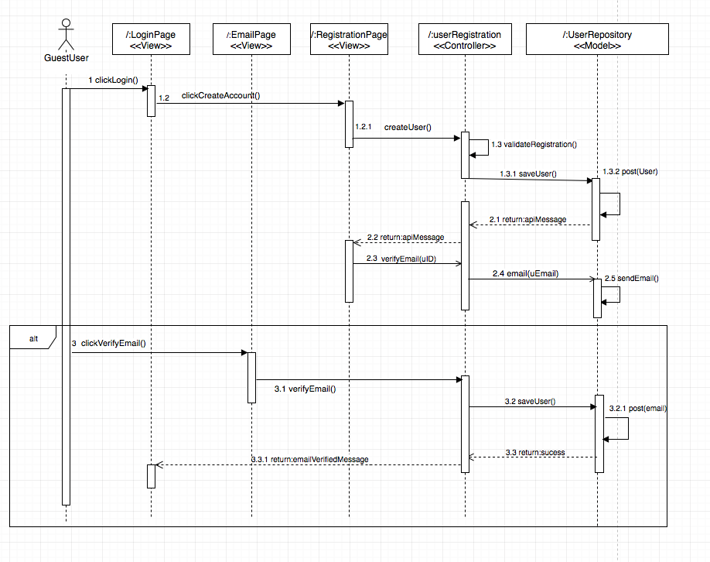

## 

## 

## **Class Diagram**

**Unit & Integration Tests**

**Unit & Integration Tests**

**Test Case 1 (Sunny Day)**

**ID: VIP-SD-717-01**

**Purpose**

* Ensure Registration form creates a user.

**Precondition**

* User fills out entire form .

**Input**

* User Clicks on Register User .

**Expected Result**

* User Created message.

**Actual Result**

* User Created message.

**Test Case 2 (Sunny Day)**

**ID: VIP-SD-717-02**

**Purpose**

* Ensure Registration form creates a user when PI does not enter fiu email .

**Precondition**

* User fills out entire form .

**Input**

* User Clicks on Register User and excludes an fiu email.

**Expected Result**

* User Please Verify Email Message.

**Actual Result**

* User Please Verify Email Message.

**Test Case 3 (Sunny Day)**

**ID: VIP-SD-717-03**

**Purpose**

* Ensure Registration form creates a user when PI does not have panther ID.

**Precondition**

* User fills out entire form and excludes a panther ID.

**Input**

* User Clicks on Register User.
* Entire form is completed except panther ID.

**Expected Result**

* User Created message.

**Actual Result**

* User Created message .

**Test Case 4 (Rainy Day)**

**ID: VIP-RD-717-01**

**Purpose**

* Ensure Registration form creates a user when user inputs invalid password.

**Precondition**

* User fills out entire form and excludes a capital letter from the password.

**Input**

* User Clicks on Register User.
* Entire form is completed password or confirm password.

**Expected Result**

* Error message saying password must contain capital letter .

**Actual Result**

* Error message saying password must contain capital letter .

## 

## **User Guide**

Step 1: User Fills out registration form completely.

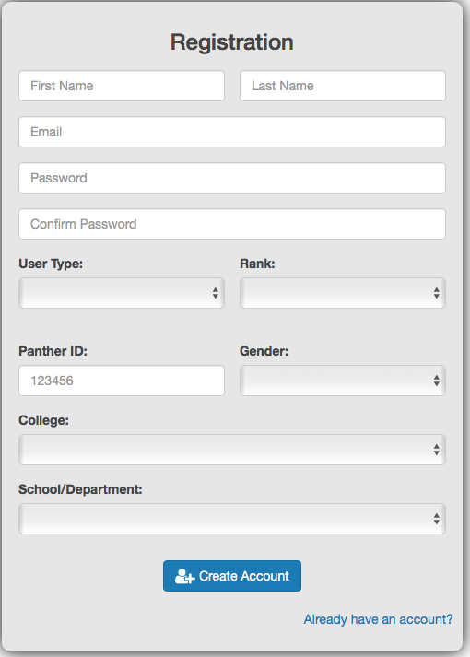

Step 2: User Verifies Email:

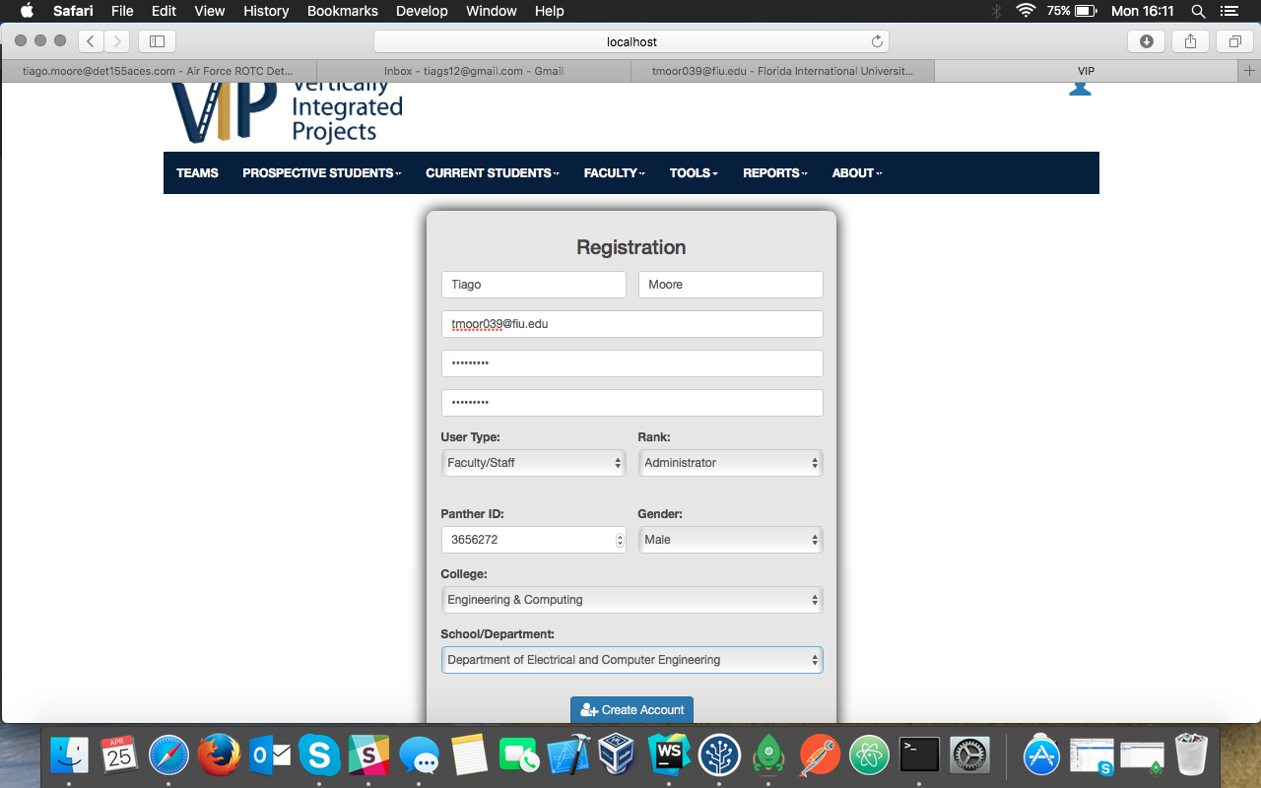

Step 3: User Verifies Email

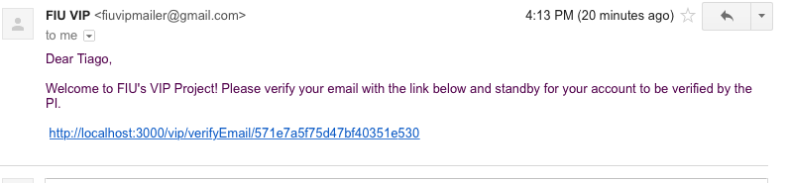

Step 4: User Clicks on link:

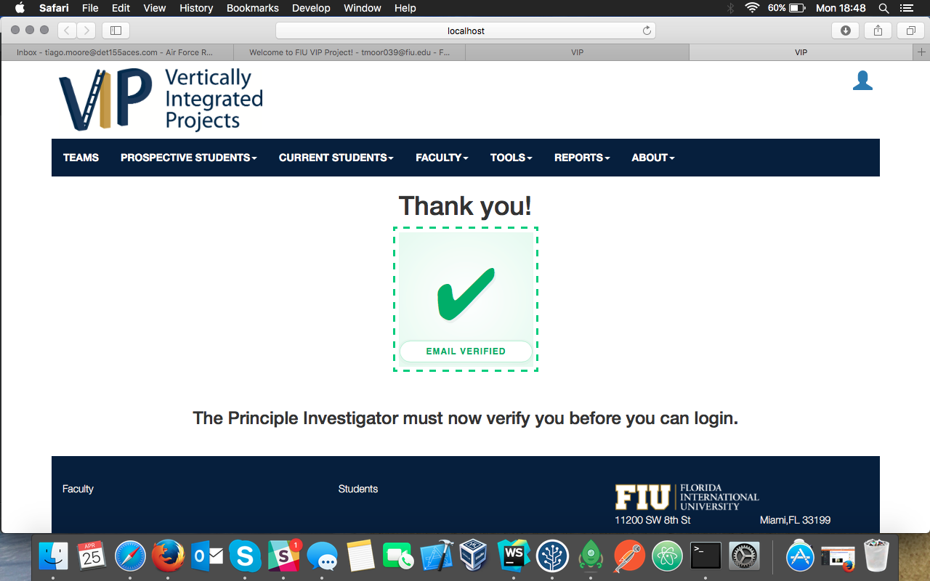

Step 5: PI Gets Email / Clicks Link / Verifies User

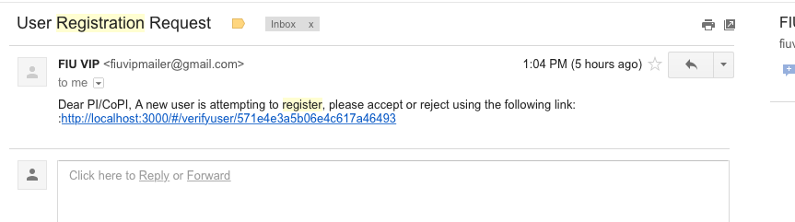

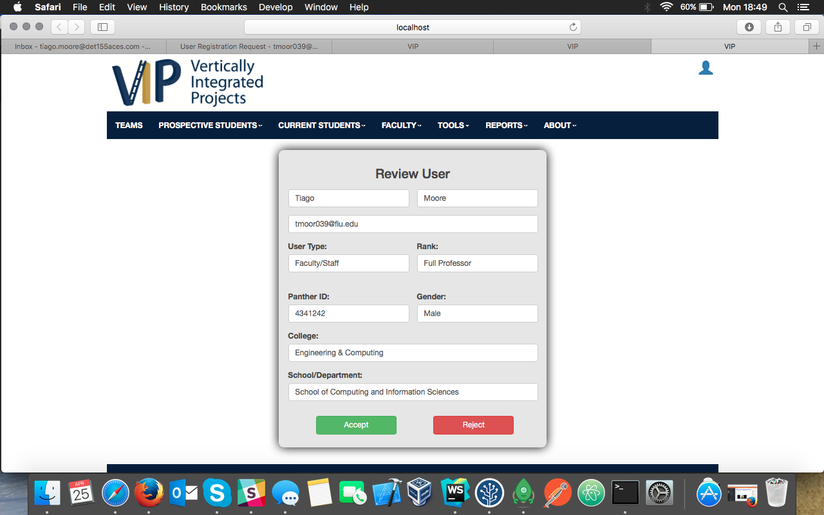

User is now eligible to login.