*Florida International University*

*School of Computing and Information Sciences*

CIS 4911 - Senior Capstone Project

Software Engineering Focus

Feature Document

User Story #895

**Team Member:**

Andres Villa

**Product Owner(s)**:

Masoud Sadjadi

**Mentor(s)**:

Masoud Sadjadi

**Instructor**: Masoud Sadjadi

# 

# **User Story**

* As a user, I would like to view the Undergraduate Application Page, so that I may see whatever forms are needed to apply to an Undergraduate VIP Project

## **Use Case**

**Use Case ID:(VIP-895) View apply undergraduates page**

Details:

Actor: User

Pre-conditions:

1. User has navigated to VIP main page

Description:

1. Use case begins when user clicks Apply/Undergraduate Students tab
2. VIP site will respond with a page containing Information on how to apply as an undergraduate students
3. Docker will pull the repository using the latest commit

Post-conditions:

1. User will be navigated to a page containing info on how to apply as an Undergraduate

Alternative Courses of Action:

1. User can click on “Click here to apply” and will be navigated to a login page

Exceptions:

N/A

Related Uses Case:

N/A

Decision Support:

Frequency: Low. Estimated average of one addition per application execution.

Criticality: Medium. Allows the Member to add data into the social aspect integration features.

Risk: Low. Implementing this use case employs standard web-based technology.

Constraints:

1. Usability:
   1. No training time  required.
   2. User guide should provide more in-depth information on Docker if necessary.
2. Reliability:
   1. Mean time to Failure – 5% failures for every twenty four hours of operation is acceptable.
   2. Availability – Down time for Login Back-up 30 minutes in a 24 hour period.
3. Performance:
   1. The build should be triggered within 20 seconds
4. Supportability:
   1. The docker build should support any branch on the repository

Modification History:

Owner: Andres Villa.

Initiation date: 04/04/2016

Date last modified: 04/04/2016

## 

## 

## 

## **Sequence Diagram**

## competitionSequence (1).png

## 

## 

## 

## **Class Diagram**

competitionClass.png

## 

**Unit & Integration Tests**

**Test Case 1 (Sunny Day)**

**ID: VIP-SD-854-01**

**Purpose**

* Ensure that the competition page contains the appropriate data

**Precondition**

* User has reached the VIP webpage

**Input**

* User clicks Competition Information tab

**Expected Result**

* Competition Information is returned to the browser

**Actual Result**

* Competition Information is returned to the browser

## 

## 

## **User Guide**

1. Click the competition information in the header

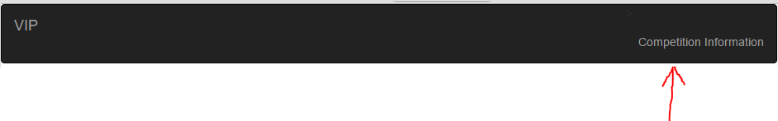

1. The competition Information will be displayed

