*Florida International University*

*School of Computing and Information Sciences*

CIS 4911 - Senior Capstone Project

Software Engineering Focus

Feature Document

User Story #927

**Team Member:**

Victoriano Vega

**Product Owner(s)**:

Masoud Sadjadi

**Mentor(s)**:

Masoud Sadjadi

**Instructor: Masoud Sadjadi**

# **User Story**

# Change Forgotten Password

-As a user, I would like to be able to change my password through my registered email, so that I may be able access my account if I forgot my current password.

## **Use Case**

**Use Case ID:(VIP-927) Change Forgotten Password**

Details:

Actor: User

Pre-conditions:

1. User have successfully navigated to <http://vip-dev.cis.fiu.edu/#/>
2. User clicks on the blue icon in order to login

Description:

1. Use case begins when user clicks on “Forgotten your Password?” link, which is located in the bottom left part of the login window form.
2. Clicking on that link will redirect you to another page in order to reset your password.
3. The user will enter the registered email in order to receive the instructions to reset his/her password.
4. When the user clicks on the “Continue” button, the email will be sent to start the process of changing the password.
5. The user open his/her email and clicks on the link that was sent to his/her.
6. When the user clicks on the link, it will be redirect to the VIP page again in order to change the password.
7. User enters new password and retype again the new password to confirm that those match perfectly.
8. The new password will be stored in the database.

Post-conditions:

1. The password will be updated with the new information.

Alternative Course of Action

1. In step D.3, the user has to enter a valid and registered email
2. In step D.6, the user has to enter a strong password and also meet the requirements of entering the new password.

Constraints:

1. Usability:
   1. No training time  required.
   2. The user should be able to use this case easily.
2. Reliability:
   1. Mean time to Failure – 5% failures for every twenty four hours of operation is acceptable.
   2. Availability – Down time for Login Back-up 30 minutes in a 24 hour period.
3. Performance:
   1. Request for changing the password should be done immediately after being requested.
   2. The system should be able to handle as many forgotten password requests as the user needs.
4. Supportability:
   1. The link for reset the password will be corrected display in Chrome, IE, Firefox.

Modification History:

Owner: Victoriano Vega.

Initiation date: 04/21/2016

Date last modified: 04/22/2016

## 

## **Sequence Diagram**

## C:\Users\Vituchin\Documents\FIU\spr2016\senior\VIP\forget_password\forget_password\reset_password_last.png

## **Class Diagram**

C:\Users\Vituchin\Documents\FIU\spr2016\senior\VIP\forget_password\forget_password\class_diagram_password.png

**Use Case Diagram**



**Unit & Integration Tests**

**Test Case 1 (Sunny Day)**

**ID: VIP-SD-927-01**

**Purpose**

* To test if the notification can be sent properly when the user creates a new project.

**Precondition**

* Faculty and staff have navigated to <http://vip-dev.cis.fiu.edu/#/project-proposal>
* Faculty and staff have filled out correctly the “Team Proposal Form”

**Input**

* User clicks on “Submit” button.

**Expected Result**

* An email notification is sent to the PI.

**Actual Result**

* An email notification is sent to the PI.

**Test Case 2 (Rainy Day)**

**ID: VIP-RD-927-01**

**Purpose**

* To test if the notification can be sent properly when the user creates a new project.

**Precondition**

* Faculty and staff have navigated to <http://vip-dev.cis.fiu.edu/#/project-proposal>
* Faculty and staff have filled out correctly the “Team Proposal Form”

**Input**

* User clicks on “Submit” button.

**Expected Result**

* An email notification is sent to the PI.

**Actual Result**

* The email notification will not be sent because the mail server did not recognize the email of the PI.

## 

## **User Guide**

1. Open FIU VIP site and click on the blue icon in order to log in

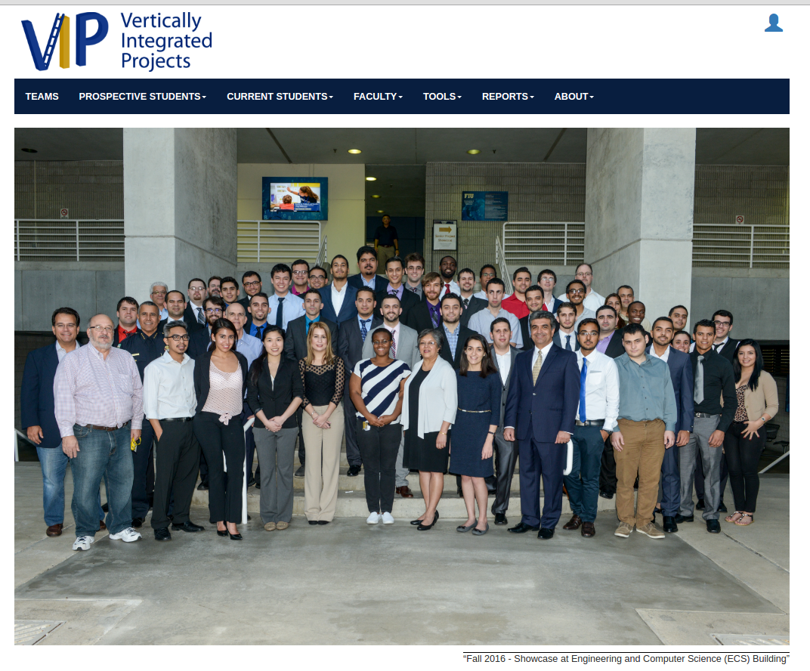

2. The log in form will be opened and the user clicks on the link “forgotten your password?”

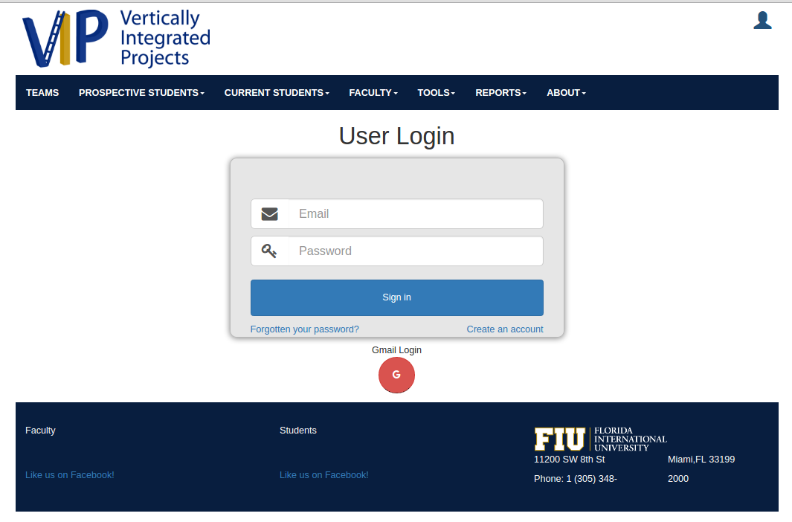

3. A new page will be opened to with new form in order to enter the registered email

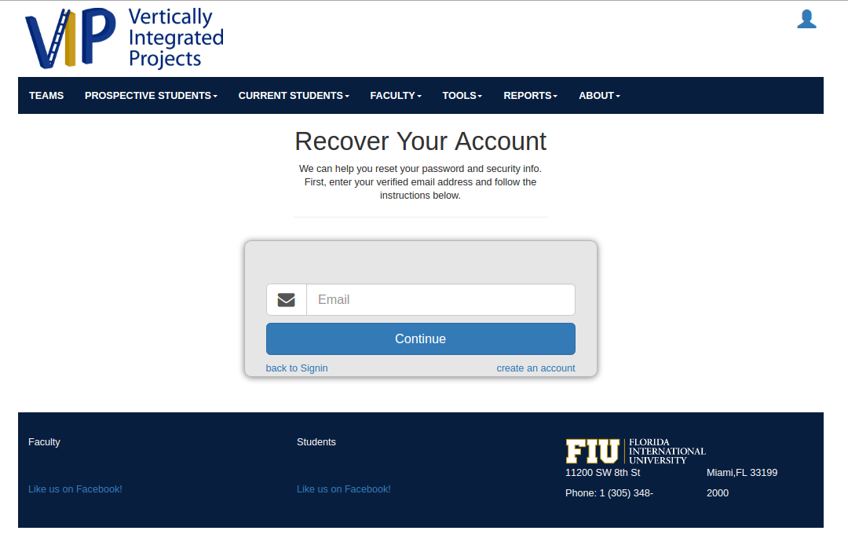

4. The user enters his/her registered email and clicks on “Continue” button

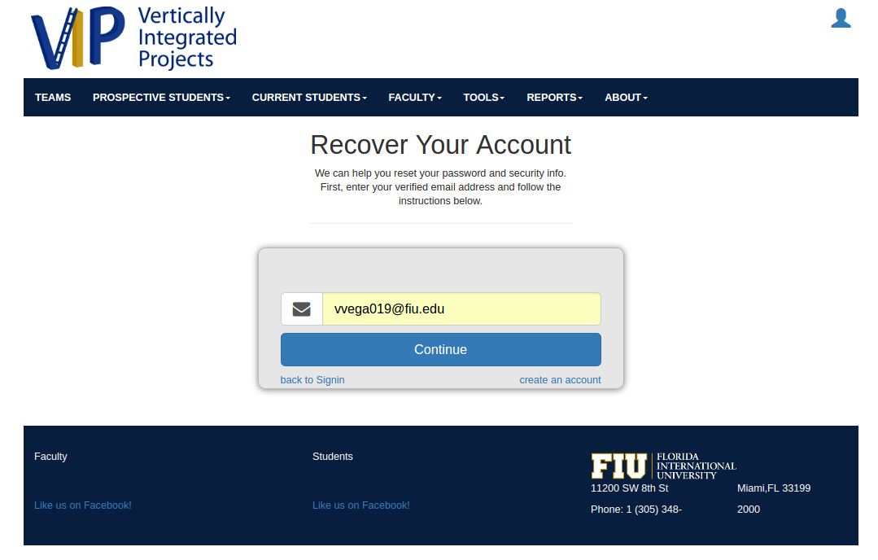

5. A message is shown saying that an email has been sent to your email.

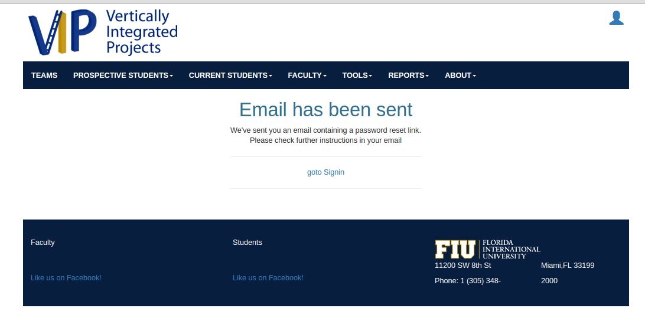

6. User opens his/her email and click on the link

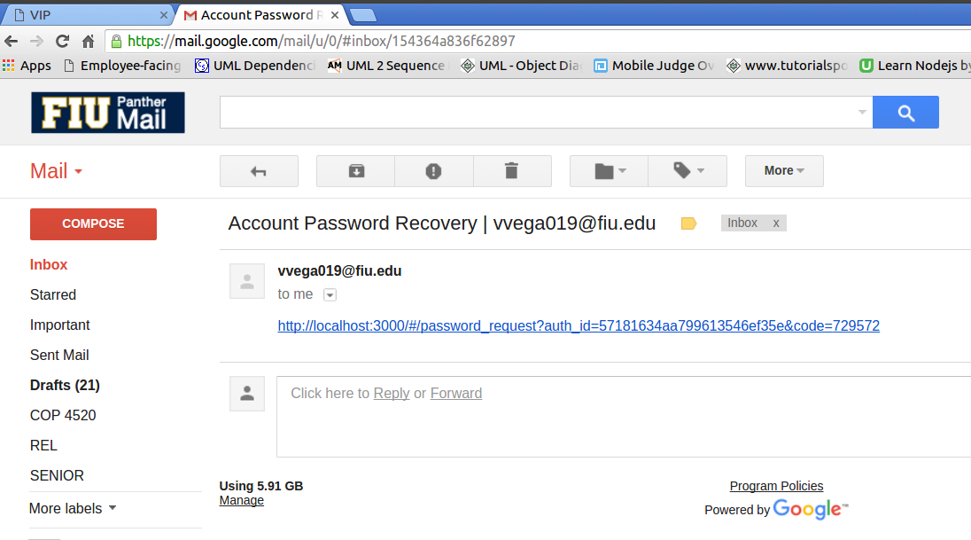

7. User clicks on the link and he/she will be redirect to the VIP recovery password page

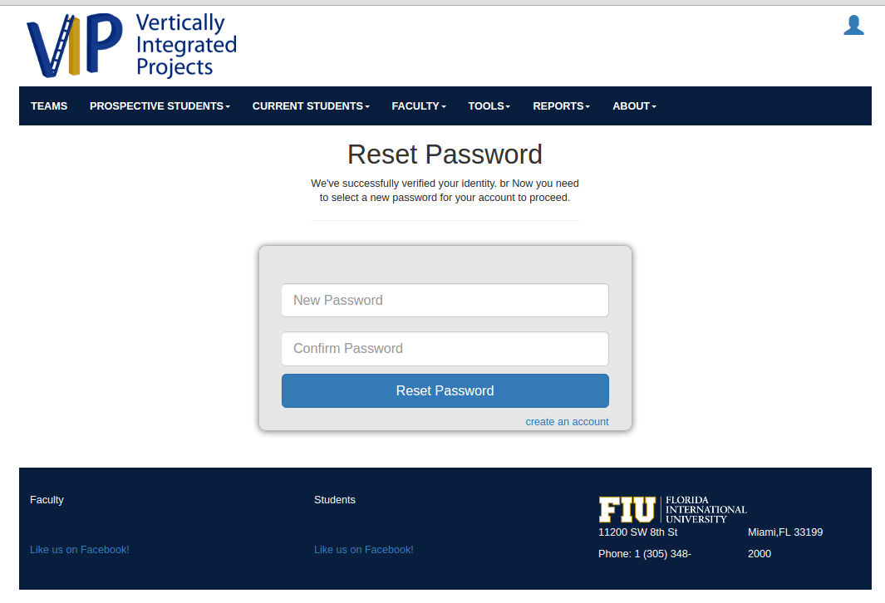

8. User will enter his/her new password, and then will click on “Reset Password” button.

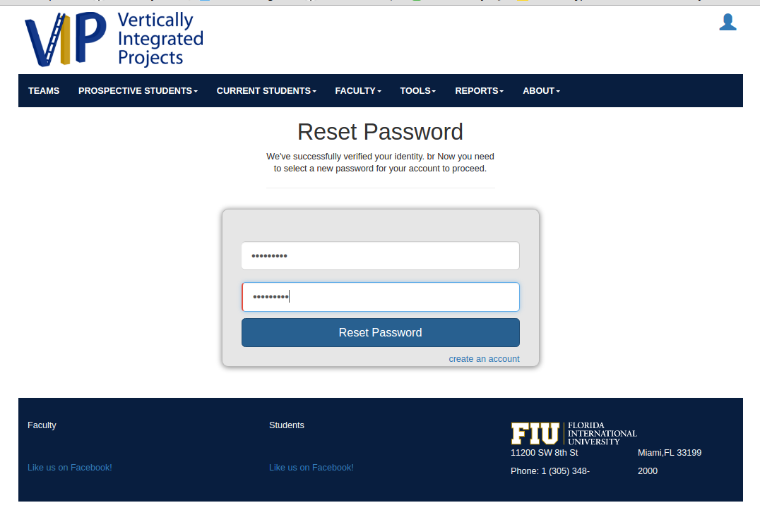

9. A message comes up that confirms that the password has been changed.

