*Florida International University*

*School of Computing and Information Sciences*

Software Engineering Focus

Feature Document

User Story ID #702 Implement Interaction to Reset Puzzle (Puzzle 3)

**Name:** Santiago Bolivar

**Team Member(s):** Armando Carrasquillo, Daniel Perez, Santiago Bolivar

**Project:** VR-Gaming to Broad Participation in CS

**Product Owner(s)**: Francisco Ortega

**Mentor(s)**: Francisco Ortega

**Instructor**: Masoud Sadjadi

**User Story Name: Implement Interaction to Reset Puzzle (Puzzle 3)**

* Description: As a developer, I want to implement a function for the user to reset Puzzle 3 in Unreal, so that if the user gets the incorrect solution they can easily restart the puzzle.

Acceptance Criteria

* Verify that the puzzle gets reset only when requested by the user.
* Verify that when the function is executed the books on the shelf automatically get moved back to their initial location.
* Verify that the function is keeping record of how many times the user reseted the puzzle.

**Use Case**

* Name: Reset Puzzle
* Actor: User
* Preconditions: N/A
* Description <Flow of events>:

1. The user presses a button to reset the puzzle.
2. All of the books get moved back to their initial location.
3. The counter for the number of resets is incremented.

**Use Case Diagram**

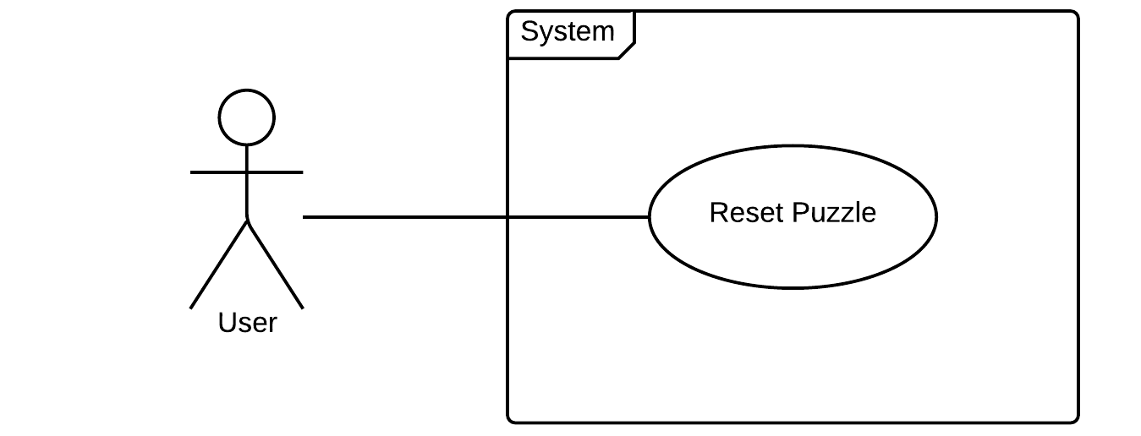

**Sequence Diagram**

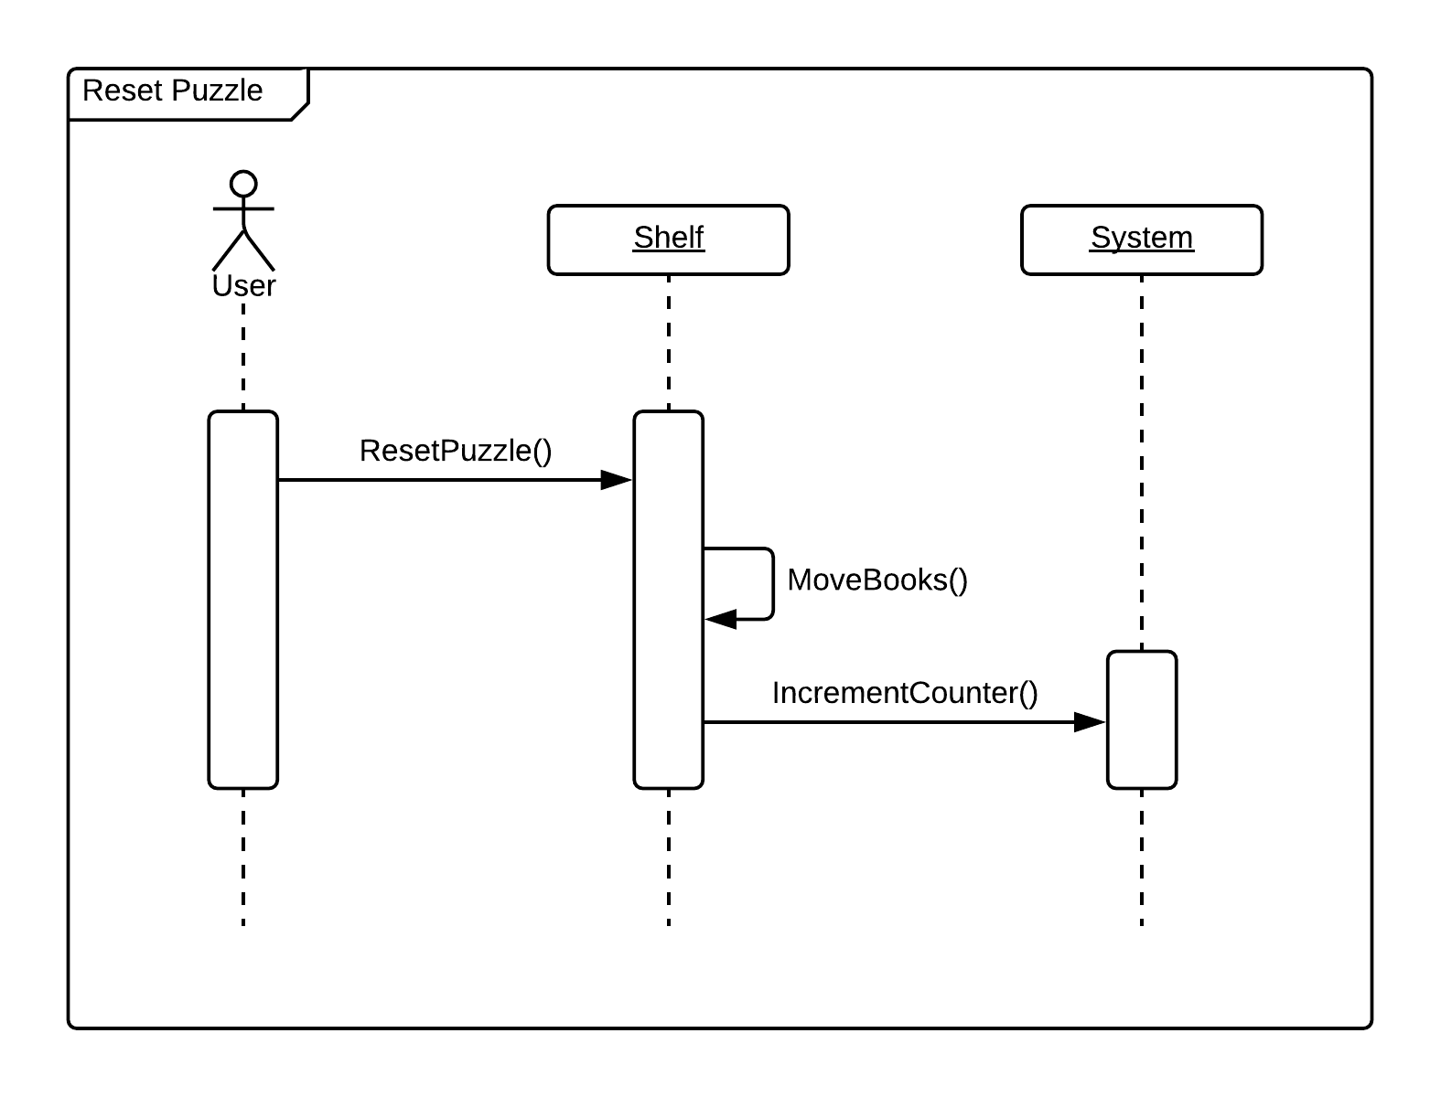

**Class Diagram**

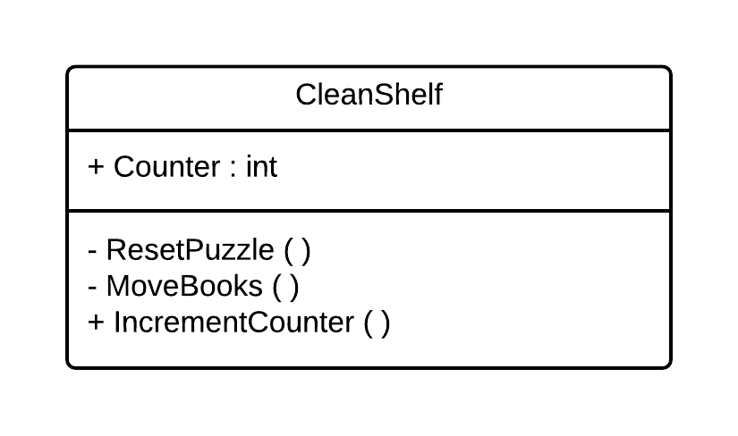

**Unit Test**

* Test case ID: reset_puzzle
* Description/Summary of Test: Allow the user to restart the puzzle.
* Pre-condition: N/A
* Expected Results: Books are sent back to table for user to start the puzzle again.
* Actual Result: Books are sent back to table for user to start the puzzle again.
* Status (Fail/Pass): Pass
* Test case ID: increment_counter
* Description/Summary of Test: Every time that the user resets the puzzle, counter is increased.
* Pre-condition: N/A
* Expected Results: Counter increases once the puzzle has been reseted.
* Actual Result: Counter increased once the puzzle has been reseted.
* Status (Fail/Pass): Pass
* Test case ID: move_books
* Description/Summary of Test: After user resets the puzzle all the book are moved to their original location.
* Pre-condition: User presses reset button
* Expected Results: Books are moved from the shelf to the table.
* Actual Result: Books are moved from the shelf to the table.
* Status (Fail/Pass): Pass

**Visual User Guide**

