*Florida International University*

*School of Computing and Information Sciences*

Software Engineering Focus

Feature Document

User Story ID #699 Implement Adding Objects to Scale (Puzzle 2)

**Name:** Daniel Perez

**Team Member(s):** Armando Carrasquillo, Daniel Perez, Santiago Bolivar

**Project:** VR-Gaming to Broad Participation in CS

**Product Owner(s)**: Francisco Ortega

**Mentor(s)**: Francisco Ortega

**Instructor**: Masoud Sadjadi

**User Story Name: Implement Adding Objects to Scale (Puzzle 2)**

* Description: As a developer, I want to implement a function for the user to add apples to a scale in Unreal, so that the user can work on the puzzle.

Acceptance Criteria

* Verify that the function recognizes when objects are placed on the scale.
* Verify that the function recognizes which type of objects are placed on the scale.
* Verify that the function is keeping one record for the objects placed on the left side of the scale and one record for the objects placed on the right side of the scale.
* Verify that the function warns the user when an incorrect object is placed on the scale and then remove that object from the scale.
* Verify that multiple objects can be placed on the scale.

**Use Case**

* Name: Place Object on Scale
* Actor: User
* Preconditions: The user is able to move objects around and theres available space on the scale to place objects.
* Description <Flow of events>:

1. The user grabs an object in the room.
2. The user places the object on the scale.
3. The scale checks what type of object was placed.
   1. If the object is not an apple, then warn the user and remove the object from the scale.

**Use Case Diagram**

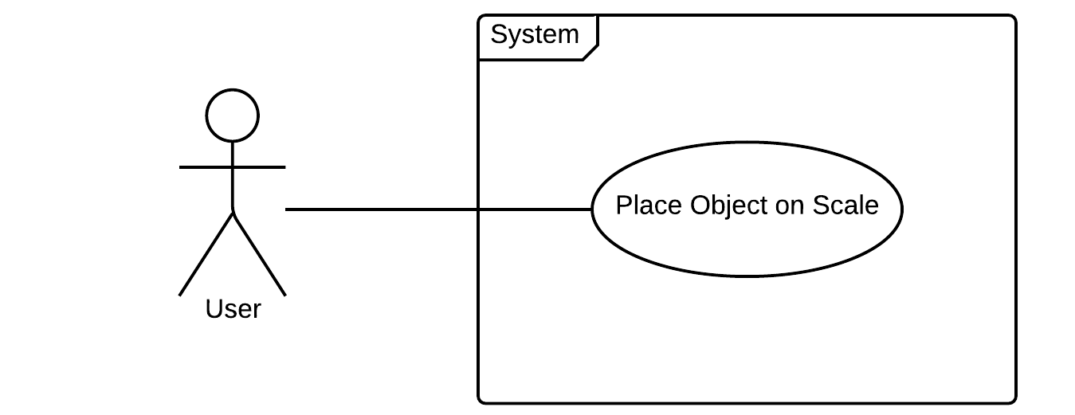

**Sequence Diagram**

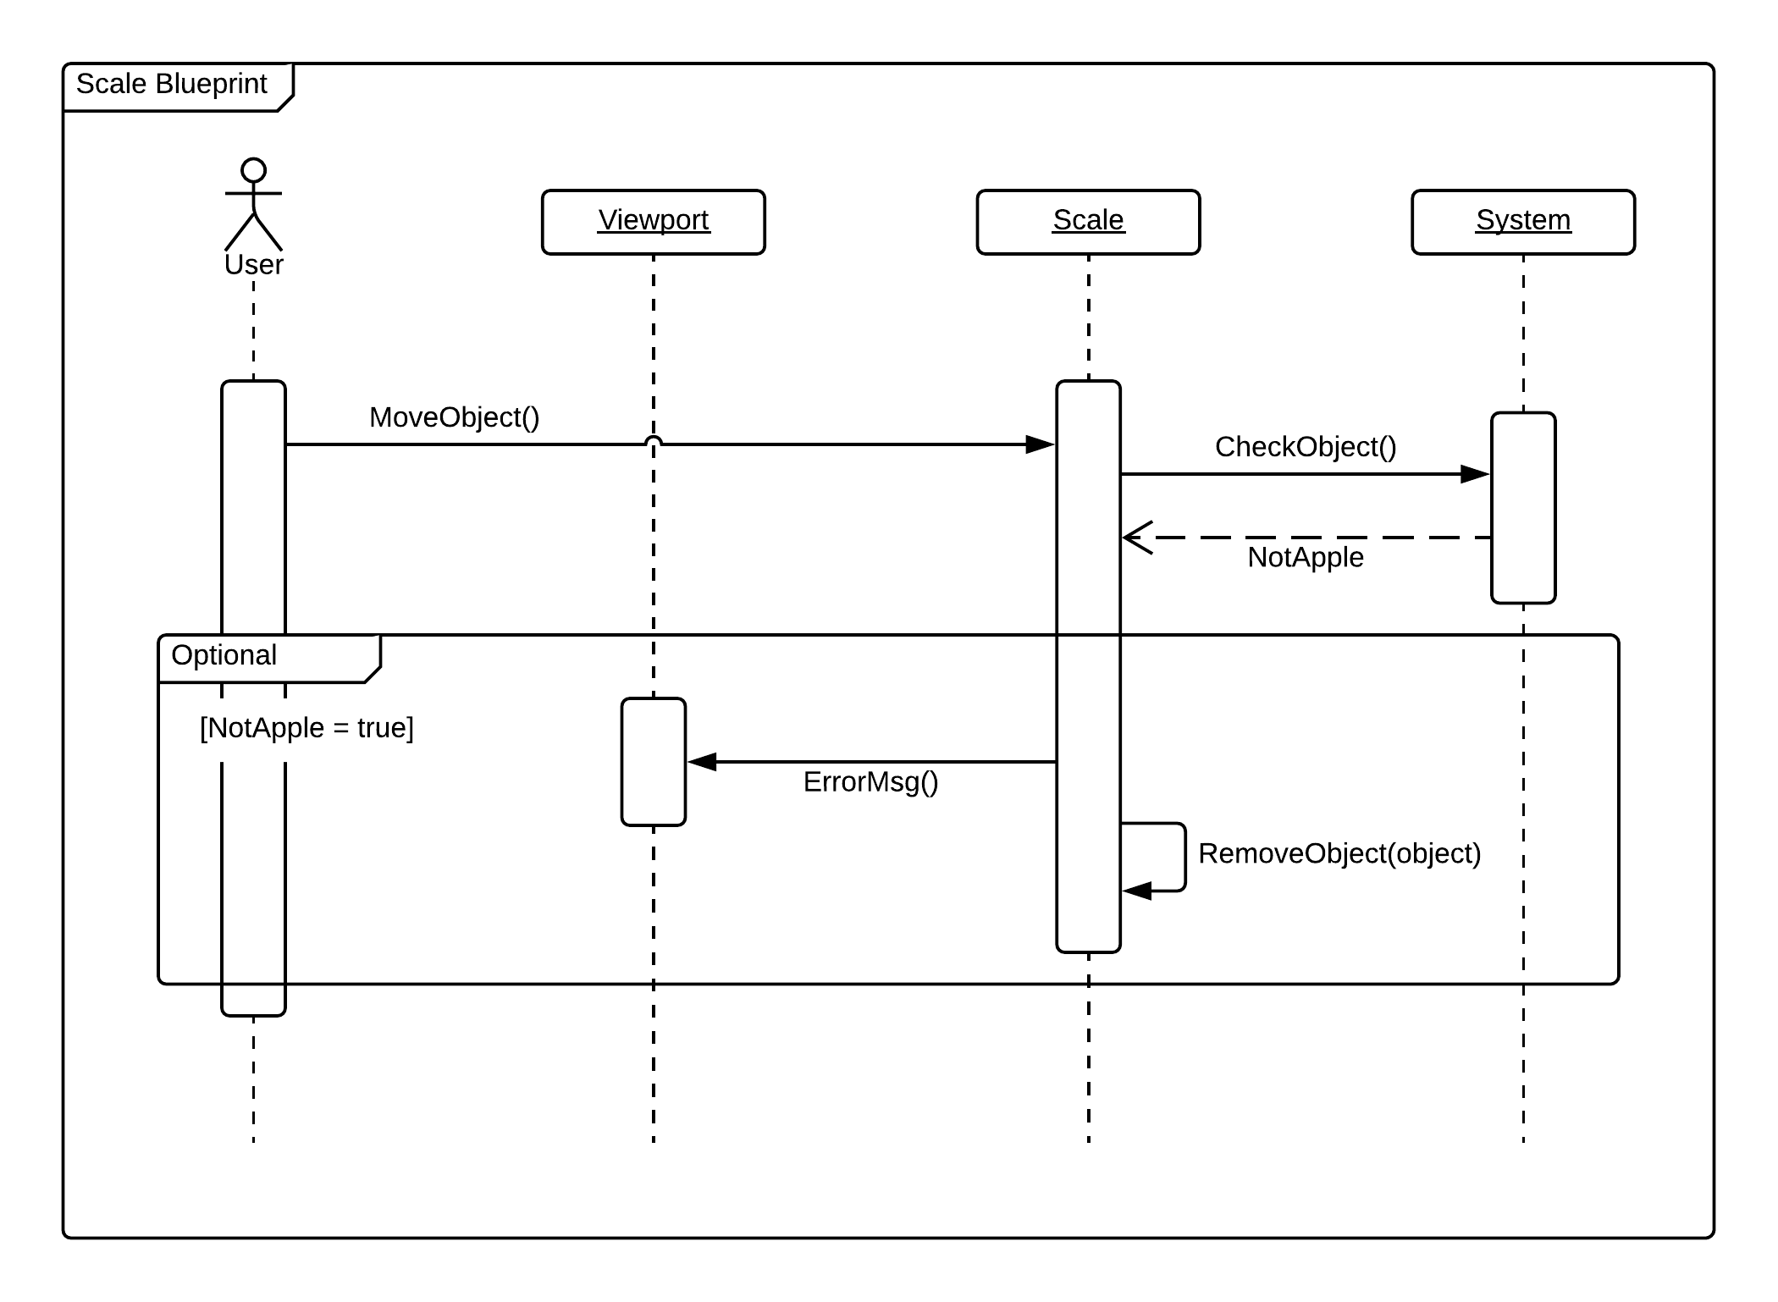

**Class Diagram**

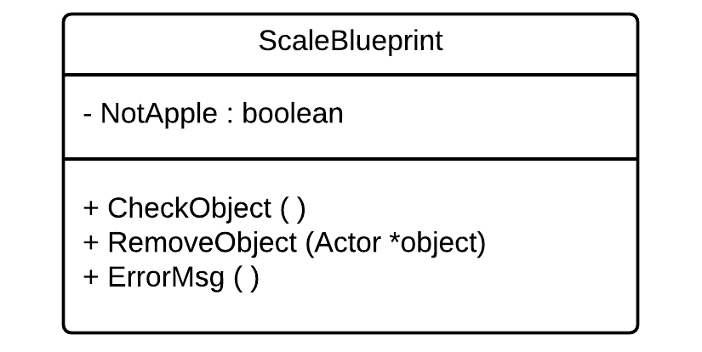

**Unit Test**

* Test case ID: identify_object_p2
* Description/Summary of Test: The scale identifies which object was placed on it.
* Pre-condition: The user places an object on the scale.
* Expected Results: Scale identifies the name of the object.
* Actual Result: Scale identified the name of the object.
* Status (Fail/Pass): Pass
* Test case ID: get_actors_left
* Description/Summary of Test: The system checks which objects are placed on the left side of the scale and returns a list of those objects.
* Pre-condition: Objects must be placed on the scale.
* Expected Results: A list of objects placed on the left side of the scale.
* Actual Result: A list of objects placed on the left side of the scale.
* Status (Fail/Pass): Pass
* Test case ID: get_actors_right
* Description/Summary of Test: The system checks which objects are placed on the right side of the scale and returns a list of those objects.
* Pre-condition: Objects must be placed on the scale.
* Expected Results: A list of objects placed on the right side of the scale.
* Actual Result: A list of objects placed on the right side of the scale.
* Status (Fail/Pass): Pass
* Test case ID: remove_object_p2
* Description/Summary of Test: The object is removed from the scale only if the object is not an apple.
* Pre-condition: The user places a non-apple object on the scale.
* Expected Results: The non-apple object gets removed from the scale.
* Actual Result: The non-apple object got removed from the scale.
* Status (Fail/Pass): Pass
* Test case ID: error_msg_p2
* Description/Summary of Test: The user gets a notification for placing a non-apple object on the scale.
* Pre-condition: The user places a non-apple object on the scale.
* Expected Results: The user receives the notification.
* Actual Result: The user received the notification.
* Status (Fail/Pass): Pass

**Visual User Guide**

