*Florida International University*

*School of Computing and Information Sciences*

Software Engineering Focus

Feature Document

User Story ID #700 Implement Interaction to Display Objects Weight (Puzzle 2)

**Name:** Daniel Perez

**Team Member(s):** Armando Carrasquillo, Daniel Perez, Santiago Bolivar

**Project:** VR-Gaming to Broad Participation in CS

**Product Owner(s)**: Francisco Ortega

**Mentor(s)**: Francisco Ortega

**Instructor**: Masoud Sadjadi

**User Story Name: Implement Interaction to Display Objects Weight (Puzzle 2)**

* Description: As a developer, I want to implement a function to show the user which side of the scale has more weight, so that the user can collect the necessary information to solve the puzzle.

Acceptance Criteria

* Verify that the function succeeds if and only if apples are placed on the scale.
* Verify that the function notifies the user if the scale was activated with no apples placed on it.
* Verify that the function is able to read the weight of each apple and that the sum of apples on each side of the scale has the correct weight.
* Verify that the function plays an animation to notify the user that the scale is working when the user activates the scale to get the weight.
* Verify that the scale either tilts to one side or remains balanced depending on the weight when the user activates the scale.
* Verify that the function keeps record of how many times the scale was used.

**Use Case**

* Name: Display Weight of Objects
* Actor: User
* Preconditions: Objects must be placed on the scale and objects consist only of apples.
* Description <Flow of events>:

1. The user activates the scale.
2. The scale calculates the weight of the apples on each side.
   1. If no apples are placed on the scale, then notify the user.
3. An animation is played to notify the user that the scale is working.
4. The scale displays the weight of the apples placed on it by either tilting to one side or by remaining balanced.
5. The counter for the number of times the scale was used is incremented.

**Use Case Diagram**

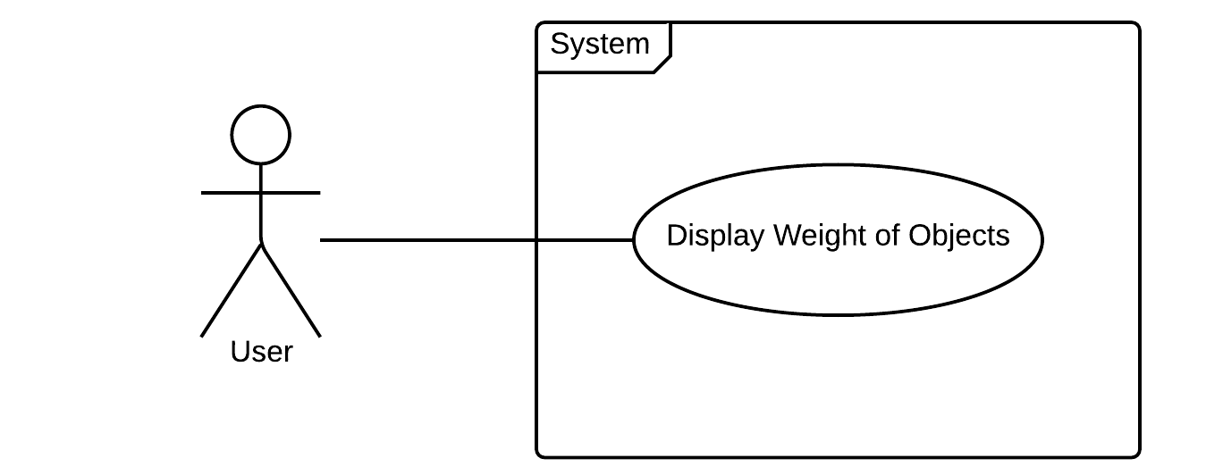

**Sequence Diagram**

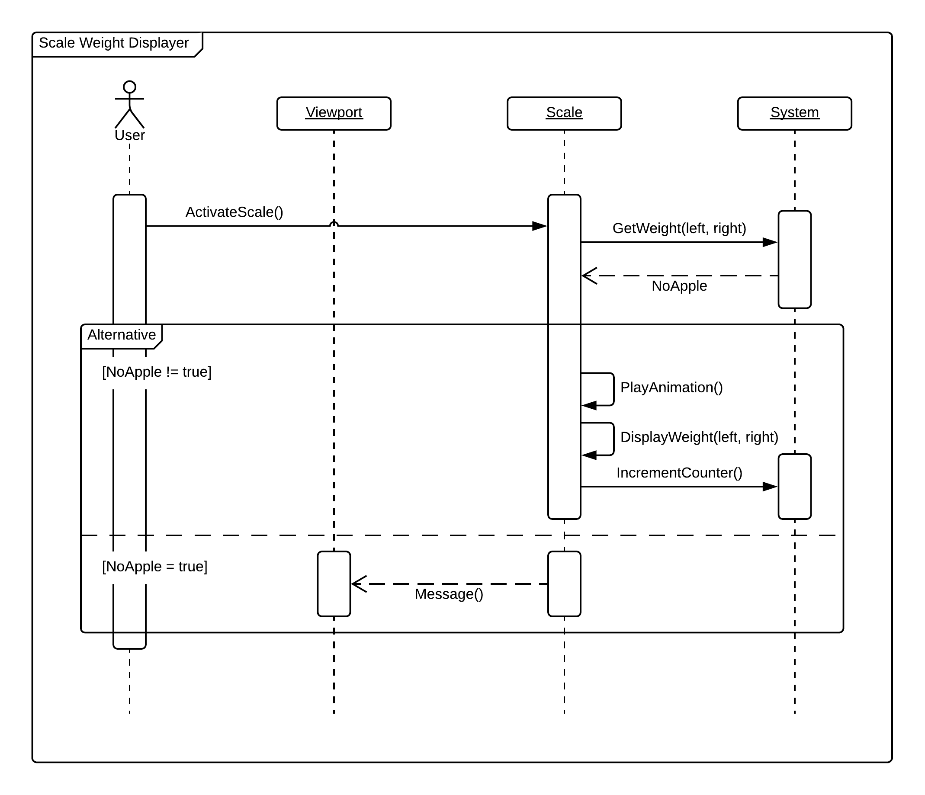

**Class Diagram**

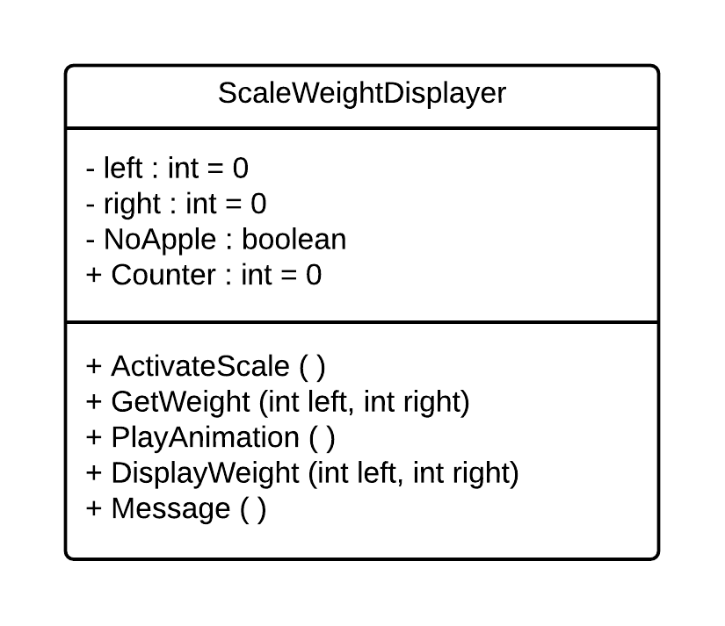

**Unit Test**

* Test case ID: check_for_actors
* Description/Summary of Test: The scale must have apples placed on it before the scale is activated. If no apples are on the scale, then the user is notified that they must place an apple on the scale before activating it.
* Pre-condition: The user activates the scale.
* Expected Results: The scale displays the weight on a successful event, otherwise the user is notified.
* Actual Result: The scale displayed the weight on a successful event and the user was notified on an unsuccessful event.
* Status (Fail/Pass): Pass
* Test case ID: get_weight_left
* Description/Summary of Test: The weight of each apple on the left side of the scale is added to get the total sum of weight.
* Pre-condition: Apples must be placed on the left side of the scale.
* Expected Results: The total sum of weight of all the apples on the left side of the scale.
* Actual Result: The total sum of weight of all the apples on the left side of the scale.
* Status (Fail/Pass): Pass

* Test case ID: get_weight_right
* Description/Summary of Test: The weight of each apple on the right side of the scale is added to get the total sum of weight.
* Pre-condition: Apples must be placed on the right side of the scale.
* Expected Results: The total sum of weight of all the apples on the right side of the scale.
* Actual Result: The total sum of weight of all the apples on the right side of the scale.
* Status (Fail/Pass): Pass

* Test case ID: scale_animation
* Description/Summary of Test: An animation is played to notify the user that the scale is working.
* Pre-condition: The user activates the scale and apples are placed on the scale.
* Expected Results: The animation is played.
* Actual Result: The animation is played.
* Status (Fail/Pass): Pass

* Test case ID: display_weight
* Description/Summary of Test: The scale either tilts to one side or remains balanced depending on the weight when the user activates the scale.
* Pre-condition: The user activates the scale and apples are placed on the scale.
* Expected Results: The scale either tilts to one side or remains balanced.
* Actual Result: When the left side had more weight the scale tilted to the left; when the right side had more weight the scale tilted to the right; when both sides had equal weight the scale remained balanced.
* Status (Fail/Pass): Pass

* Test case ID: increment_counter_p2
* Description/Summary of Test: A counter for the number of times the scale was used is incremented when the user successfully activates the scale.
* Pre-condition: The user activates the scale and apples are placed on the scale.
* Expected Results: The counter increments.
* Actual Result: The counter incremented.
* Status (Fail/Pass): Pass

**Visual User Guide**

