*Florida International University*

*School of Computing and Information Sciences*

Software Engineering Focus

Feature Document

User Story ID #696 Implement Function to Move Objects

**Name:** Santiago Bolivar

**Team Member(s):** Armando Carrasquillo, Daniel Perez, Santiago Bolivar

**Project:** VR-Gaming to Broad Participation in CS

**Product Owner(s)**: Francisco Ortega

**Mentor(s)**: Francisco Ortega

**Instructor**: Masoud Sadjadi

**User Story Name: Implement Function to Move Objects**

* Description: As a developer, I want to implement a function for the user to move objects around in Unreal, so that I can avoid having to retype the code for grabbing and releasing objects.

Acceptance Criteria

* Verify that when an object is grabbed the object is being held until the user releases it.
* Verify that when an object is released the object is placed in the correct orientation.
* Verify that only one object can be moved at a time.

**Use Case**

* Name: Move Object
* Actor: User
* Preconditions: The object is a movable object.
* Description <Flow of events>:

1. The user grabs an object.
2. The user is able to move around with the held object.
3. The user is able to release the object.

**Use Case Diagram**

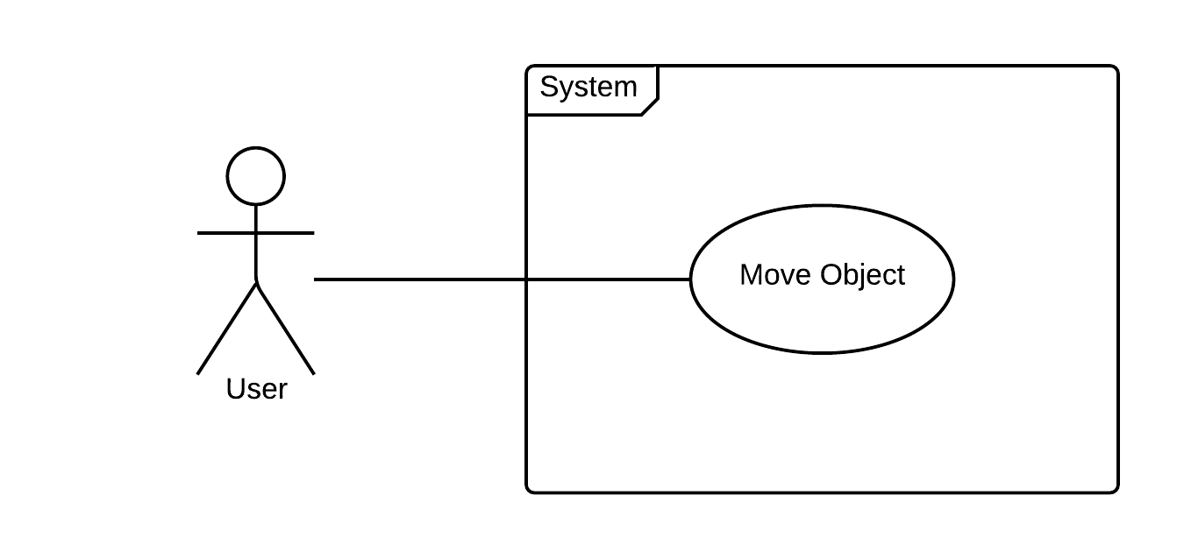

**Sequence Diagram**

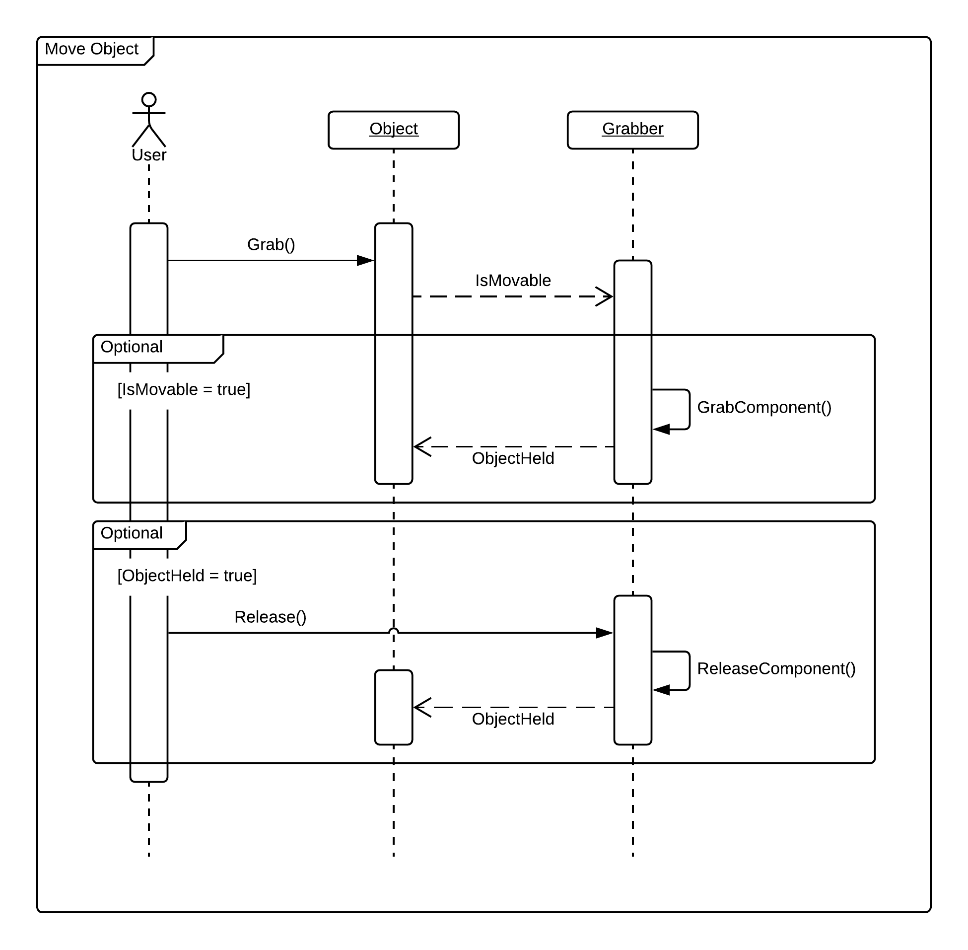

**Class Diagram**

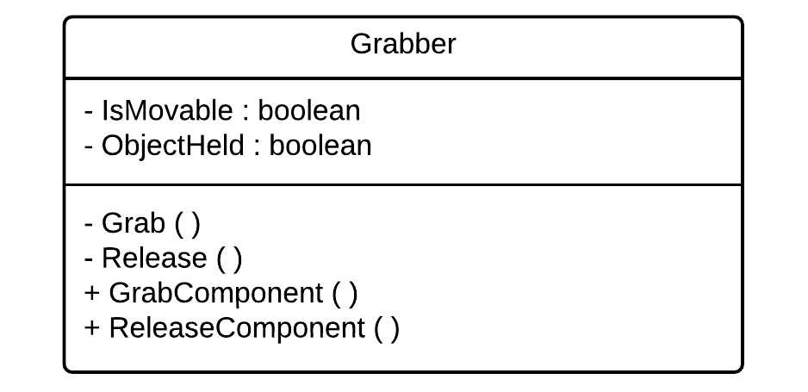

**Unit Test**

* Test case ID: get_physics_body_in_reach
* Description/Summary of Test: The system checks if there is a movable object in reach.
* Pre-condition: User is located in front of an movable object.
* Expected Results: User gets notified that object is movable.
* Actual Result: User gets notified that object is movable.
* Status (Fail/Pass): Pass
* Test case ID: grab_object
* Description/Summary of Test:The system maintains object location and rotation in front of the user.
* Pre-condition: User has clicked on movable object.
* Expected Results: Object location and rotation is held in front of camera.
* Actual Result: Object location and rotation is held in front of camera.
* Status (Fail/Pass): Pass
* Test case ID: release_object
* Description/Summary of Test: The system frees the object location and rotation from in front of user.
* Pre-condition: User is currently holding object.
* Expected Results: Object releases on the current location.
* Actual Result: Object releases on the current location.
* Status (Fail/Pass): Pass

**Visual User Guide**

