*Florida International University*

*School of Computing and Information Sciences*

Software Engineering Focus

Feature Document

User Story ID #698 Implement Interaction to Heat Up Cauldron

(Puzzle 1)

**Name:** Armando Carrasquillo

**Team Member(s):** Armando Carrasquillo, Daniel Perez, Santiago Bolivar

**Project:** VR-Gaming to Broad Participation in CS

**Product Owner(s)**: Francisco Ortega

**Mentor(s)**: Francisco Ortega

**Instructor**: Masoud Sadjadi

**User Story Name: Implement Interaction to Heat Up Cauldron (Puzzle 1)**

* Description: As a developer, I want to implement a function for the user to heat up the cauldron, so that the user can check if their solution to the current iteration was correct.

Acceptance Criteria

* Verify that the function only succeeds if the right combination of potions was added for the current iteration and that they’re the only objects in the cauldron.
* Verify that the function notifies the user if their solution was correct.
* Verify that the iteration counter increments when the function succeeds.
* Verify that the function resets the potion flags after each iteration.

**Use Case**

* Name: Heat Up Cauldron
* Actor: User
* Preconditions: N/A
* Description <Flow of events>:

1. The user presses a button to heat up the cauldron.
2. The cauldron heats up.
   1. If the solution is correct, then the user is notified and the iteration counter gets incremented.
   2. Reset all the potion flags.
3. Repeat steps 1 and 2 until the iteration counter equals the number of required successes.

**Use Case Diagram**

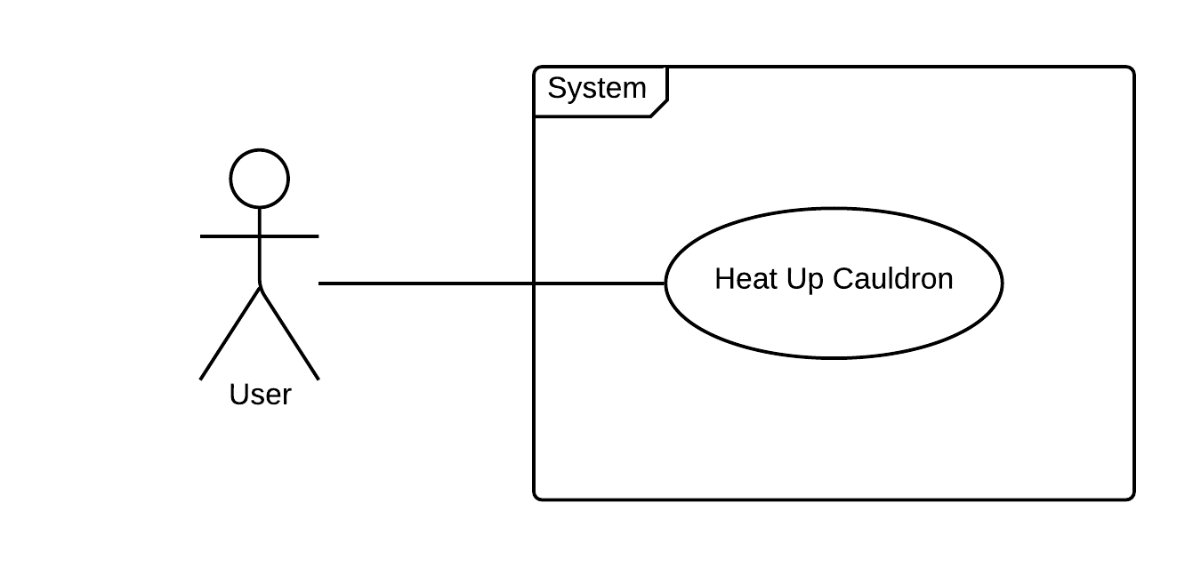

**Sequence Diagram**

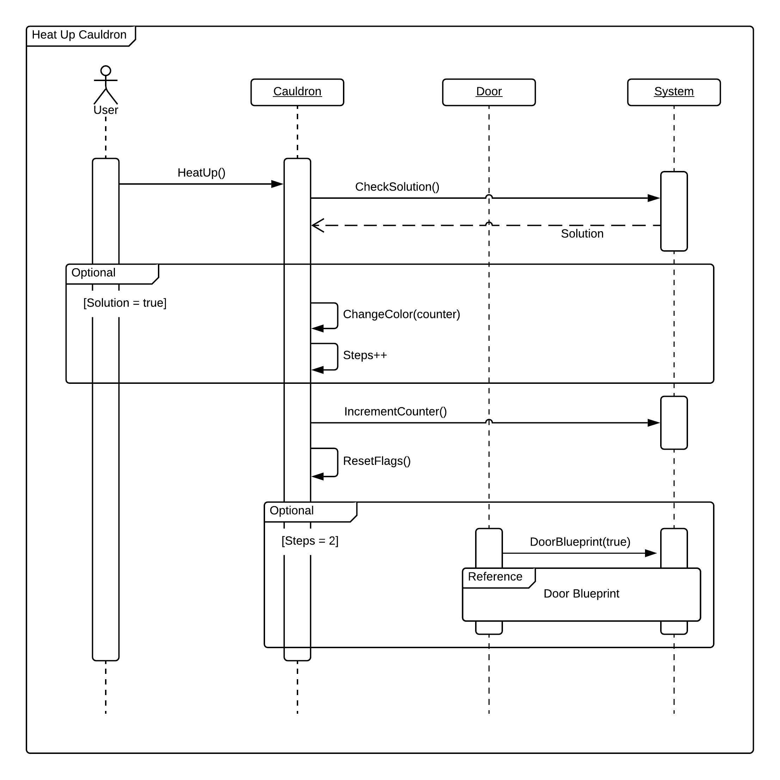

**Class Diagram**

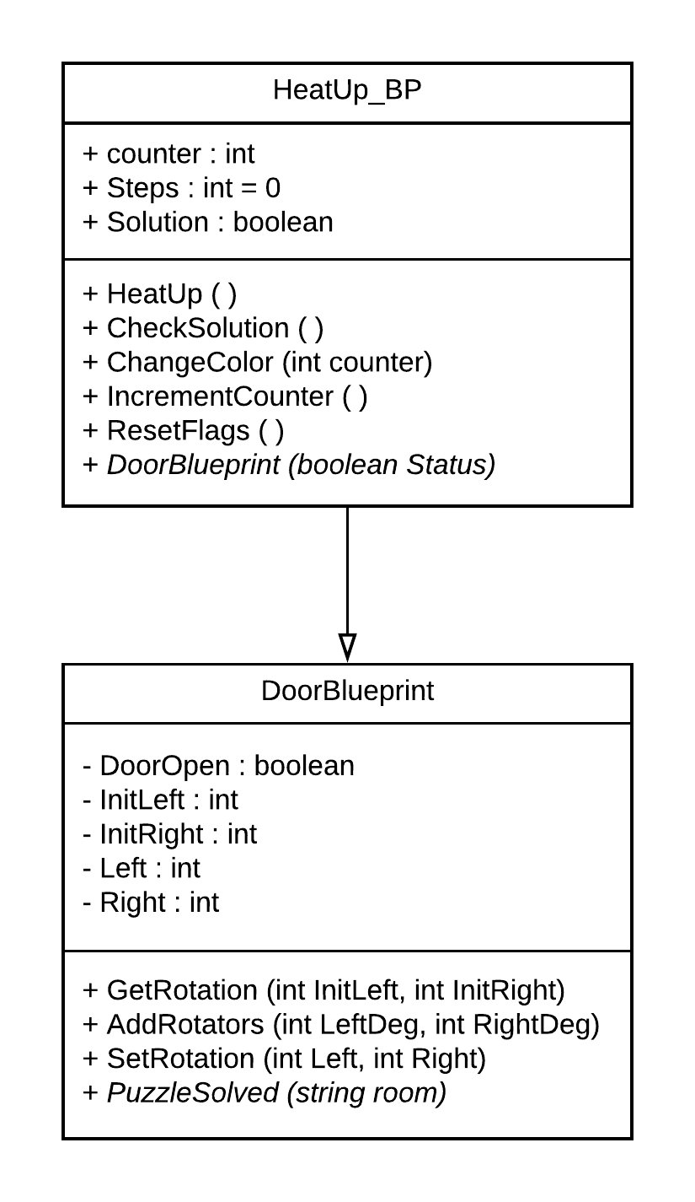

**Unit Test**

* Test case ID: check_solution_p1
* Description/Summary of Test: Checks to see if the correct potions were placed in the Cauldron.
* Pre-condition: Activate Heat Up button.
* Expected Results: Checks to see if the correct potions were placed.
* Actual Result: Checks to see if the correct potions were placed.
* Status (Fail/Pass): Pass
* Test case ID: notify_result_p1
* Description/Summary of Test: Changes the particle effect on the Cauldron.
* Pre-condition: Solution within cauldron is correct.
* Expected Results: Changes particle effect within cauldron.
* Actual Result: Particle effect changed.
* Status (Fail/Pass): Pass
* Test case ID: increment_counter_p1
* Description/Summary of Test: Increcements counter of successful solutions.
* Pre-condition: A successful solution was made, and the particle effect changed.
* Expected Results: The counter of total solutions is increased.
* Actual Result: The counter of total solutions is increased.
* Status (Fail/Pass): Pass
* Test case ID: reset_flags_p1
* Description/Summary of Test: Resets the potion flags.
* Pre-condition:The solution was completed, and the next round of solutions began.
* Expected Results: The potion flags should be set to false.
* Actual Result: Potion flags set to false.
* Status (Fail/Pass): Pass

**Visual User Guide** 