*Florida International University*

*School of Computing and Information Sciences*

Software Engineering Focus

Feature Document

User Story ID #728 Implement In-Game Menu

**Name:** Armando Carrasquillo

**Team Member(s):** Armando Carrasquillo, Daniel Perez, Santiago Bolivar

**Project:** VR-Gaming to Broad Participation in CS

**Product Owner(s)**: Francisco Ortega

**Mentor(s)**: Francisco Ortega

**Instructor**: Masoud Sadjadi

**User Story Name: Implement In-Game Menu**

* Description: As a developer, I want to implement an in-game menu, so that the user can access help and information when needed.

Acceptance Criteria

* Verify that the following options are available: resume, controls, hints, achievements, and quit game.
* Verify that the resume option exits the in-game menu.
* Verify that the controls option displays a guide on how to play the game.
* Verify that the hints option displays a hint on how to solve the current puzzle the user is on.
* Verify that the achievements option displays all of the achievements by completion.
* Verify that the quit game option exits the game.

**Use Case**

* Name: In-Game Menu
* Actor: User
* Preconditions: The user started the game.
* Description <Flow of events>:

1. The user presses the menu button.
2. The in-game menu is displayed on screen.
   1. If the user selects an option (other than resume or quit game) from the menu, then that option is displayed.
   2. If the user presses the resume option, then the in-game menu is taken off screen.
   3. If the user presses the quit game option, then the user is returned to the main menu.

**Use Case Diagram**

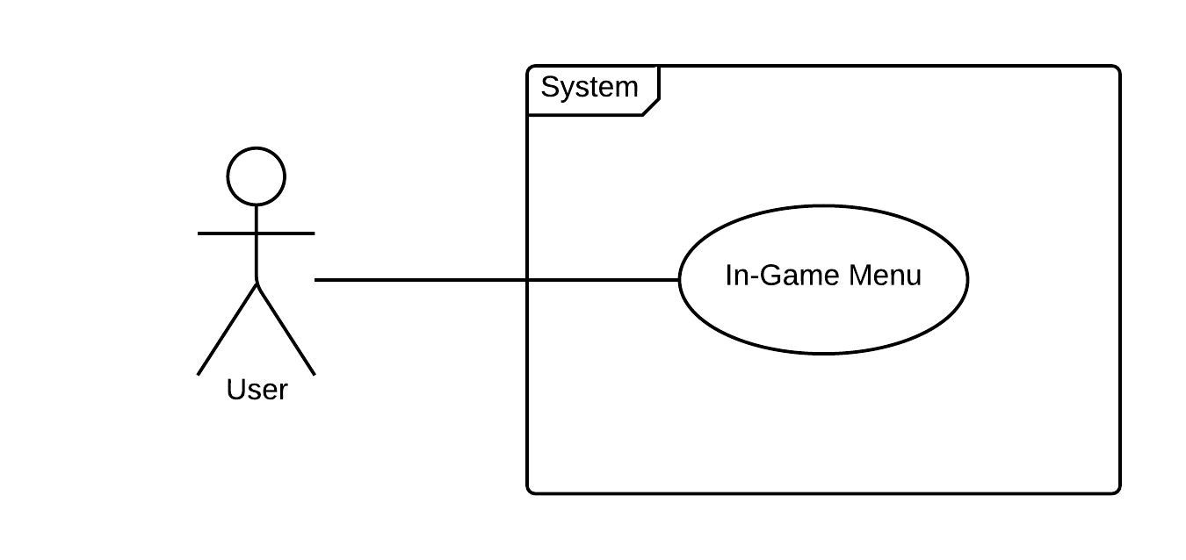

**Sequence Diagram**

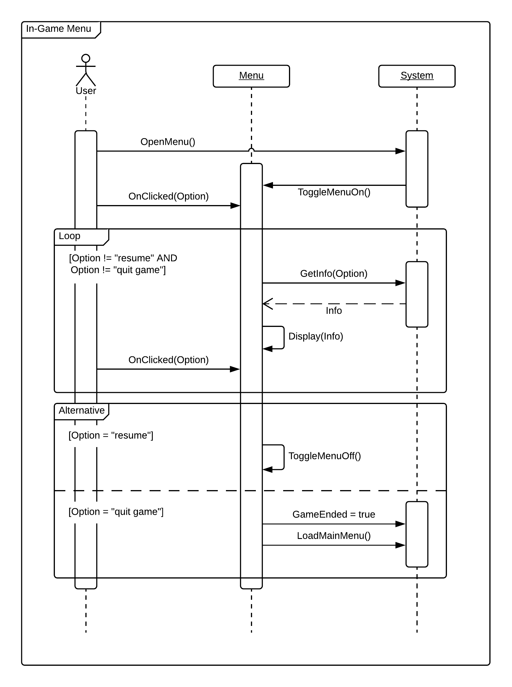

**Class Diagram**

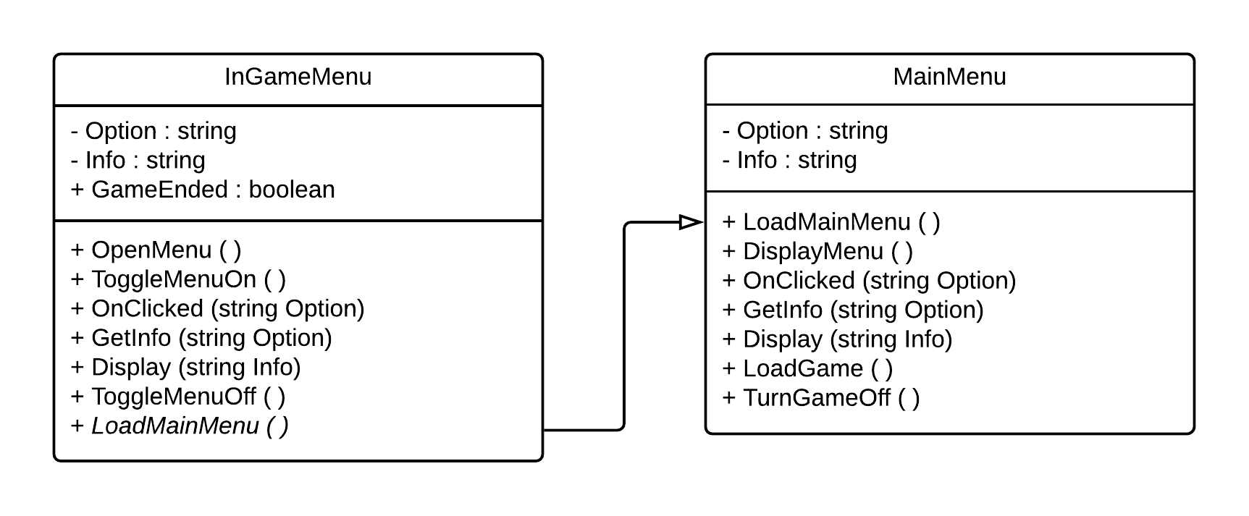

**Unit Test**

* Test case ID: menu_options
* Description/Summary of Test: The following options are shown in the menu: resume, controls, hints, achievements, and quit game.
* Pre-condition: User opened the menu.
* Expected Results: The menu options are shown.
* Actual Result: The menu options are shown.
* Status (Fail/Pass): Pass
* Test case ID: controls_option
* Description/Summary of Test: The controls option displays a guide on how to play the game.
* Pre-condition: User selected controls option.
* Expected Results: The controls are displayed.
* Actual Result: The controls are displayed.
* Status (Fail/Pass): Pass
* Test case ID: hints_option
* Description/Summary of Test: The hints option displays a hint on how to solve the current puzzle the user is on.
* Pre-condition: User selected hints option.
* Expected Results: A hint is displayed.
* Actual Result: A hint is displayed.
* Status (Fail/Pass): Pass
* Test case ID: achievements_option
* Description/Summary of Test: The achievements option displays all of the achievements by completion.
* Pre-condition: User selected achievements option.
* Expected Results: The achievements are displayed.
* Actual Result: The achievements are displayed.
* Status (Fail/Pass): Pass
* Test case ID: exit_option
* Description/Summary of Test: The resume option exits the menu.
* Pre-condition: User selected resume option.
* Expected Results: The menu closes.
* Actual Result: The menu closed.
* Status (Fail/Pass): Pass

**Visual User Guide**

