*Florida International University*

*School of Computing and Information Sciences*

Software Engineering Focus

Feature Document

User Story ID #724 Implement Functionality for Doors

**Name:** Santiago Bolivar

**Team Member(s):** Armando Carrasquillo, Daniel Perez, Santiago Bolivar

**Project:** VR-Gaming to Broad Participation in CS

**Product Owner(s)**: Francisco Ortega

**Mentor(s)**: Francisco Ortega

**Instructor**: Masoud Sadjadi

**User Story Name: Implement Functionality for Doors**

* Description: As a developer, I want to implement the functionality of a door in Unreal, so that the door can open and close on command.

Acceptance Criteria

* Verify that the door opens on command.
* Verify that the door closes on command.
* Verify that the functionality of the door remains when creating a copy of the door.

**Use Case**

* Name: Door Blueprint
* Actor: Developer
* Preconditions: Door object must be present in level.
* Description <Flow of events>:

1. The door opens when a specific event occurs.
2. The door closes when a specific event occurs.

**Use Case Diagram**

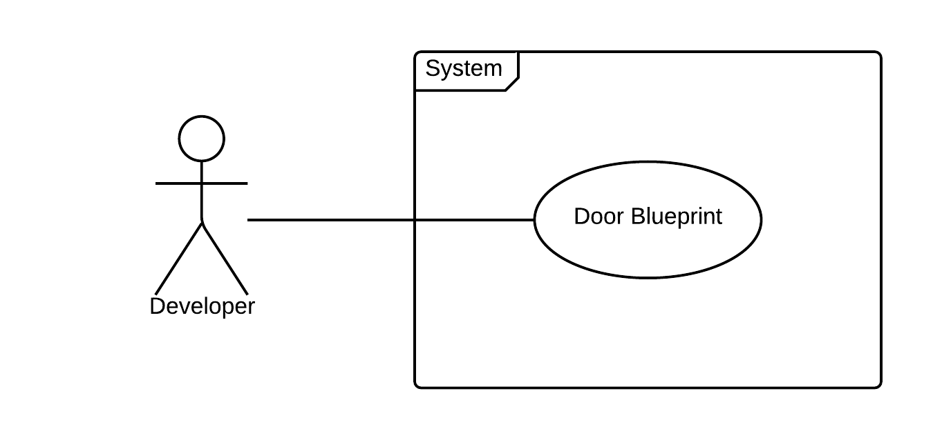

**Sequence Diagram**

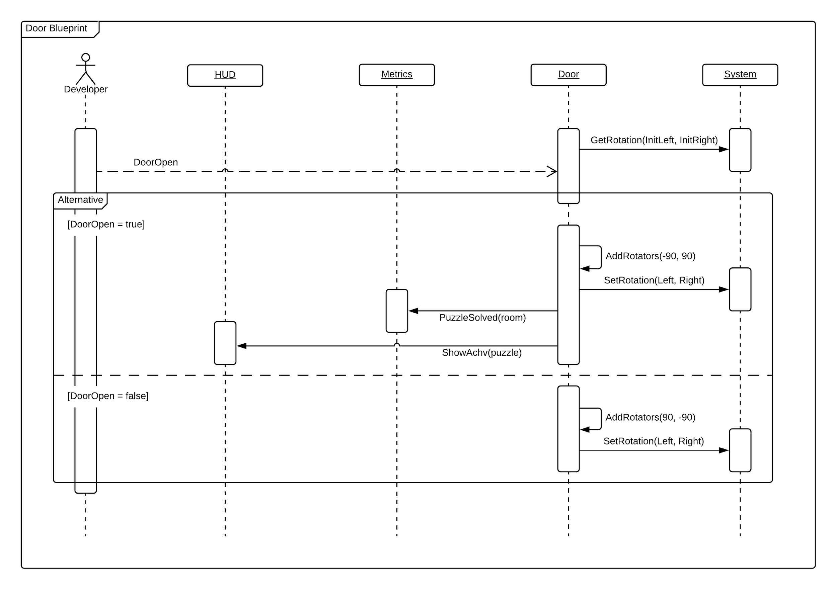

**Class Diagram**

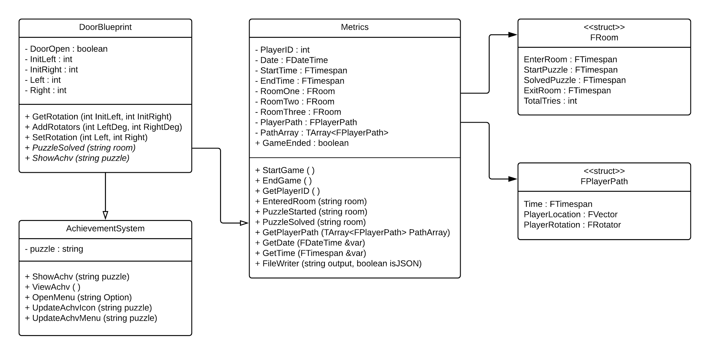

**Unit Test**

* Test case ID: door_open
* Description/Summary of Test: The door opens on command.
* Pre-condition: Door must exist in level.
* Expected Results: Door opens.
* Actual Result: Door opened.
* Status (Fail/Pass): Pass
* Test case ID: door_close
* Description/Summary of Test: The door closes on command.
* Pre-condition: Door must exist in level.
* Expected Results: Door closes.
* Actual Result: Door closed.
* Status (Fail/Pass): Pass
* Test case ID: door_functionality
* Description/Summary of Test: The functionality of the door remains when creating a copy of the door.
* Pre-condition: Door must exist in level.
* Expected Results: The door copy retains the functionality of the door.
* Actual Result: The door copy retained the functionality of the door.
* Status (Fail/Pass): Pass

**Visual User Guide**

