*Florida International University*

*School of Computing and Information Sciences*

Software Engineering Focus

Feature Document

User Story ID #727 Implement Achievement System

**Name:** Santiago Bolivar

**Team Member(s):** Armando Carrasquillo, Daniel Perez, Santiago Bolivar

**Project:** VR-Gaming to Broad Participation in CS

**Product Owner(s)**: Francisco Ortega

**Mentor(s)**: Francisco Ortega

**Instructor**: Masoud Sadjadi

**User Story Name: Implement Achievement System**

* Description: As a developer, I want to implement an achievement system for the game, so that the user gets notified when a puzzle has been solved.

Acceptance Criteria

* Verify that the achievement is shown on screen when a puzzle is solved.
* Verify that the achievement can toggle the achievement menu option.
* Verify that the HUD is updated after the achievement has been unlocked.
* Verify that the menu is updated after the achievement has been unlocked.

**Use Case**

* Name: Achievement System
* Actor: User
* Preconditions: An achievement is unlocked.
* Description <Flow of events>:

1. The achievement is shown on screen.
   1. The user has an option to immediately view information about the achievement in the menu.
2. The achievement icon in the HUD is updated.
   1. The icon color changes from grey to gold.
3. The menu is updated.
   1. The achievement is now viewable from the menu at any time.

**Use Case Diagram**

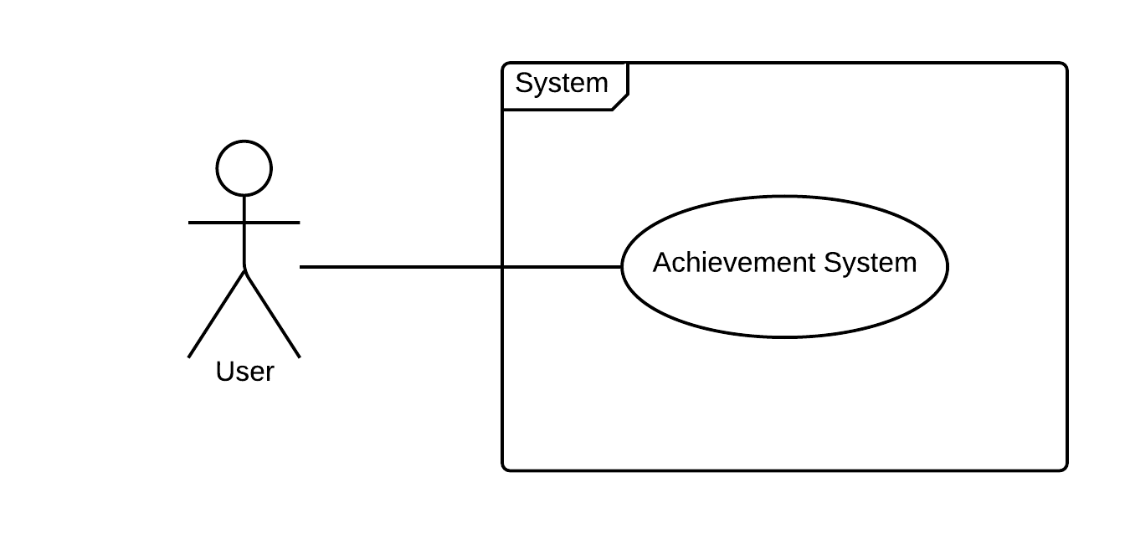

**Sequence Diagram**

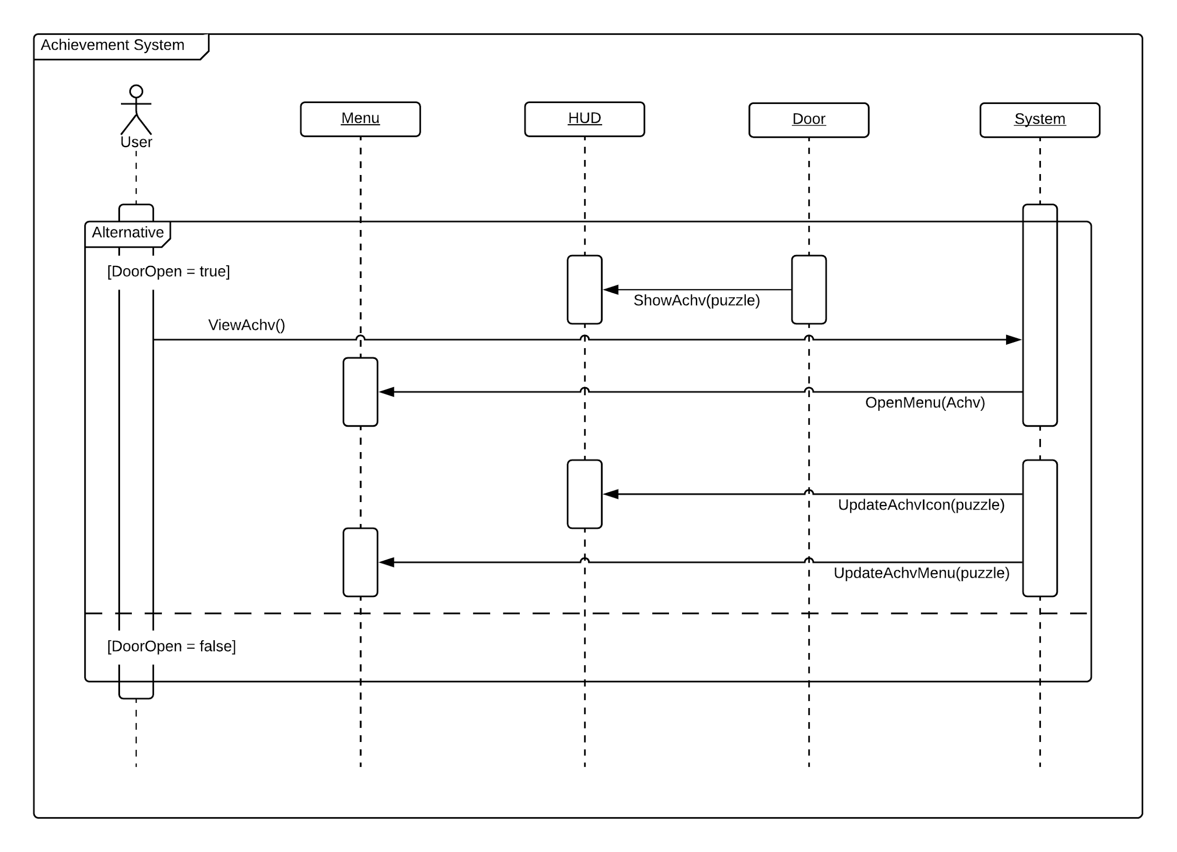

**Class Diagram**

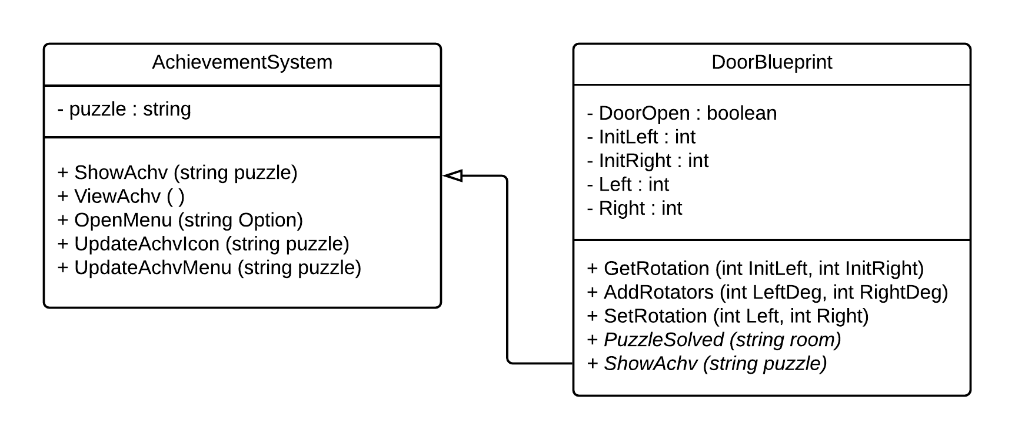

**Unit Test**

* Test case ID: show_achievement
* Description/Summary of Test: The achievement is shown on screen.
* Pre-condition: A puzzle was solved.
* Expected Results: The achievement is shown on screen.
* Actual Result: The achievement is shown on screen.
* Status (Fail/Pass): Pass
* Test case ID: toggle_achievement_menu
* Description/Summary of Test: The achievement can toggle the achievement menu option.
* Pre-condition: An achievement was shown on screen and the user accessed it.
* Expected Results: Display the achievement option in the menu.
* Actual Result: Displayed the achievement option in the menu.
* Status (Fail/Pass): Pass
* Test case ID: update_achievement_icon
* Description/Summary of Test: The achievement icon in the HUD is updated.
* Pre-condition: An achievement was unlocked.
* Expected Results: The icon color changes from grey to gold.
* Actual Result: The icon color changed from grey to gold.
* Status (Fail/Pass): Pass
* Test case ID: update_achievement_menu
* Description/Summary of Test: The achievement option in the menu is updated.
* Pre-condition: An achievement was unlocked.
* Expected Results: The achievement is viewable from the menu at any time.
* Actual Result: The achievement is viewable from the menu at any time.
* Status (Fail/Pass): Pass

**Visual User Guide**

