*Florida International University*

*School of Computing and Information Sciences*

Software Engineering Focus

Feature Document

User Story ID #754 Create Game Completed Trigger

**Name:** Armando Carrasquillo

**Team Member(s):** Armando Carrasquillo, Daniel Perez, Santiago Bolivar

**Project:** VR-Gaming to Broad Participation in CS

**Product Owner(s)**: Francisco Ortega

**Mentor(s)**: Francisco Ortega

**Instructor**: Masoud Sadjadi

**User Story Name: Create Game Completed Trigger**

* Description: As a developer, I want to create a trigger for the player to complete the game, so that the proper events take place.

Acceptance Criteria

* Verify that when the trigger is activated the game is ended.
* Verify that the congratulation screen is displayed to the player.
* Verify that the player is returned to the main menu after viewing the congratulations.

**Use Case**

* Name: Game Completed Trigger
* Actor: User
* Preconditions: The game is completed.
* Description <Flow of events>:

1. The game is ended.
2. The congratulation screen is displayed to the player.
3. The player is returned to the main menu after viewing the congratulations.

**Use Case Diagram**

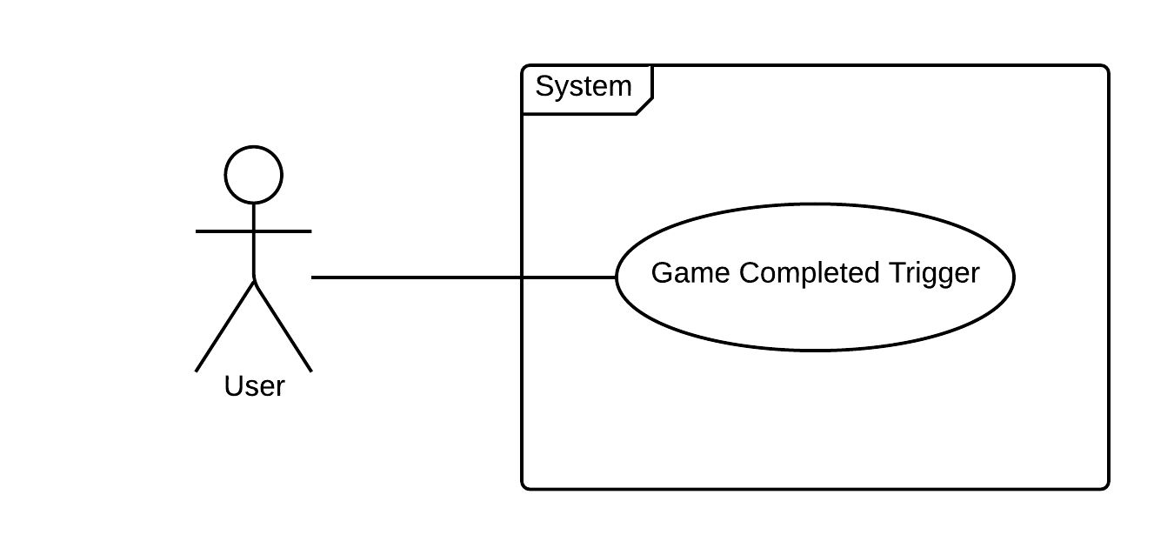

**Sequence Diagram**

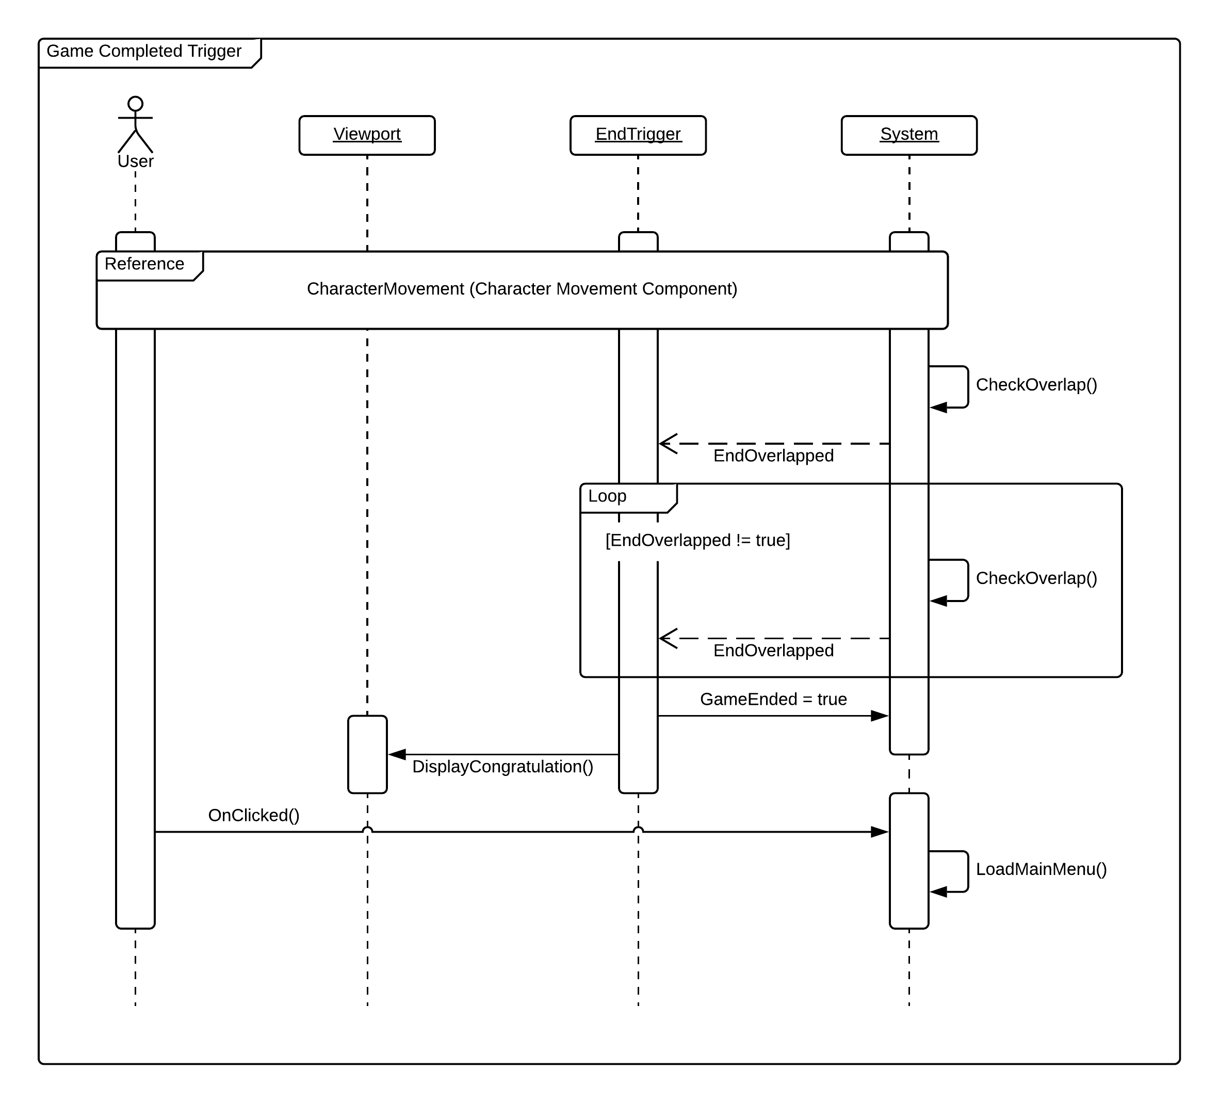

**Class Diagram**

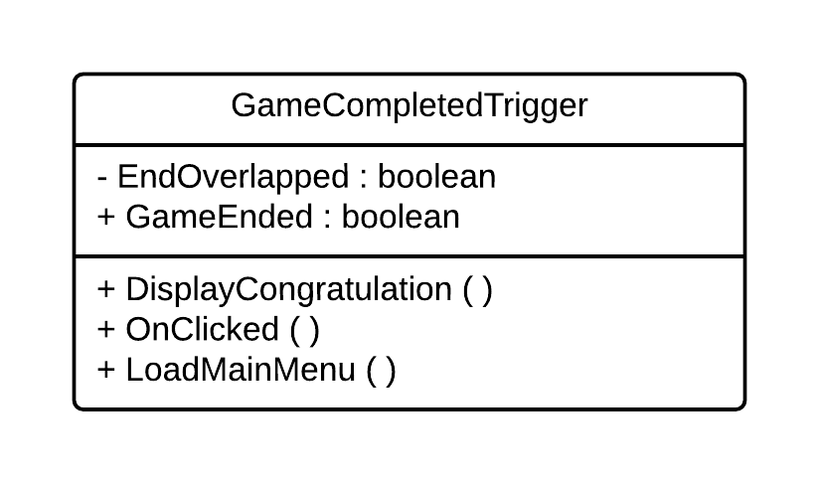

**Unit Test**

* Test case ID: game_ end
* Description/Summary of Test: The game ends when the trigger is activated.
* Pre-condition: Trigger is activated.
* Expected Results: The game ends when the trigger is activated.
* Actual Result: The game ended when the trigger was activated.
* Status (Fail/Pass): Pass
* Test case ID: congrats_screen
* Description/Summary of Test: The congratulation screen is displayed to the player.
* Pre-condition: The game is ended through the trigger.
* Expected Results: The congratulations screen gets displayed to the player.
* Actual Result: The congratulations screen got displayed to the player.
* Status (Fail/Pass): Pass
* Test case ID: return_to_main_menu
* Description/Summary of Test: The player is returned to the main menu after viewing the congratulations.
* Pre-condition: The player viewed the congratulations screen.
* Expected Results: The player gets returned to the main menu after viewing the congratulations screen.
* Actual Result: The player is returned to the main menu after viewing the congratulations screen.
* Status (Fail/Pass): Pass

**Visual User Guide**

