**Use Case Diagram**

*Florida International University*

*School of Computing and Information Sciences*

CEN 5011- Advanced Software Engineering

Feature Document

User Story #1186

# **Search name in admin panel**

**Team Member:**

Ravi Kiran Agarthi

**Product Owner(s)**:

Masoud Sadjadi

**Mentor(s)**:

Mohsen Taheri

**Instructor**: Masoud Sadjadi

# 

# 

# **User Story - Save semester for both project proposal and application for a project**

● As a user, I would like to save on which semester does Professor proposes the project and on which semester student applies for a project so that I could check information based on the semester.

## **Use Case**

**Use Case ID:** (VIP-1186)

**Details:** Save semester details

**Actor:** Staff/Faculty and Student

**Pre-conditions:**

1. Staff/Faculty and Student has navigated to the VIP website.

2. Staff/Faculty and Student is able to login and click on Project Proposal form and Apply for a Project form respectively.

**Description:**

1. Both Staff/Faculty and Student should be able to find and use semester drop down menu in the respective forms.

2. Both Staff/Faculty and Student should be able to submit the form without any errors

**Post-conditions:**

1. Both Staff/Faculty and Student semester details that they have filled on the forms should be saved in the database

**Alternative Courses of Action:**

N/A

**Exceptions:**

N/A

**Related Uses Case:**

N/A

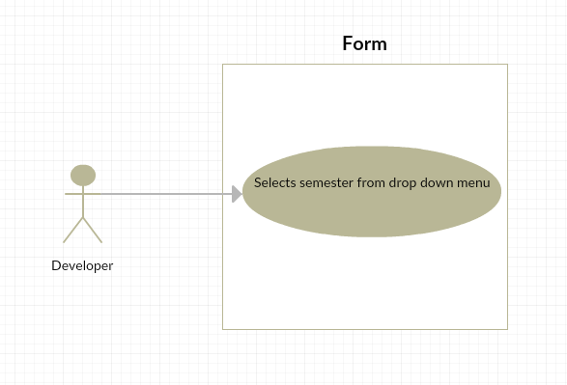

**Sequence Diagram**

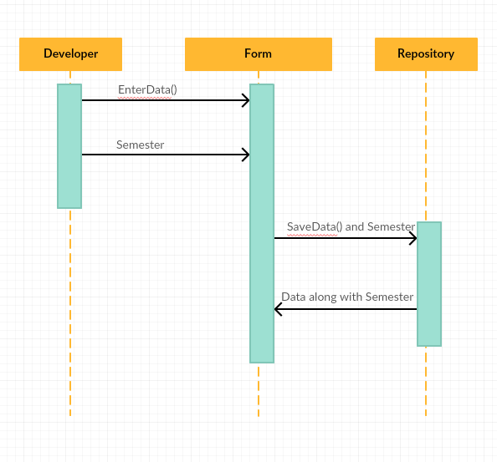

**Class Diagram**

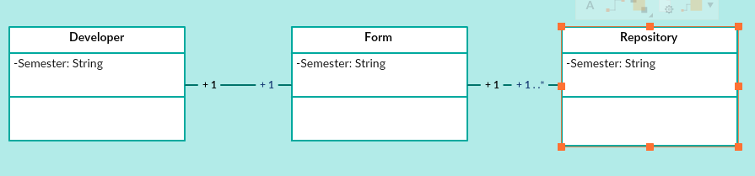

**Unit & Integration Tests:**

## **● Test Case 1(Sunny Day)** ○ Purpose: Test that when Professor proposes a project, the semester details are getting saved in database

## ○ Precondition: Staff/Faculty has reached the VIP site and reached the Project Proposal Form.

## ○ Input: Staff/Faculty selects a semester from drop down menu and submits the form after entering all the required fields.

## ○ Expected Result: The semester details should be saved in the database. ○ Actual Result: The semester details are getting saved in the database. ○ Status: SUCCESS

## 

## **● Test Case 2(Sunny Day)** ○ Purpose: Test that when Student Applies for a project, the semester details are getting saved in database

## ○ Precondition: Student has reached the VIP site and reached the Apply to a Project Form.

## ○ Input: Student selects a semester from drop down menu and submits the form after entering all the required fields.

## ○ Expected Result: The semester details should be saved in the database. ○ Actual Result: The semester details are getting saved in the database. ○ Status: SUCCESS

## 

## 

## 

## 

## 

## 

## **Visual User Guide**

Project Proposal Form:

1. Staff/Faculy Proposing a Project Title “Testing_Semester_Capture”

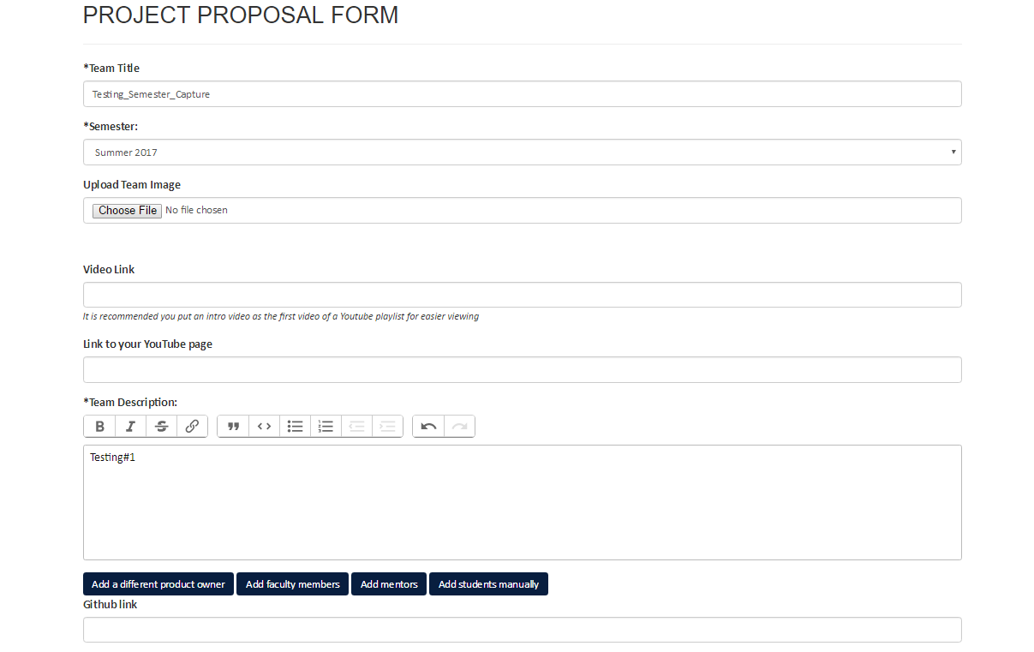

2. Submits the From

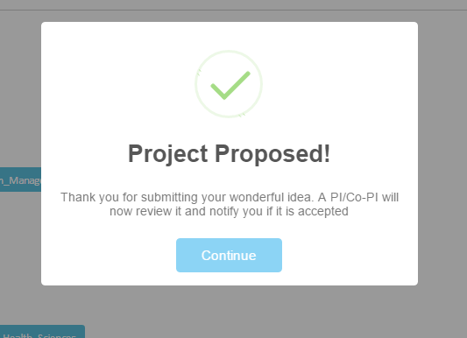

3. After Pi/CoPi approval

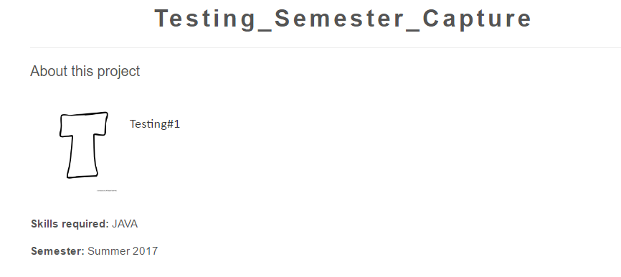

Semester is saved in Database

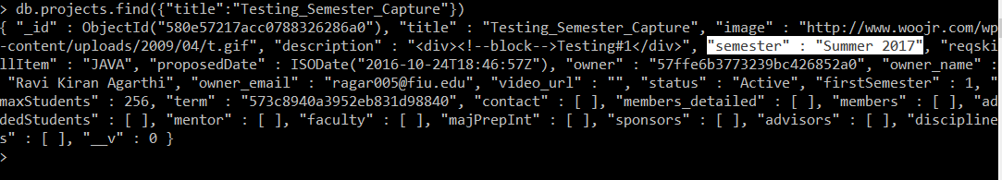

Apply for a Project From

1. Student applies for a Project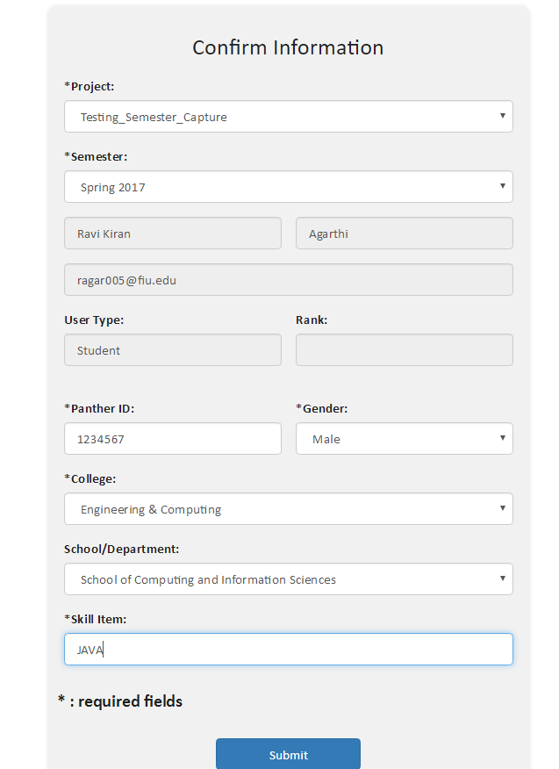

2. Capturing semester in Database

