*Florida International University*

*School of Computing and Information Sciences*

CIS 4911 - Senior Capstone Project

Feature Document

User Story #1152

# Mingle Filed and Logo

**Team Member:**

Joseph Gonzalez

**Product Owner(s)**:

Masoud Sadjadi

**Mentor(s)**:

Mohsen Taheri

**Instructor**: Masoud Sadjadi

# **User Story - Testing and Creating Mingle Filed Entry and Social Icon in VIP Projects**

* As a User, I would like to be able to have a link on the project page that sends me directly to the Mingle site

## **Use Case**

**Use Case ID:** (VIP-1152)

**Details:** Adding a Mingle URL entry in the “Project Proposal Form” and a Mingle Social Icon on the “Project Profile Page”.

**Actor:** Users

**Pre-Condition:**

* User has navigated the VIP site
* One User must be a “Faculty/Staff or Pi/CoPI” level user
* Other Users must be a member of the Project which Project Profile Page they are accessing.

**Description:**

1. Use Case begins when a Faculty/Staff or PI/CoPI navigates to the “Project Proposal Form” (<http://vip.fiu.edu/#/project-proposal>)
2. User fills out the form, and inputs a link in the option labeled “Mingle Link”
3. User submits Project for Approval
4. PI/CoPI approve the new project
5. The Product Owner/Project Members navigate to the “Project Page” (<http://vip.fiu.edu/#/vip-projects>)
6. The Product Owner/Project Members navigate to the “Project Details Page” (<http://vip.fiu.edu/#/vip-projects-detailed/><uniqueProjectHashHere>)
7. Under the section labeled “Discover More” will be any links that were created in step 2
8. Users click on the Social Icon Link “M” that corresponds to Mingle

**Post-Conditions:**

1. Users are redirected to their “Mingle Login Page” (<https://fiu-scis-seniorproject.mingle.thoughtworks.com>)
2. From here Users can login and access their project’s Mingle page

**Alternative Course of Action**

N/A

**Exceptions:**

1. User is not a Project Member or Product owner for the Project they are trying to access
2. Project Owner did not set the “Mingle Link” in the “Project Proposal Form”

**Related Use Cases:**

N/A

**Decision Support:**

**Frequency:** High: Users need to access Mingle often.

**Criticality:** Low: No immediate effect on the rest of the sites performance

**Risk:** Low.

**Constraints:**

1. **Usability:** 
   1. No training time required.
   2. User guide should provide more in-depth information.
2. **Reliability:** 
   1. Mean time to Failure – 1% failures for every twenty four hours of operation is acceptable.
   2. Availability – Dependent on Users
3. **Performance:** 
   1. Link takes less than 5 seconds to redirect users to Mingle Page
4. **Supportability:**
   1. All modern web browsers should be supported.

**Modification History:**

**Owner:** Joseph Gonzalez

**Initiation date:** 9/202016

**Date last modified:** 9/22/2016

**Use Case Diagram**

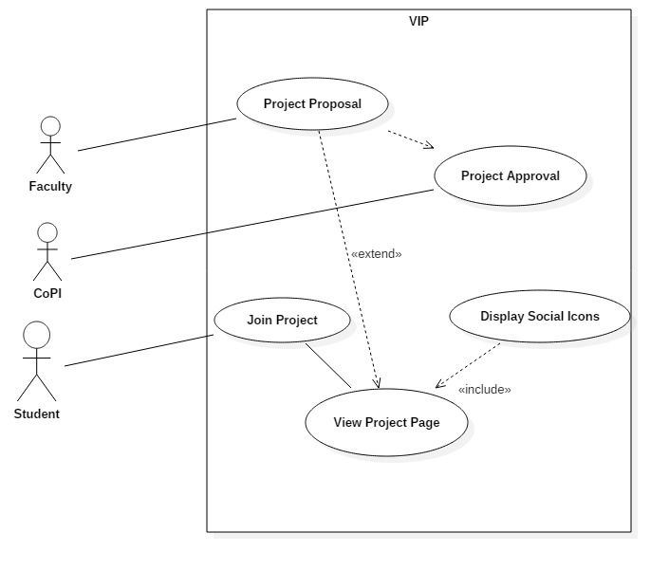

**Sequence Diagram**



**Class Diagram**

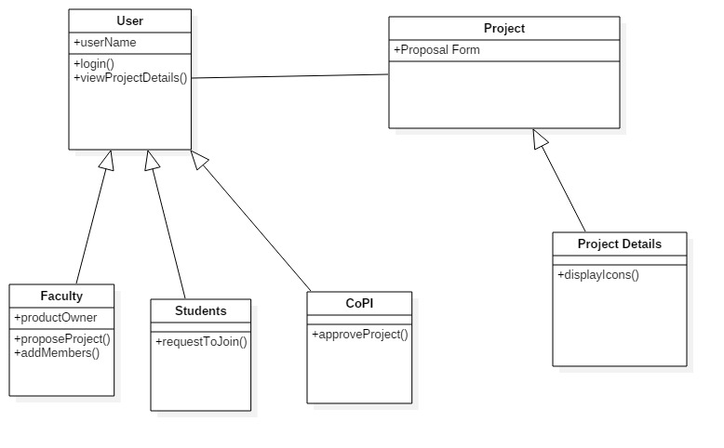

**Unit & Integration Tests:**

**Test Case 1 (Sunny Day)**

**ID: VIP-SD-1152-01**

**Purpose**

* Ensure the “Mingle Link” section of the “Project Proposal Form” saves the URL correctly

**Precondition**

* User fills out the Mingle Link and required fields in the Project Proposal form.

**Input**

* User Clicks on the “Submit” button at the bottom of the page.

**Expected Result**

* Mingle Link is included in the Project Details entry

**Actual Result**

* Same as expected.

**Test Case 2 (Sunny Day)**

**ID: VIP-SD-1152-02**

**Purpose**

* Ensure Mingle Social Link Icon appears when a Mingle Link is tied to a Project.

**Precondition**

* User is the Product Owner or Project Member of the Project.
* Mingle Link section of the Project Proposal Form was filled out

**Input**

* User Navigates to the “Project Details Page”.

**Expected Result**

* The Mingle Social Icon appears under the ‘Discover More” section of the “Project Details Page”

**Actual Result**

* Same as expected.

**Test Case 3 (Sunny Day)**

**ID: VIP-SD-1152-03**

**Purpose**

* Ensure the Mingle Social Icon redirects users to their Mingle Login Page

**Precondition**

* User is the Product Owner, or Project Member of the Project
* Mingle Link section of the “Project Proposal Form” was filled out.

**Input**

* User Navigates to the “Project Details Page”
* User clicks the “M” Icon for Mingle under the “Discover More” section of the page

**Expected Result**

* User is redirected to the “Mingle Login Page”

**Actual Result**

* Same as expected.

**User Guide:**

Step 1. User Navigates to Project Proposal Form

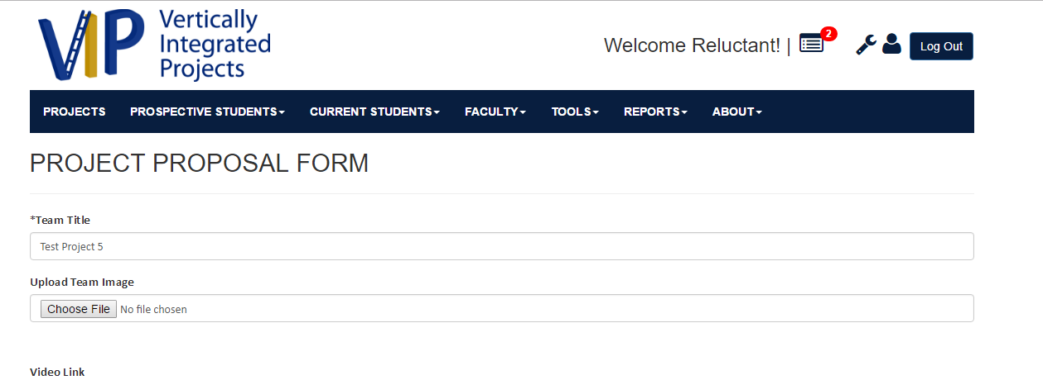

Step 2. User Scrolls down to the “Mingle Link” text box in the form

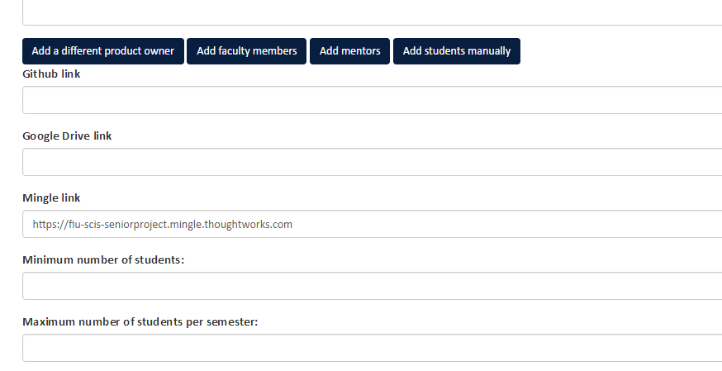

Step 3. User Submits the Project

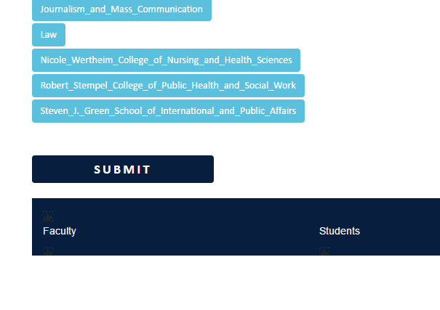

Step 4. The Project is now submitted, once a PI/CoPI has approved the project, the user must navigate to the Projects Page by clicking the “Projects” Button on the header of the site

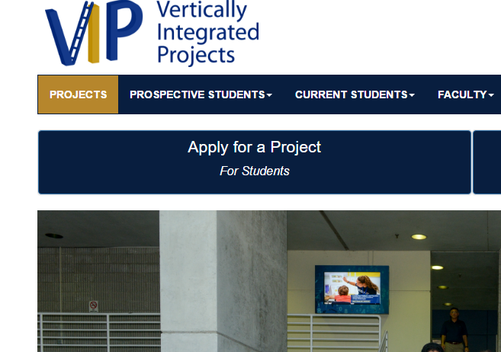

Step 5. User Navigates to their Project

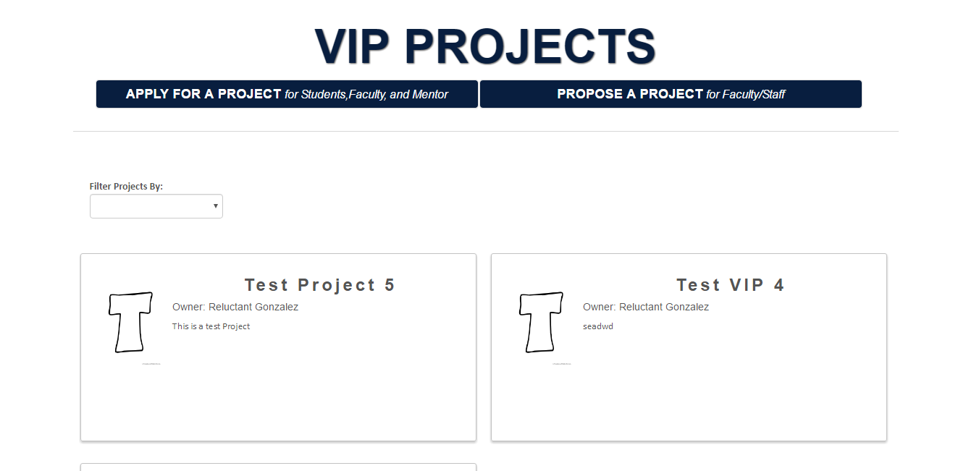

Step 6. User Navigates to their Project Details Page

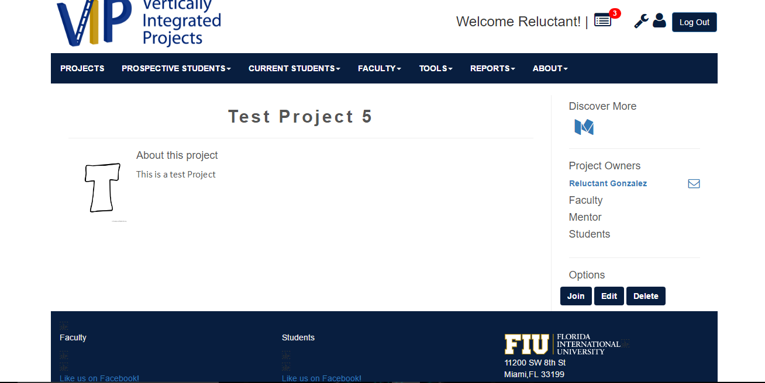

Step 7. User Navigates to the “M” social icon under the Discover More section of the webpage

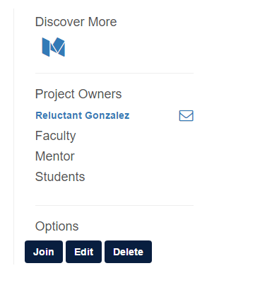

Step 8. The user clicks the “M” social link, and is redirected to the Mingle Login Page

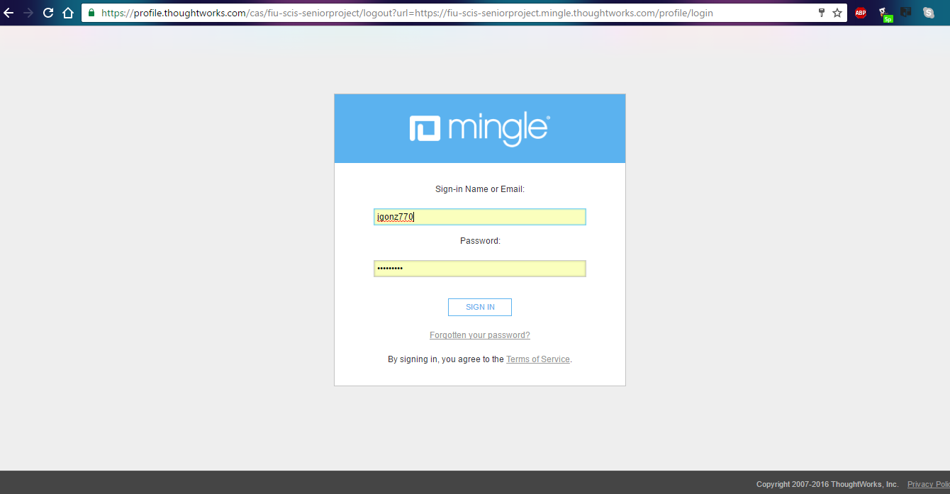

From here they login, and access their Mingle as needed.