*Florida International University*

*School of Computing and Information Sciences*

CIS 5011 Advanced Software Engineering

Feature Document

User Story #1143

# **Adding Excel report in Admin Panel.**

Team Member:

Nandini Dandu

Product Owner(s):

Masoud Sadjadi

Mentor(s):

Mohsen Taheri

Instructor:

Masoud Sadjadi

**User Story**

As an admin, I would like to have an excel icon in the admin panel. When the admin wants list of students, faculty information he can simply click on the excel icon to generate it.

## **USECASE:**

## **Use Case ID:** (VIP-1143)

**Actor: Pi/coPi**

**Pre-Condition:**

We need to consider that the admin is in the admin panel.

Admin selects the user type and other fields in the filters and clicks on “LookUp”.

A list of students or the respected chosen details are generated

**Description:**

The use case will begin when the admin clicks on the excel report icon.

**Post-Conditions:**

Admin must be able to generate the excel report when clicked on the icon.

The report will contain all the information that the admin wants.

Alternative Course of Action:

N/A

Exceptions:

N/A

Related Use Cases:

N/A

**Use case Diagrams:**

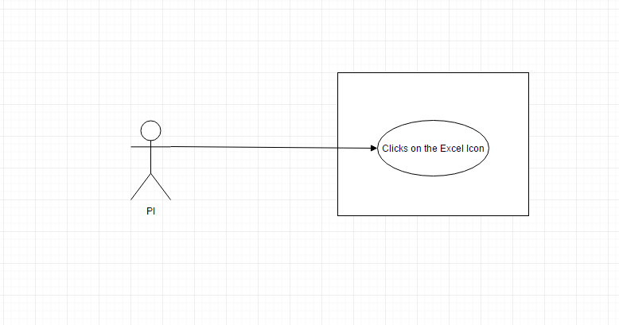

**Sequence Diagram:**

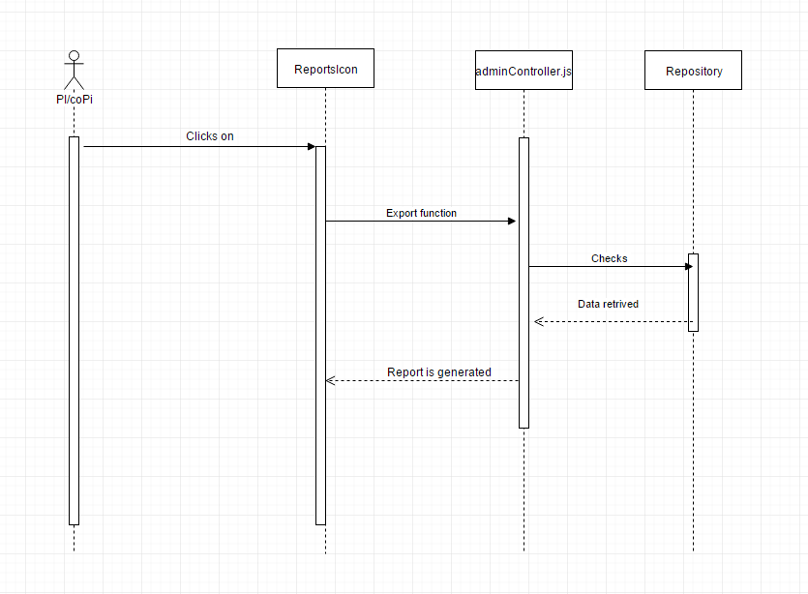

**Class Diagram:**

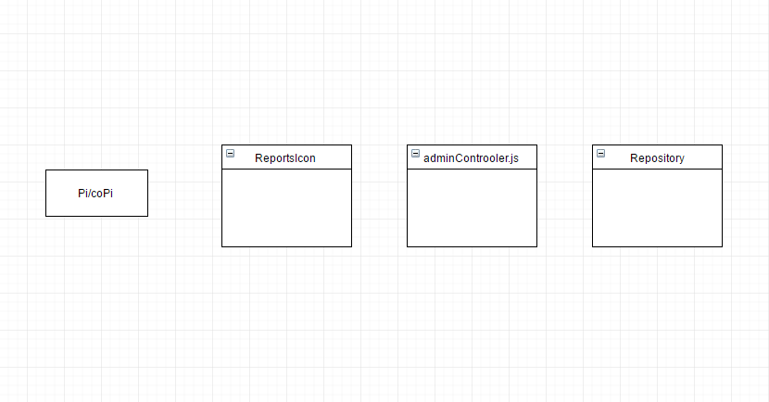

**Unit & Integration Tests:**

* **Test Case 1(Sunny Day)**

**Purpose**: To check if admin is able to generate the excel report

## **Precondition**: Admin is in the admin panel

## **Input**: Admin selects the respective fields or uses the search box

## and clicks on the excel icon

## **Expected Result:** A report must be generated automatically with the

## name current and Report.xlsx all the fields and details of the

## requested user type

## **Actual Result:** The admin must be able to get an excel report with

## current date and all

## the details

## **Status:** SUCCESS

## 

## **Test Case 2(Rainy Day) Purpose**: To check if the admin is able to generate an excel sheet.

## **Precondition:** Admin is in the admin panel.

## **Input:**Admin selects the respective fields and clicks on the Excel Icon.

## **Expected Result**: Admin would not be able to generate the report or

## the details.

## **Actual Result:** An excel report with details will not be generated

## when admin clicks on excel icon

## **Status:** SUCCESS

# 

# **User Guide:**

Following are the visual pictures of the excel report generation.

1. The admin is in the login page. Admin selects the filters and clicks on lookup to get the required details or else he simply searches using the search box.

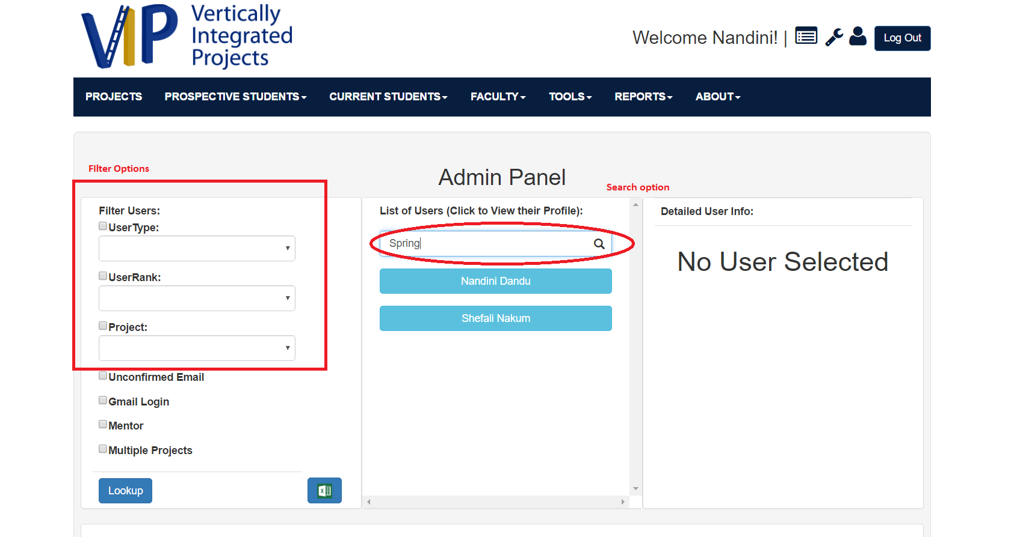

Admin clicks on the excel icon and a report is generated automatically. The name of the report generated with **current data and Report.xsls**

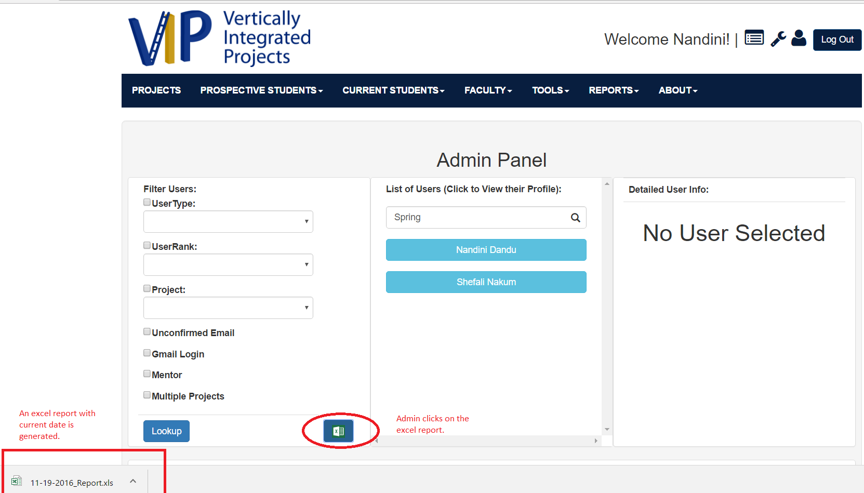

The excel report with the required information.

