*Florida International University*

*School of Computing and Information Sciences*

CIS 4911 - Senior Capstone Project

Feature Document

User Story #1146

Make login permanently on the user's system after first login

**Team Member:**

Franco Hernandez

**Product Owner(s)**:

Masoud Sadjadi

**Mentor(s)**:

Mohsen Taheri

**Instructor**: Masoud Sadjadi

# **User Story – Make login permanently on the user's system after first login**

* As a user, I would like to be able to be permanently be logged after the first login.

## **Use Case**

Use Case ID: (VIP-1146)

Details: Creating a remember_me checkbox and a cookie that remember user id and password for a determined period of time.

Actor: Users.

Pre-conditions:

* User has navigated to the VIP website.
* User must be staff member or Pi/CoPI user.
* User must check checkbox and login for first time

Description:

1. Use case begins when the user navigates to the VIP website login page
2. The user enter user id and password
3. The user check the remember me checkbox
4. The user click on the signin button

Post-conditions:

1. Users should be able to stay logged for a week

Alternative Courses of Action:

N/A

Exceptions:

N/A

Related Uses Case:

N/A

**Decision Support:**

**Frequency:** Low: Users only need to check the remember_me checkbox once every two weeks

**Criticality:** Low: No immediate effect on the rest of the sites

**Risk:** Low.

**Constraints:**

1. **Usability:** 
   1. No training time required.
   2. User guide should provide more in-depth information.
2. **Reliability:** 
   1. Mean time to Failure – 1% failures for every twenty four hours of operation is acceptable.
   2. Availability – Dependent on Users
3. **Performance:**
   1. Request should be sent and saved within 5 secs.
4. **Supportability:**
   1. All modern web browsers should be supported.

**Modification History:**

*Owner:* Franco Hernandez

*Initiation date:* 09/20/2016

*Date last modified:* 09/28/2016

**Use Case Diagram**

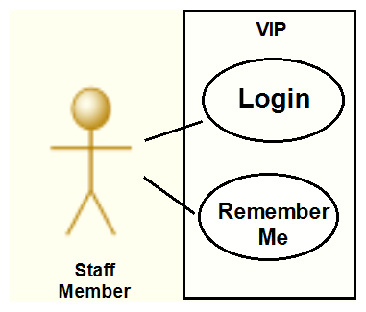

**Sequence Diagram**

**Test Case 1 (Sunny Day)**

**ID: VIP-SD-1146-01**

**Purpose**

* Ensure the checkbox are able to be checked and unchecked

Precondition

* User fills out the login information

Input

* User Clicks on the on the checkbox.

Expected Result

* User stay login for a period of 2 weeks

Actual Result

* Same as expected.

**User Guide:**

Step 1. User Navigates to User Login Form

Step 2. User Enters User Login Information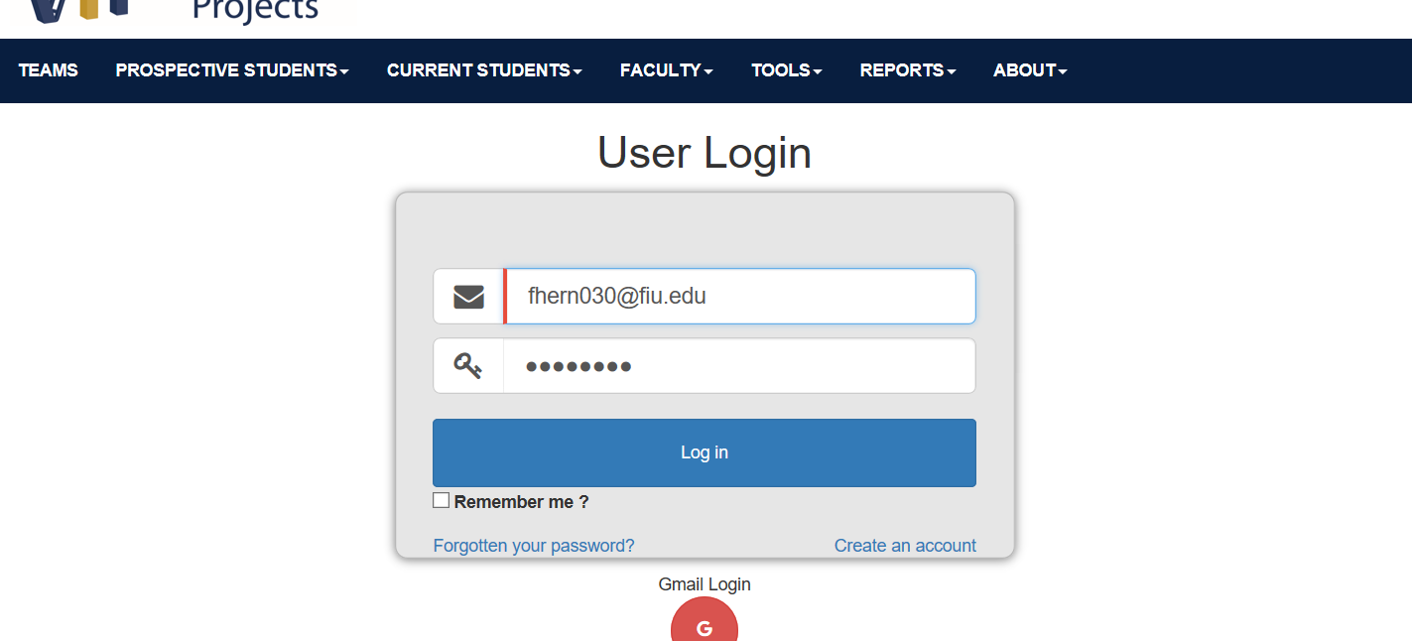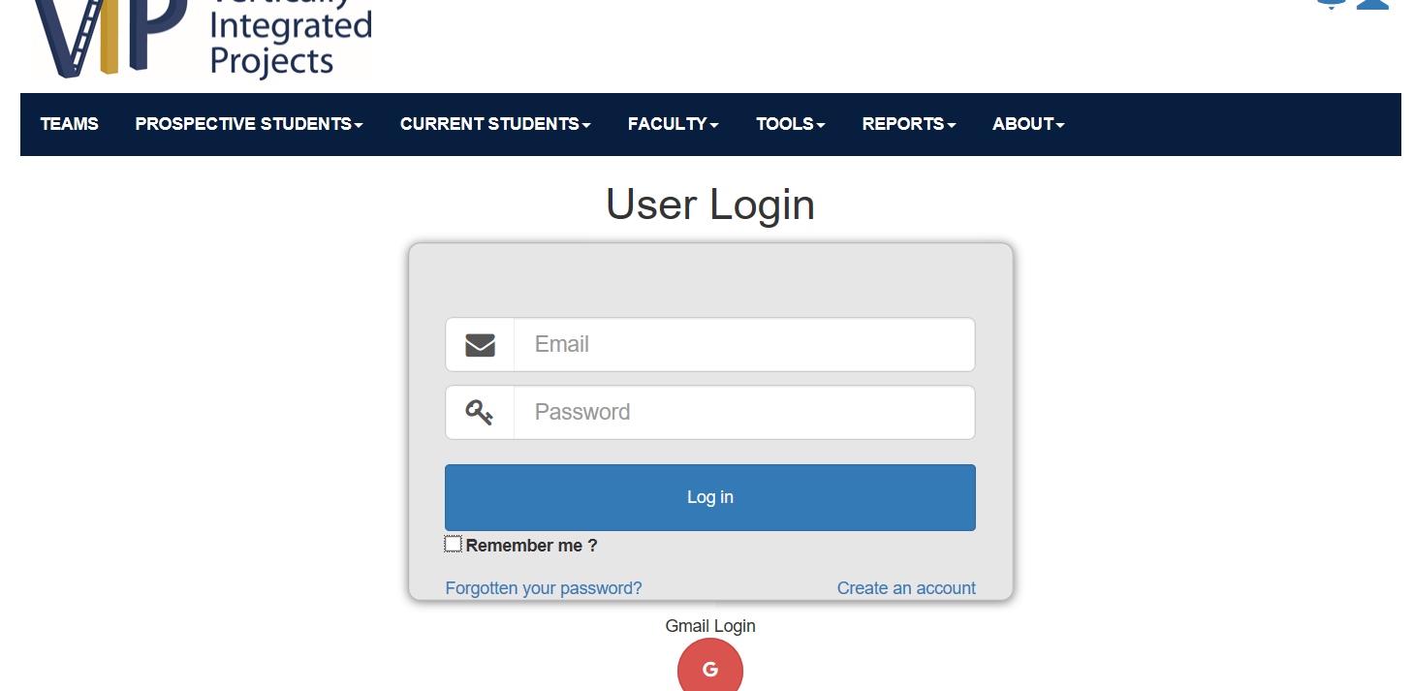



Step 3. User Check Remember_Me CheckBox

