*Florida International University*

*School of Computing and Information Sciences*

CIS 5011 Advanced Software Engineering

Feature Document

User Story #1172

# **Dividing the webpage into multiple sections and adding guideline videos**

Team Member:

Nandini Dandu

Product Owner(s):

Masoud Sadjadi

Mentor(s):

Mohsen Taheri

Instructor:

Masoud Sadjadi

**User Story**

·   
As an admin , I would like to divide the web page into sections, one for students and the other one for the faculty. Along with that I would like to add guideline videos, that would be helpful for the students and the faculty.

**Details:**  
Divide the login webpage into two sections and adding respective guideline videos to them.

Actor: Faculty, Student

**Pre-Condition:**

We have to consider the faculty and student. Both of them are on the login page.

**Description:**

1. The use case will begin when the student would be on the login page. The students just have to click on the Google Icon as they the FIU email is already linked to Gmail. They do not need to create an account. If the students do not know something they would watch the user guideline video which is next to the google icon.

2. For the faculty they would have to enter their username and password. Similarly the faculty have the guideline videos as how to go through the website.

**Post-Conditions:**

1. Students/ Faculty must be able to access the VIP website without any issues.

Alternative Course of Action:

N/A

Exceptions:

N/A

Related Use Cases:

N/A

**Use case Diagrams:**

Following are the use case diagrams for Student and Faculty respectively.

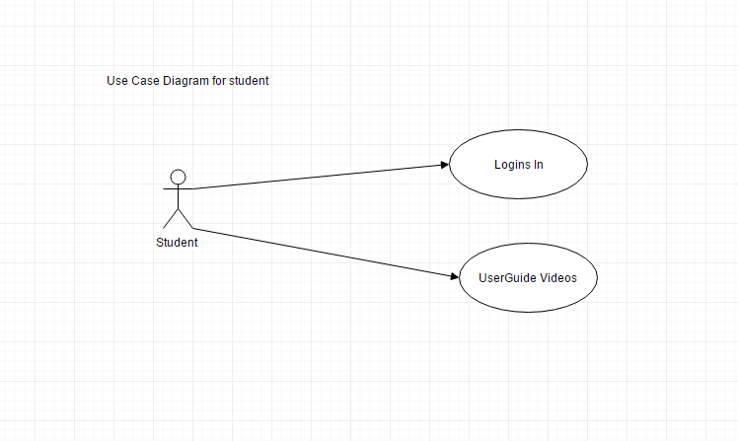

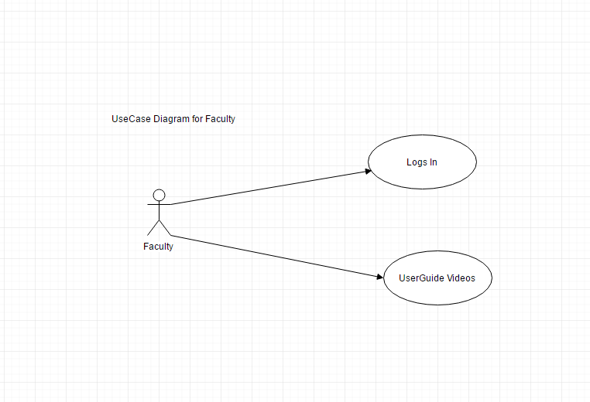

**Unit & Integration Tests:**

* **Test Case 1(Sunny Day)**

**Purpose**: To check if student/faculty are able to login without any issues.

## **Precondition**: Student/faculty are on the main login page.

## **Input**: Student has to click on the google icon to log into the

## website without entering username and password. The Faculty on

## the other hand should be giving the username and password.

## **Expected Result:** Student/Faculty should be able to log in into

## the website.

## **Actual Result:** The student will login by clicking on the icon and the faculty

## by entering the username and password. **Status:** SUCCESS

## 

## **Test Case 2(Rainy Day) Purpose**: To see if Student/Faculty are able to login the VIP website.

## **Precondition:** Student/faculty are on the main VIP login page.

## **Input:**Student clicks on the google icon and faculty enters the

## username and password.

## **Expected Result**: Student/ Faculty would not be able to login into

## the website. **Actual Result:** Student/faculty would not able to go past the login

## page. They would not have access to the website. **Status:** SUCCESS

# 

# **User Guide:**

Following are the visual guide pictures of the VIP website. The first one is the login page that has been divided into multiple sections for the login for students/Faculty. Along with the user guide videos that would help them if they have some issues.

