*Florida International University*

*School of Computing and Information Sciences*

CEN 5011- Advanced Software Engineering

Feature Document

User Story #1142

# **Add format to "PROJECT PROPOSAL FORM" 's team description**

**Team Member:**

Ravi Kiran Agarthi

**Product Owner(s)**:

Masoud Sadjadi

**Mentor(s)**:

Mohsen Taheri

**Instructor**: Masoud Sadjadi

# 

# 

# **User Story - Add format to "PROJECT PROPOSAL FORM" 's team description**

● As a user, I would like to view the description of project in the same format as the professor has entered so that it would be easy to understand.

## **Use Case**

**Use Case ID:** (VIP-1142)

**Details:** Add format to "PROJECT PROPOSAL FORM" 's team description

**Actor:** Faculty

**Pre-conditions:**

1. Faculty has navigated to the VIP website.

2. Faculty is browsing the VIP website as any user(student, Faculty, or admin) after logging in.

3. Faculty should see different projects in the website and also should view individual project by clicking on a project.

**Description:**

1. Use case begins when the User opens the vip website

2. The User may or may not sign in to the website

3. User should see all the projects in the Projects page with descriptions in good format.

4. If User clicks on any project then the project detail page will be with project description in the exact same format that has been entered during proposal of a project.

5. If Faculty wants to propose a project then he can select propose a project form and should find toolbar above the text area provided to enter description.

6. This format should be kept same throughout the website wherever it displays it.

**Post-conditions:**

1. Users should find description in the same format that has been entered during proposal of a project

2. Users should see the projects in the home page with good format

3.. Faculty can make use of tool bar above the project description box while proposing a project

**Alternative Courses of Action:**

N/A

**Exceptions:**

N/A

**Related Uses Case:**

N/A

**Use Case Diagram**

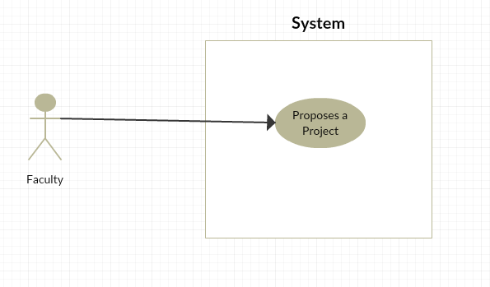

**Sequence Diagram**

N/A

**Class Diagram**

N/A

**Unit & Integration Tests:**

## **● Test Case 1(Sunny Day)** ○ Purpose: Test that the format of project description stays the same as professor entered in the proposal form in the Projects page and also in the project detail information.

## ○ Precondition:Faculty has reached the VIP site and reached project Proposal form.

## ○ Input: Faculty has to enter description in the form.

## ○ Expected Result: The format of the description should stay the same in the Projects page and stays the same even after clicking on a particular project. ○ Actual Result: The format of the description stays the same in the Projects page and stays the same even after clicking on a particular project. ○ Status: SUCCESS

## **● Test Case 2(Sunny Day)** ○ Purpose: Test that the toolbar in the project proposal form is working ○ Precondition:Faculty has reached the VIP site and reached project Proposal form.

## ○ Input: Faculty has to enter description in the form.

## ○ Expected Result: The description format can be changed with the help of toolbar options and can be saved ○ Actual Result: The description format is getting changed with the help of toolbar options and getting saved smoothly with no errors ○ Status: SUCCESS

## **● Test Case 1(Rainy Day)** ○ Purpose: Test that the format of project description stays the same as professor entered in the proposal form in the Projects page and also in the project detail information.

## ○ Precondition: Faculty has reached the VIP site and reached project Proposal form.

## ○ Input: Faculty didn’t enter the description and submitted the form

## ○ Expected Result: Popup message showing to enter the required fields. ○ Actual Result: sPopup message showing to enter the required fields. ○ Status: SUCCESS

## **Visual User Guide**

Project Proposal Form

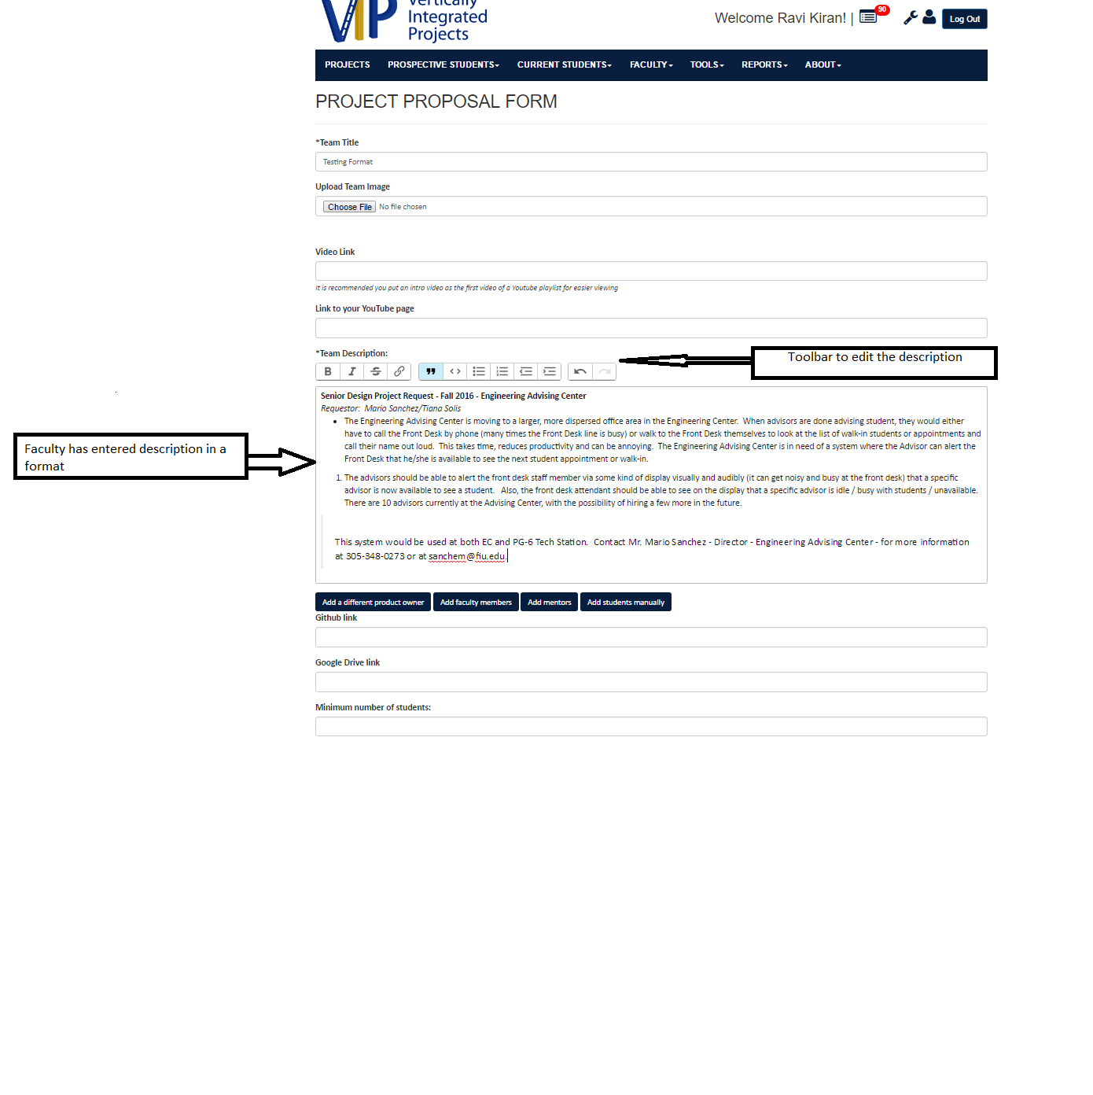

VIP Projects

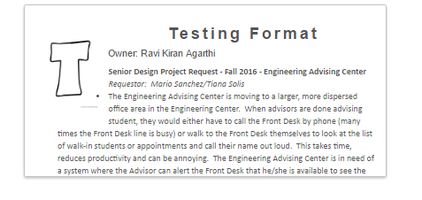

Vip Projects Detail view

