*Florida International University*

*School of Computing and Information Sciences*

CIS 4911 - Senior Capstone Project

Software Engineering Focus

Final Deliverable

Virtual Roll Call 1.0

Team # 18

**Team Members**

Peter Reidy

Frank Vincench

**Product Owner**: Jason Cohen

**Instructor**: Masoud Sadjadi

**Copyright and Trademark Notices**

All Virtual Roll Call specific logos and slogan material is copyright of Pinecrest P.D. All other materials developed for this project is available open source under MIT License.

***Abstract***

The first chapter includes an introduction, which will serve to explain the problem definition, the scope of the project, if any, terminology used and an overview of the rest of the document. Chapter two talks about the project plan which helps to define the project’s organization & work breakdown. The third chapter talks about system requirements and functional dependencies, as well as any models in the system. Finally, chapter four includes all of the different diagrams used to visualize the system.

**Table of Contents**

|  |  |
| --- | --- |
| **Chapter** | **Page** |
| **1. Introduction** | **5** |
| 1.1. Problem Definition | **5** |
| 1.2. Background | **5** |
| 1.3. Definitions | **6** |
| 1.4. Overview of document | **6** |
| **2. Feasibility Study** | **5** |
| 2.1 Description of Current System | **5** |
| 2.2. Proposed New System | **6** |
| 2.3. High-Level Definition of User Requirements | **6** |
| **3. User Stories** | **9** |
| 3.1 Implemented User Stories | **10** |
| 3.2 Pending User Stories | **11** |
| **4. Hardware and Software Resources** | **12** |
| **5. Architectural Patterns** | **15** |
| **6. System Diagrams** | **16** |
| **7. System Validation** | **19** |
| **8. UML Diagrams** | **28** |
| **8. User Interface Design** | **47** |
| **9. Sprint Review Reports** | **59** |
| **10. References** | **63** |

# Introduction

In this section we will discuss the current system and its flaws or weaknesses and how we plan to address these problems and increase the efficiency of the new system. We will talk about the proposed system and why the new system is needed.

This document will describe Virtual Roll Call and its different components. It will discuss its purpose and its possible future growth into a more advanced system as it expands to other police departments. Also, It will contain what is required for the system to be implemented and completed.

## 1.1 Problem Definition

The current system is inflexible, inefficient, and has many variables that may affect the outcome of success. The new proposed system will be more flexible, more efficient in terms of time, and hopefully leads to a better dissemination of information to officers. We will compare the new system and the old system using the old system’s shortcomings to come up with and define the requirements of the new system.

The old system was an in person meeting where an officer’s superior handed down orders, documents, and information down to the officers. The new proposed system will be a web based application that allows superior officers to hand down prior information about a specific task in progress efficiently.

## 

## 

## 1.2. Background

Traditionally the first 15 minutes of a police officer’s shift is spent at the station in a briefing room where the shift supervisor, commonly of sergeant rank, goes over a clipboard of information with the officers. This information ranges from internal department matters to crime trends, be on the look outs (BOLOs) as well as any other information that needs to be passed on to the officers at the commencement of their daily tour of duty.

## 1.3. Definitions

***Roll Call***- The first meeting of an officer’s day where a shift supervisor goes over information about the current and previous shift along with assignments.

***Virtual Roll Call*** - A Web system that aims to improve the organization and execution of Roll Calls by police officers.

***Document -*** A pdf or MP4 file that contains information that needs to be distributed.

***Task -*** The same as Document, Can be used interchangeably.

***Category -*** A subject that a document or task falls under.

***Shift -*** The timeslot that an officer would be working or patrolling.

# 2. Feasibility Study

## 2.1 Current System

In the current system all officers need to be present at the beginning of their shift to receive orders and requires the presence of the officers and a superior to actually be successful. But because it’s the beginning of the shift, there may be many factors that may prevent an officer from coming to the meeting on time, or even attending at all. Any member, supervisor or subordinate, not being present would result in a failure of the system, requiring special attention and extra resources. Reasons for missing the meeting may include Being stuck in traffic, attending a court case, having to respond to calls because of high call volume, or other things that may take the officer away from the meeting.

## 2.2 Purpose of New System

The name of the new proposed system is called Virtual Roll Call. The main idea of this system is to facilitate and improve the current way officers have access to the recorded information about a specific case/task that is assigned to them. It will improve the way information is transferred from one department to the other, and as a result improve and speed up the briefing to the working officers. With this new system, officers will also have access to information from a past date, for instance 14 days before. The information could be contained in regular text, scanned documents (PDF’s), word documents, Powerpoints, etc, and will be managed by the officer’s supervisor; in most cases it happens to be Sargeant. Officers will not be able to register themselves. Only a user type administrator will be able to register & delete officers as well as updating information such as name, last name, username, password, etc. They will also be able to monitor when an officer is reviewing the daily the information.

## 2.3. High-Level Definition of User Requirements

Requirements involve building a high-end web client based application. The web client will have access to information about the cases, and render the changes on the system. This web application will need to only be secure so that only police officers of the Pinecrest Village’s police department may access it. There will also need to be three levels of privilege in the system that are hierarchical where the highest level of privilege can perform the actions of any lower level. The UI should be simple and easy to use in a way that is intuitive to use so that little training is required to reach proficiency. Files need to be opened on the client computers in the Web Browser or the client’s native player.

# User Stories

Virtual Roll Call requires a series of user stories in order to complete its implementation.

These include the following:

Login Module:

* Password Encryption
* Forwarding users to their pages according to their credentials. (admins,supervisors,Officer)

Officer Module:

* Watch Orders
* Document Viewer
* Idle Logout
* Logging user activity

Administrator Module:

* Register Users
* Update Users information
* Remove Users
* Edit Archives
* Adding new categories
* Removing New categories
* View Logs
* View as lower type users(Officers, supervisors)
* Idle Logout

Supervisor Module

* Adding documents to categories.
* Pinning Tasks.
* View as Officers.
* Idle Logout.

## Implemented User Stories

**User Story # 0 – Login**

As a User or above, would like to log in so that I can have all personal details and orders associated with me available in a personalized view.

**User Story # 1 – Account Creation**

As an administrator, I would like to be able to create accounts, and if appropriate assign the accounts to supervisor users.

**User Story # 2 – Tabbed View**

As a user, I would like to view one topic of tasks at a time, so that I may have an organized view of all tasks that need to be completed by me.

**User Story # 4 – Pinning Tasks**

As a supervisor or administrator, I would like to be able to pin tasks so that users may view the tasks and the task will not be archived or removed until some supervisor or administrator removes the pinned task.

**User Story # 6 – Document/Task Assignment**

As an Administrator or Supervisor, I would like to assign tasks and distribute documents to my subordinates through a simple UI so that they may view the proper orders and tasks for the day.

**User Story # 8 – Tab/Folder Creation**

As an Administrator, I would like to create new types of tasks and hence new tabs So that the system may be expanded to deal with more types of tasks.

**User Story # 9 – User Monitoring**

As an administrator, I would like to be able to view if users are logging in and spending an appropriate amount of time viewing tasks so that I may take appropriate actions to either discipline or motivate the users to keep up to date on tasks.

**User Story # 10 – Account Modification**

As an administrator, I would like to be able to change account information such as access level, password, and other account details of the users, So that officers’ information can be kept up to date rather than creating a new account for every change.

**User Story # 7 – Preview Task Assignment**

As a supervisor or administrator, I would like to preview the view of tasks that have been given to a subordinate so that I may review them as correct.

**User Story # 3 – Task History**

As a user I would like to be able to view my history of tasks, so that if I have missed any time or days I may go back to catch up on my duties.

## 

## Pending User Stories

**User Story # 5 – Task Archiving**

As a user I would like old tasks to be archived, so that in the event that old records are needed, tasks for the day may be retrieved.

**User Story # 11 – Information Archiving/Deleting**

As an administrator, I would like to be able to archive or delete certain documents and or tasks so that Mistakes can be corrected or saved for future reference.

**User Story # 12 –Deleting New Categories**

As an administrator, I would like to be able to delete certain categories that are no longer used.

# 

# 

# Project Plan

The plan for this project is to improve the handling of information between officers during Roll calls. This includes a user friendly UI as well as well as three user level tiers to assigned system access.

## 4. Hardware and Software Resources

Software:

* Ubuntu 14.04 linux for development and testing of the site
* Apache2 as the web server because it is a proven web server and used in so many places that it has great support that can be easily found. It is also easy to work with.
* MySQL as the primary database for the application because we will need a relational database to store the data for the web app and MySQL is used in so many places and the driver support for it in PHP is good.
* Javascript, HTML, and CSS for web page development because they are the basics of any website.
* PHP 5.5+ for the main backend scripting language because as far as backend scripting languages, PHP is one of the most popular. It is easy to learn, easy to debug, reliable, and has many tools available to support development in it.
* AngularJS framework to provide a more interactive experience for users of the application. Angular will allow us to provide dynamic pages with dynamic content without refreshing entire pages.
* JQuery to catch specific events in javascript.
* Internet Explorer for testing because it is the main web browser used by the clients.
* Netbeans with the PHP plugin because netbeans is open source and code developed in netbeans will not run into any legal issues once put into production.
* PHPUnit5.0 and Facebook’s Selenium WebDriver Bindings for PHP, for automated testing of the website.

## Sprints Plan

For each sprint, list the user stories selected for implementation in descending order of priority.

### 

### Sprint 1

(08/31/2015- 09/11/2015)

**User Story # 0 - Login**

**Tasks**

* Design user table in Database for backend storage
* Create a login module to handle login specific tasks
* Add Login and account functionality to the database driver
* Create a session that reliably tracks a user is logged in
* Monitor sessions so that an account can only have one instance at a time

***Acceptance Criteria***

* Users can log in and be greeted by an appropriate page according to their access level
* Users can log out securely and remove session information easily.
* Users can only see the tasks that are targeted towards them.

**User Story # 1 - Account Creation**

***Tasks***

* Create a module That can handle the Controller and model tasks of an Administrator
* Create a form that takes in all the information in an easy to use format.
* Add operation to DBHandler to add a new entry to the database.

***Acceptance Criteria***

* List verifiable criteria for the acceptability of the implementation of this user story.

***Modeling***

Refer to UML diagrams in Appendix A that were created or modified to model the functionality that will be implemented in this sprint.

### Sprint 2

(09/14/2015- 09/25/2015)

**User Story # 2 - User Monitoring**

***Tasks***

* The collection of tasks in a sprint defines its scope, i.e., the product to be delivered at the end of the sprint.
* The collection of tasks of all sprints defines the scope of the system.

***Acceptance Criteria***

* List verifiable criteria for the acceptability of the implementation of this user story.
* …

***Sprint 3***

(09/28/2015 - 10/09/2015)

**User Story # X - Story Name**

***Tasks***

* List each task as a separate bullet point.
* The collection of tasks in a sprint defines its scope, i.e., the product to be delivered at the end of the sprint.
* The collection of tasks of all sprints defines the scope of the system.
* …

***Acceptance Criteria***

* List verifiable criteria for the acceptability of the implementation of this user story.
* …

***Modeling***

Refer to UML diagrams in Appendix A that were created or modified to model the functionality that will be implemented in this sprint.

**User Story # X - Story Name**

…

***Sprint 4***

(10/12/2015- 10/30/2015)

**User Story # X - Story Name**

***Tasks***

* List each task as a separate bullet point.
* The collection of tasks in a sprint defines its scope, i.e., the product to be delivered at the end of the sprint.
* The collection of tasks of all sprints defines the scope of the system.
* …

***Acceptance Criteria***

* List verifiable criteria for the acceptability of the implementation of this user story.
* …

***Modeling***

Refer to UML diagrams in Appendix A that were created or modified to model the functionality that will be implemented in this sprint.

**User Story # X - Story Name**

…

***Sprint 5***

(11/02/2015- 11/20/2015)

**User Story # X - Story Name**

***Tasks***

* List each task as a separate bullet point.
* The collection of tasks in a sprint defines its scope, i.e., the product to be delivered at the end of the sprint.
* The collection of tasks of all sprints defines the scope of the system.
* …

***Acceptance Criteria***

* List verifiable criteria for the acceptability of the implementation of this user story.
* …

***Modeling***

Refer to UML diagrams in Appendix A that were created or modified to model the functionality that will be implemented in this sprint.

**User Story # X - Story Name**

…

***Sprint 6***

(11/23/2015 - 12/04/2015)

**User Story # X - Story Name**

***Tasks***

* List each task as a separate bullet point.
* The collection of tasks in a sprint defines its scope, i.e., the product to be delivered at the end of the sprint.
* The collection of tasks of all sprints defines the scope of the system.
* …

* List verifiable criteria for the acceptability of the implementation of this user story.
* …

***Modeling***

Refer to UML diagrams in Appendix A that were created or modified to model the functionality that will be implemented in this sprint.

**User Story # X - Story Name**

…

***Modeling***

Refer to UML diagrams in Appendix A that were created or modified to model the functionality that will be implemented in this sprint.

***Modeling***

The sequence diagram for login can be viewed in the appendix as Figure 14.

# System Design

For architectural patterns we decided to go with the MVC architecture that is so common among websites and web applications because of its extensibility and decoupling of users and actual data.

Since the application uses the angular framework from javascript to manage all the client side requests, the Data design which is concerned with how the data is represented and stored within the system, is done through a series of http requests to php files that maintain and handle the connection between the client and server side of the system.

For example, when the supervisor uploads a document to the system, the filename is stored in the database by means of an http request to a php file who handles all the database operations. Then, the document is uploaded to the correct location. The actual file location is determined by the fields specified in the upload form used by the supervisor.

The Process Design which is concerned with how data moves through the system, is done through by means of controllers, who then have access to the database through other means. By establishing a link between the controller(s) and binding elements in an html page, we can achieve the interaction we need to run the system.

## Architectural Patterns

The main architectural pattern that this system will be implementing is the Model-View-Controller pattern, which is a very common pattern among web applications in this day and age. Another architectural patterns we will be using is the 3 tier architecture, to separate application logic, a data layer, and the user interface from each other, and each will logically exist in its own subsystem.

## System and Subsystem Decomposition

Using a UML package diagram, illustrate the major subsystems that make up your system. Include the major components of the subsystems along with the dependencies among subsystems as well as among their components.

Briefly describe the functionality provided by each subsystem.

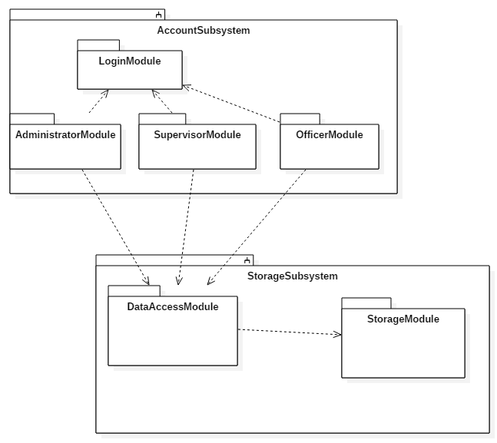

**Figure 1. - Subsystem Diagram**

## Deployment Diagram

Using a UML deployment diagram, illustrate which subsystems will reside on each hardware component and show how the different pieces are connected.

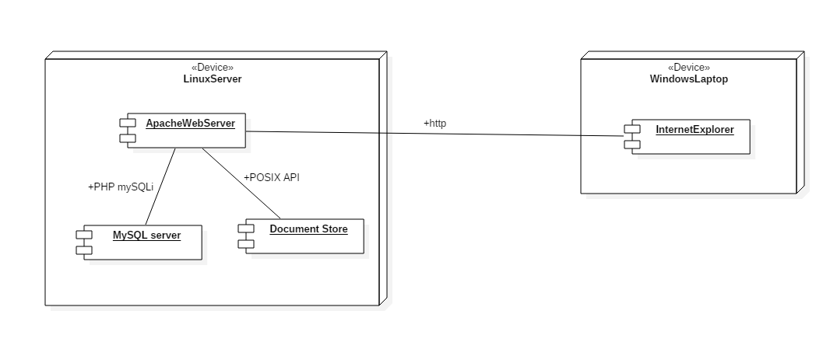

**Figure 2 - Deployment Diagram**

## Design Patterns

Singleton pattern was used for the data access subsystem where we will only have one connection to the database being accessed by multiple web connections. This pattern was chosen because when accessing data doing so in a serial manner rather than concurrent saves trouble of failure to get database write locks, increasing number of connections and therefore increasing network traffic to the database, and makes it easier to modify behavior and maintain the database driver behavior.

We used the factory pattern because when using MVC an independent controller is created and given to a specific session, and because controllers are tightly integrated with the angular framework, they are rather complicated structures which would be better be handled by a dedicated constructor and then the instances handed out to the specific sessions.

We chose the Publish Subscribe pattern because the nature of the website is similar to a content distribution site, where we will have 4 streams of content, one for each shift and another for all shifts. Publish subscribe goes with this.

# System Validation

Provide a one- or two-paragraph overview of this section. You can think of this introductory paragraph as a kind of abstract specific to this section.

**User Story # 1 - Login**

System Tests

* Test ID 1 - Logged in from an administrator account
* Test ID 2 - Logged in from a supervisor account
* Test ID 3 - Logged in from an officer account
* Test ID 4 - Attempted to login with invalid password
* Test ID 5 - Attempt to inject SQL through the username field

|  |  |
| --- | --- |
| Purpose | Test Login from Administrator account |
| Setup | Navigated to landing page, not logged in |
| Test Data | Username: Frank  Password: frank   * data input into the login fields, logged into the administrator view correctly |
| Notes | simple login passes |

|  |  |
| --- | --- |
| Purpose | Test Login from Supervisor account |
| Setup | Navigated to landing page, not logged in |
| Test Data | Username: Jason  Password: jason   * data input into the login fields, logged into the administrator view correctly |
| Notes | simple supervisor login passes |

|  |  |
| --- | --- |
| Purpose | Test Login from Officer account |
| Setup | Navigated to landing page, not logged in |
| Test Data | Username: Peter  Password: peter   * data input into the login fields, logged into the administrator view correctly |
| Notes | simple login to officer lands at officer home page.  With all login tests, need to put in explicit wait between text switch |

|  |  |
| --- | --- |
| Purpose | Test False Credentials to a real account |
| Setup | Navigated to landing Page, not logged in |
| Test Data | Username: Peter  Password: password   * data input into the login fields should show an error message stating invalid credentials |
| Notes |  |

|  |  |
| --- | --- |
| Purpose | Test the cleaning of inputs |
| Setup | Navigated to landing page, not logged in |
| Test Data | Username: IF(1 or True) drop * from users  Password:peter |
| Notes | * dangerous if unsure about security of input |

Subsystem Tests

* Test ID - Brief statement of the test purpose.
* …

**User Story # 2 - Account Creation**

* Test ID 6 - Create User With another user credentials
* Test ID 7 - Create User With invalid Fields
* Test ID 8 - Create User, Then login with user to ensure proper data was saved

|  |  |
| --- | --- |
| Purpose | Create an account with another users credentials |
| Setup | Logged in as an administrator |
| Test Data | Last Name: Frank  First Name: Vinc  username: Frank  password: frank  type of officer: Supervisor  officer Shift: B |
| Notes | Expected Failure due to the username frank already taken |

|  |  |
| --- | --- |
| Purpose | Create an account with invalid fields(one may be empty) |
| Setup | Logged in as an administrator |
| Test Data | Last Name: Frank  First Name: “”  username: Frank  password: frank  type of officer: Supervisor  officer Shift: B |
| Notes | Expected Failure due to the inability to create user without proper information |

|  |  |
| --- | --- |
| Purpose | Create an account Properly |
| Setup | Logged in as an administrator |
| Test Data | Last Name: Doe  First Name: Jane  username: Jane  password: jane  type of officer: Supervisor  officer Shift: B |
| Notes | Expected success due to new username  should delete the User In tear down of test |

**User Story # 3 Tabbed View**

* Test ID 9 - Click on different tabs to be shown different views
* Test ID 10 - Create new Tab, click on tab to view new subject
* Test ID 11 - Create new Tab, add Task to new tab, then view as an officer

|  |  |
| --- | --- |
| Purpose | Ensure the dynamic generation of the views are unique |
| Set up | Logged into an officer account |
| Test Data | The default categories that come with VRC |
| Notes | * When visiting the different views, they should have different tasks/documents |

|  |  |
| --- | --- |
| Purpose | Create a new Tab and make sure it is viewable |
| Set Up | Logged into an officer account |
| Test Data | The default categories that come with vrc  new Category: Squad Cars  samplePdf = sample.pdf |
| Notes | After the new category is created, it should be deleted from the database |

|  |  |
| --- | --- |
| Purpose | Ensure tasks are only visible by the correct shift |
| Set up | None |
| Test Data | sample.pdf - file to be uploaded  o |
| Notes | As an admin, Frank should upload the pdf to the shift of officer Peter, and also to the shift of not peter in another category, checks both categories should be a sunny day case where expected results of shown and not shown are true. |

**User Story # 4 Task History**

* Test ID 12 - Create a Task attempt to view tasks from before timeframe

|  |  |
| --- | --- |
| Purpose | To have a rainy day case for the task history use case |
| Set Up | Logged in as an officer |
| Test Data | oldSample.pdf |
| Notes | The test will have the user login to an officer account and attempt to view the oldSample.pdf, but it should not be shown because it is too old. |

|  |  |
| --- | --- |
| Purpose | To have a sunny day case where the new tasks are perfectly shown |
| Set Up | Logged in as an officer |
| Test Data | sample.pdf |
| Notes | The test will have the user login to an officer account and choose the category with the sample.pdf, and it should be there, and viewable through the pdf viewer |

* Test ID 13 - View tasks that have not been archived. Verify Date is not past archival time period

**User Story # 5 Pinning Task**

* Test ID 14 - Pin a task, then view that task is pinned to the top
* Test ID 15 - Pin a task that has already been pinned, expect error

|  |  |
| --- | --- |
| Purpose | Sunny day case for pin task use case |
| Set Up | Logged in as a supervisor |
| Test Data | DocumentId: 3 (docId to pin, leads to sample.pdf) |
| Notes | When the task is pinned, the user will click to view as an officer and it should be displayed above the rest of the tasks, before the rest of the non-pinned tasks are displayed |

|  |  |
| --- | --- |
| Purpose | Rainy Day for Pin task use case |
| Set Up | Logged in as a supervisor |
| Test Data | DocumentId: 3 |
| Notes | When the user attempts to add the document, a modal display should come up saying that the document is already pinned. |

**User Story # 6 Task Archiving**

* Test ID 16 - Post a task that is past the archival date, should not be displayed
* Test ID 17 - Post an old task, that is not past the archival date, should be displayed
* Test ID 18 - Pin an older task, should be displayed

|  |  |
| --- | --- |
| Purpose | Sunny day case for pin task use case |
| Set Up | Logged in as a supervisor |
| Test Data | DocumentId: 3 (docId to pin, leads to sample.pdf) |
| Notes | When the task is pinned, the user will click to view as an officer and it should be displayed above the rest of the tasks, before the rest of the non-pinned tasks are displayed |

|  |  |
| --- | --- |
| Purpose | Sunny day case for pin task use case |
| Set Up | Logged in as a supervisor |
| Test Data | DocumentId: 3 (docId to pin, leads to sample.pdf) |
| Notes | When the task is pinned, the user will click to view as an officer and it should be displayed above the rest of the tasks, before the rest of the non-pinned tasks are displayed |

|  |  |
| --- | --- |
| Purpose | Sunny day case for pin task use case |
| Set Up | Logged in as a supervisor |
| Test Data | DocumentId: 3 (docId to pin, leads to sample.pdf) |
| Notes | When the task is pinned, the user will click to view as an officer and it should be displayed above the rest of the tasks, before the rest of the non-pinned tasks are displayed |

**User Story # 7 - User Monitoring**

* Test ID 19 - Login as an officer, Also login as an administrator, view logged in status
* Test ID 20 - Login as an officer, log out, then log in as an administrator, view that officer is logged out
* Test ID 21 - Log in as an administrator, And view total times that an officer has been active.

|  |  |
| --- | --- |
| Purpose | Sunny day case for User Monitoring use case |
| Set Up | Logged in as a supervisor |
| Test Data | DocumentId: 3 (docId to pin, leads to sample.pdf) |
| Notes | When the task is pinned, the user will click to view as an officer and it should be displayed above the rest of the tasks, before the rest of the non-pinned tasks are displayed |

|  |  |
| --- | --- |
| Purpose | Sunny day case for user Monitoring use case |
| Set Up | Logged in as a supervisor |
| Test Data | DocumentId: 3 (docId to pin, leads to sample.pdf) |
| Notes | When the task is pinned, the user will click to view as an officer and it should be displayed above the rest of the tasks, before the rest of the non-pinned tasks are displayed |

|  |  |
| --- | --- |
| Purpose | Sunny day case for pin task use case |
| Set Up | Logged in as a supervisor |
| Test Data | DocumentId: 3 (docId to pin, leads to sample.pdf) |
| Notes | When the task is pinned, the user will click to view as an officer and it should be displayed above the rest of the tasks, before the rest of the non-pinned tasks are displayed |

# 

# 

# 

# 

# 

# Glossary

VRC: Virtual Roll Call- System used by officers to provide them with information about their tasks for the day and the information collected so far on the case(s).

# Appendix

## Appendix A - UML Diagrams

### Static UML Diagrams

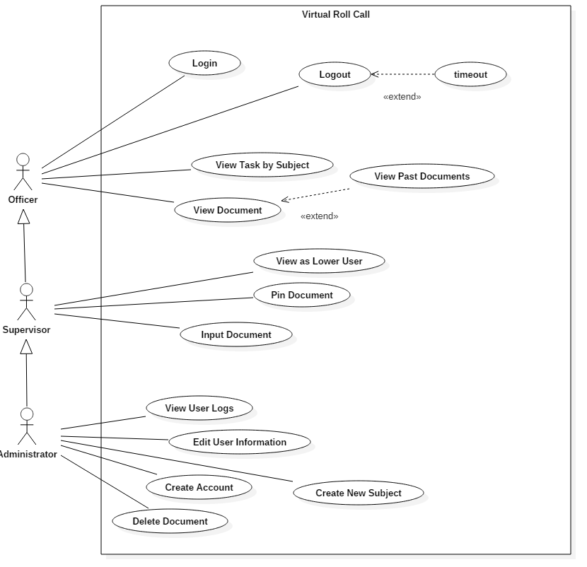

**Figure # 3 Use Case Diagram**

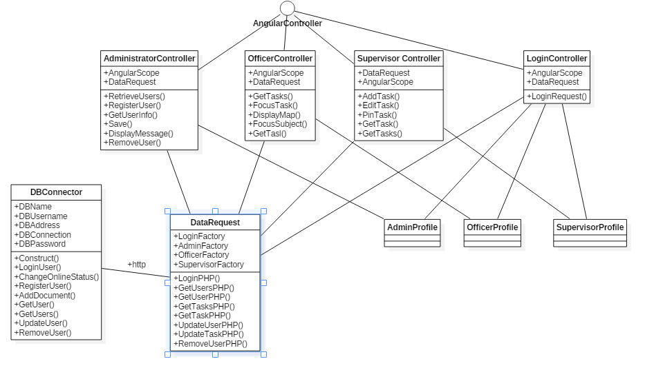

**Figure 4. Class Diagram**

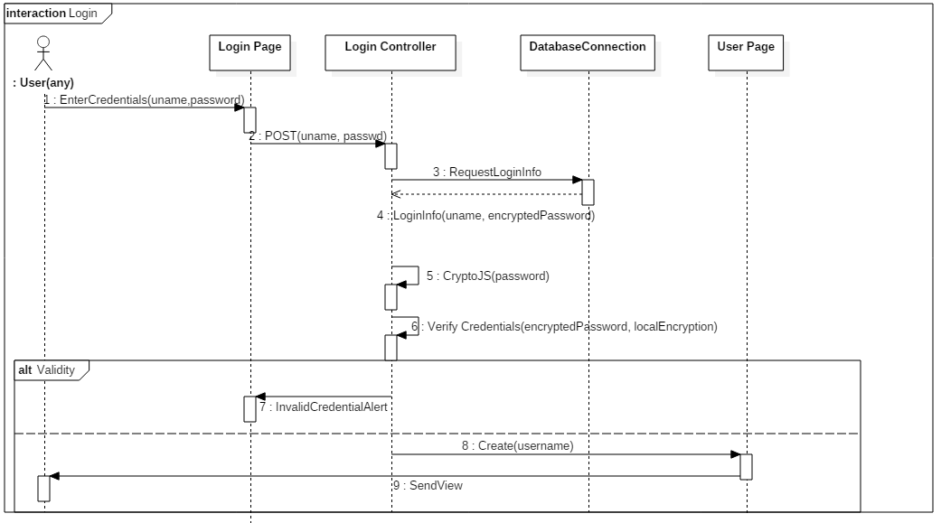

**Figure 5. Login User Story Sequence Diagram**

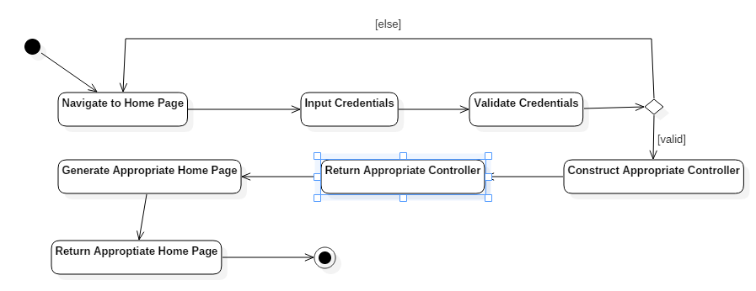

**Figure 6. Login Activity Diagram**

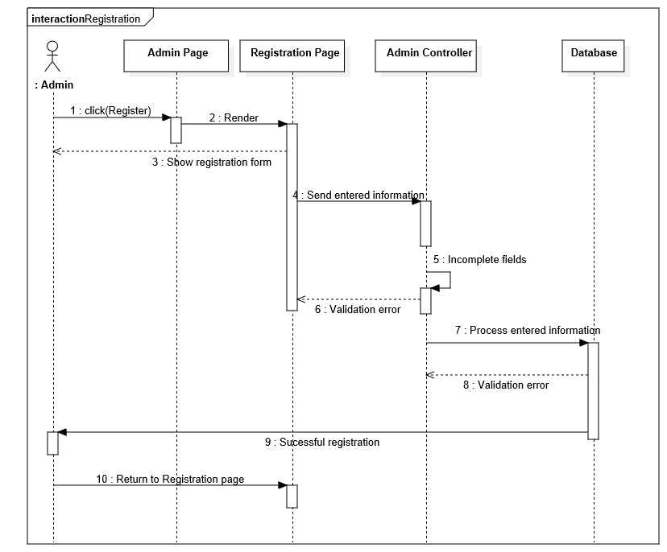

**Figure 7. Registration Sequence Diagram**

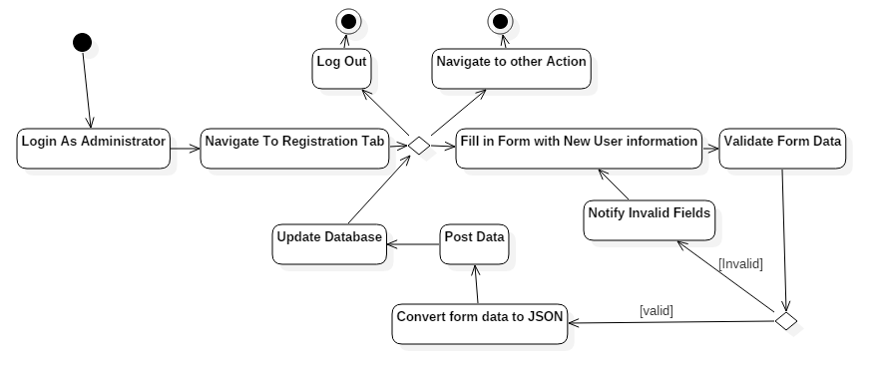

**Figure 8. Registration Activity Diagram**

## 

**Figure 9. Registered Users List Sequence Diagram**

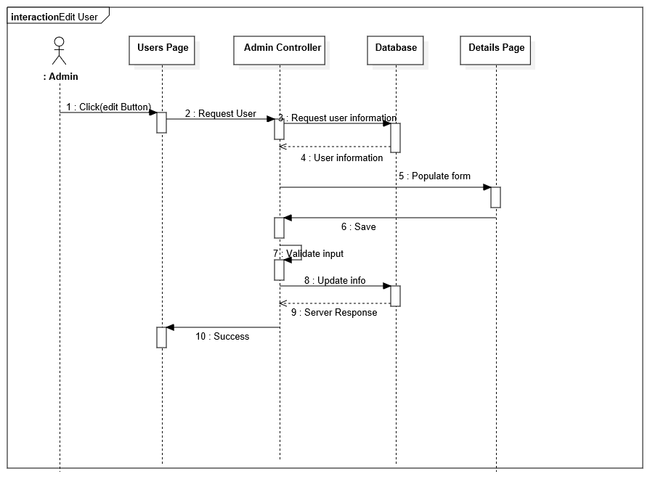

**Figure 10. Update user Information Sequence Diagram**

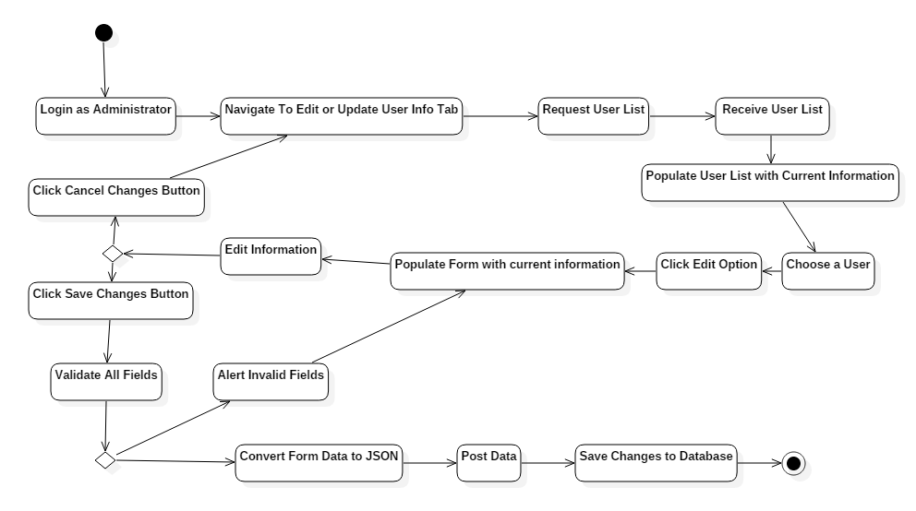

**Figure 12. Update/Edit User Information Activity Diagram**

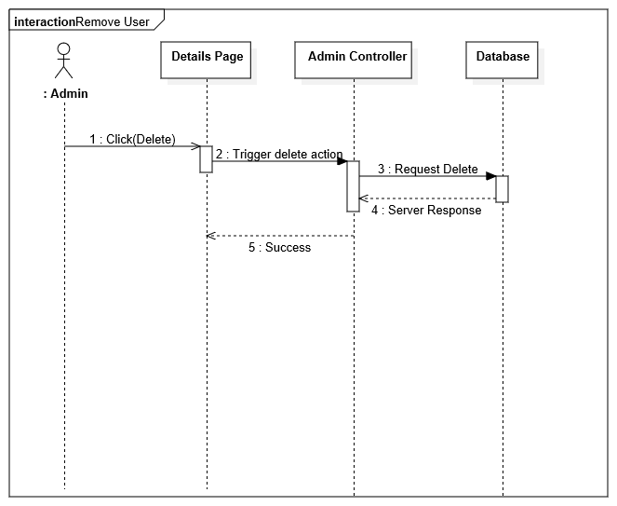

**Figure 13. Delete User Sequence Diagram**

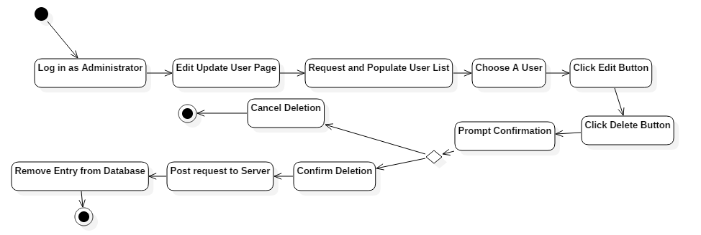

**Figure 14. Delete User Activity Diagram**

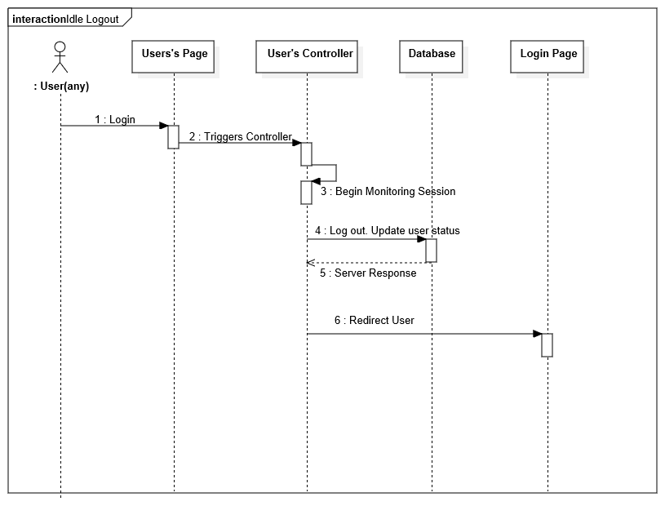

**Figure 15. Idle User Sequence Diagram**

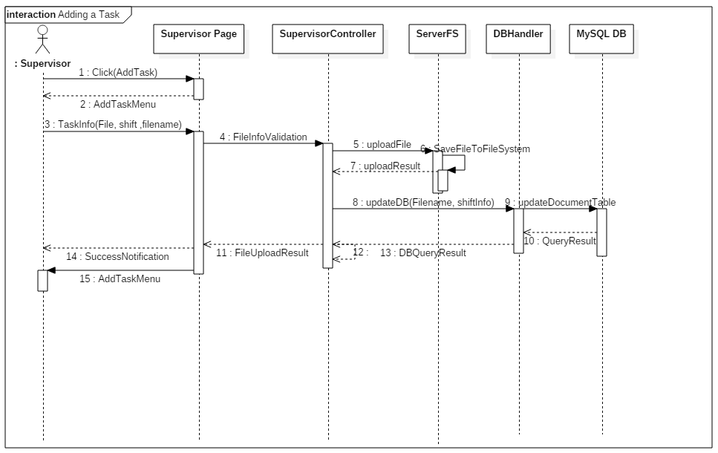

**Figure 16. Add Task Sequence Diagram**

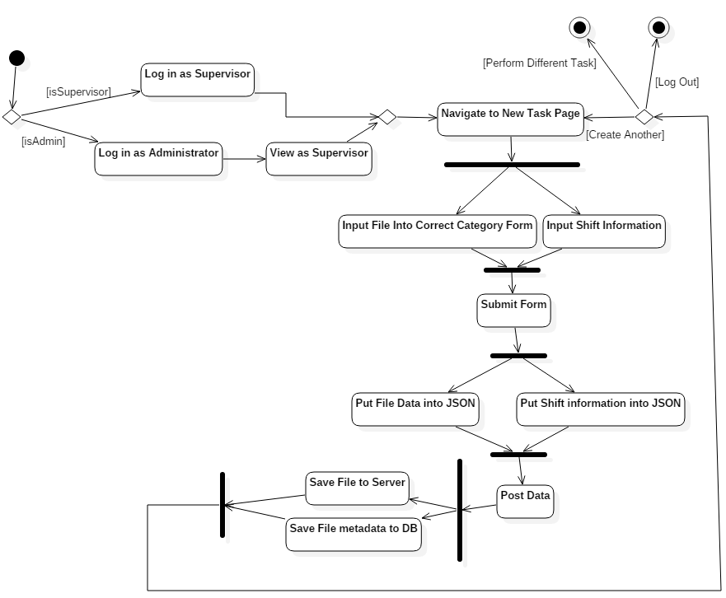

**Figure 17. Task Creation Activity Diagram**

## 

## 

## Figure 18. Document categories

## 

## 

## 

## Figure 19. Documents retrieval.

## 

**Figure 20. View Assigned Tasks Activity**

## 

## 

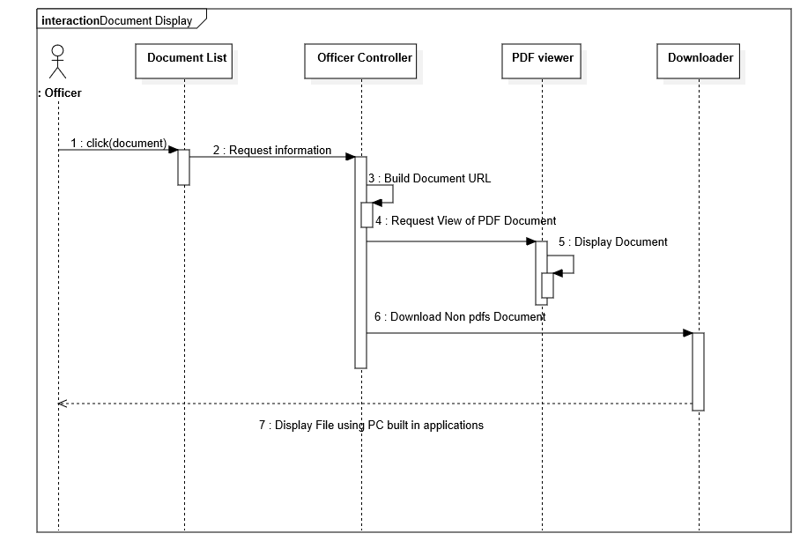

**Figure 21. Display Document Sequence Diagram**

## 

## Figure 22. Add New Categories

## 

## 

## 

## 

## 

## 

## 

## 

## Figure 23. Watch Orders

## 

## 

## 

## 

## 

## 

## 

## 

## 

**Figure 24. View Logs**

## 

## 

## 

## 

**Figure 25. Log Activity**

## Appendix B - User Interface Design

**Figure 26 - Login user interface**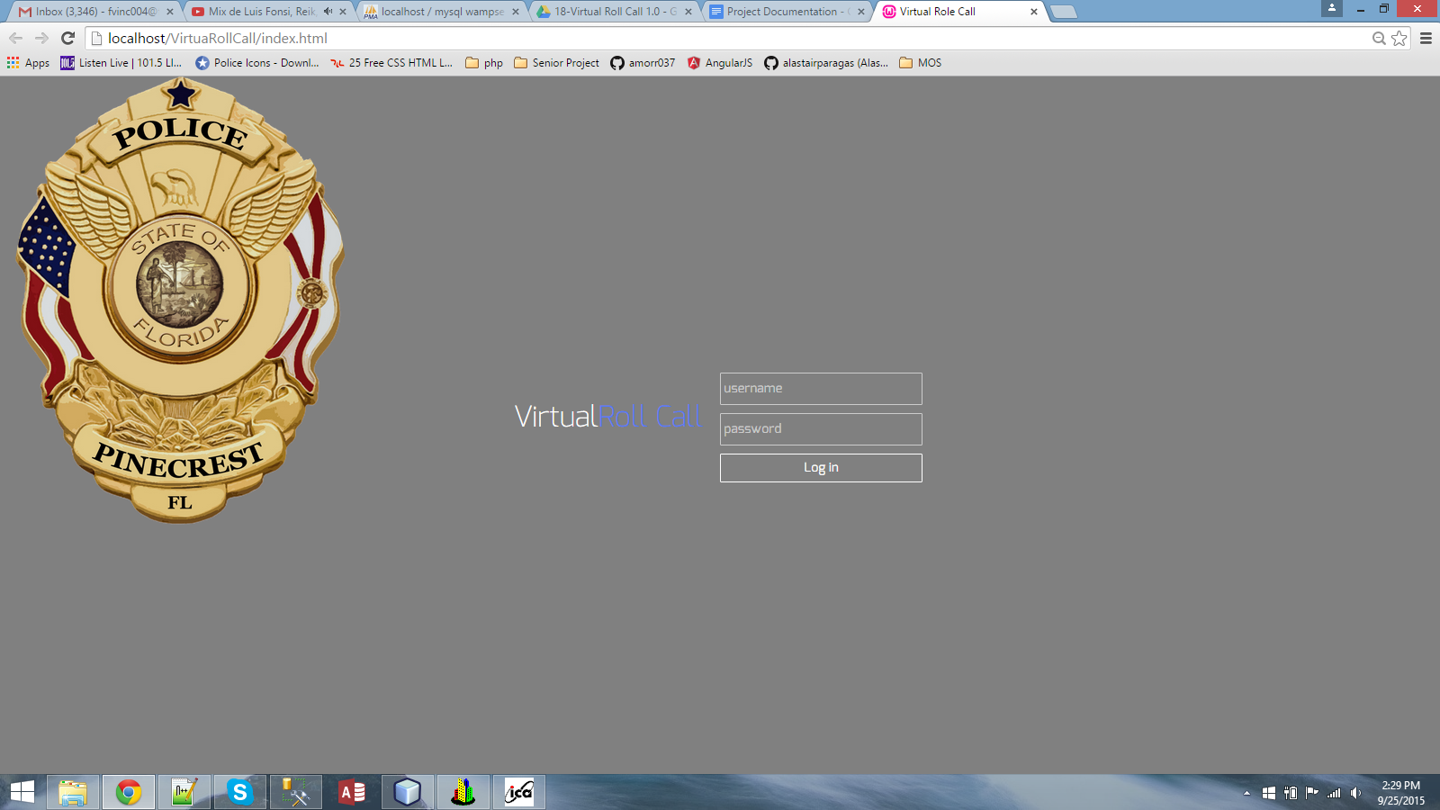

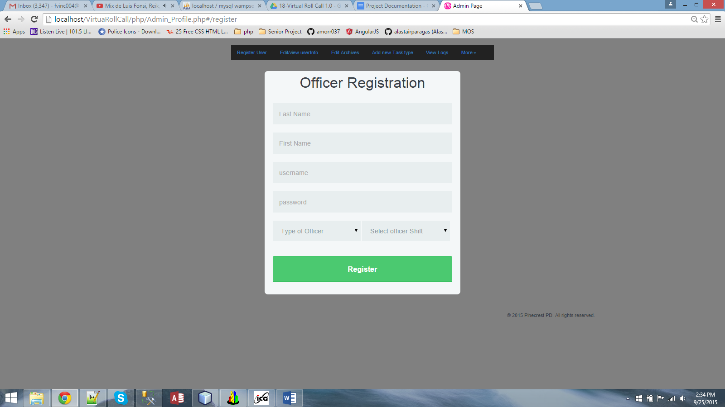

**Figure 27 - Registration**

## 

## 

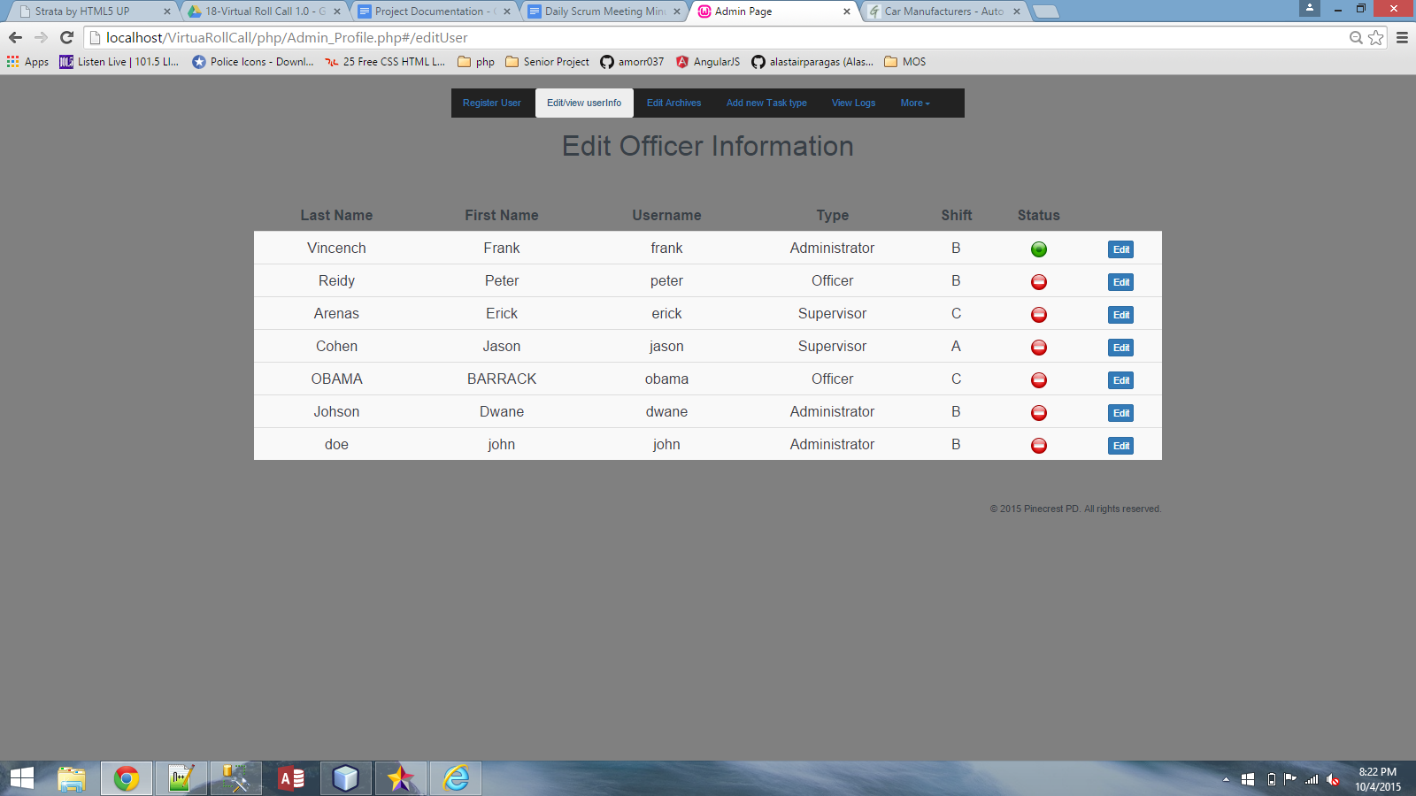

## Figure 28- Registered Users List

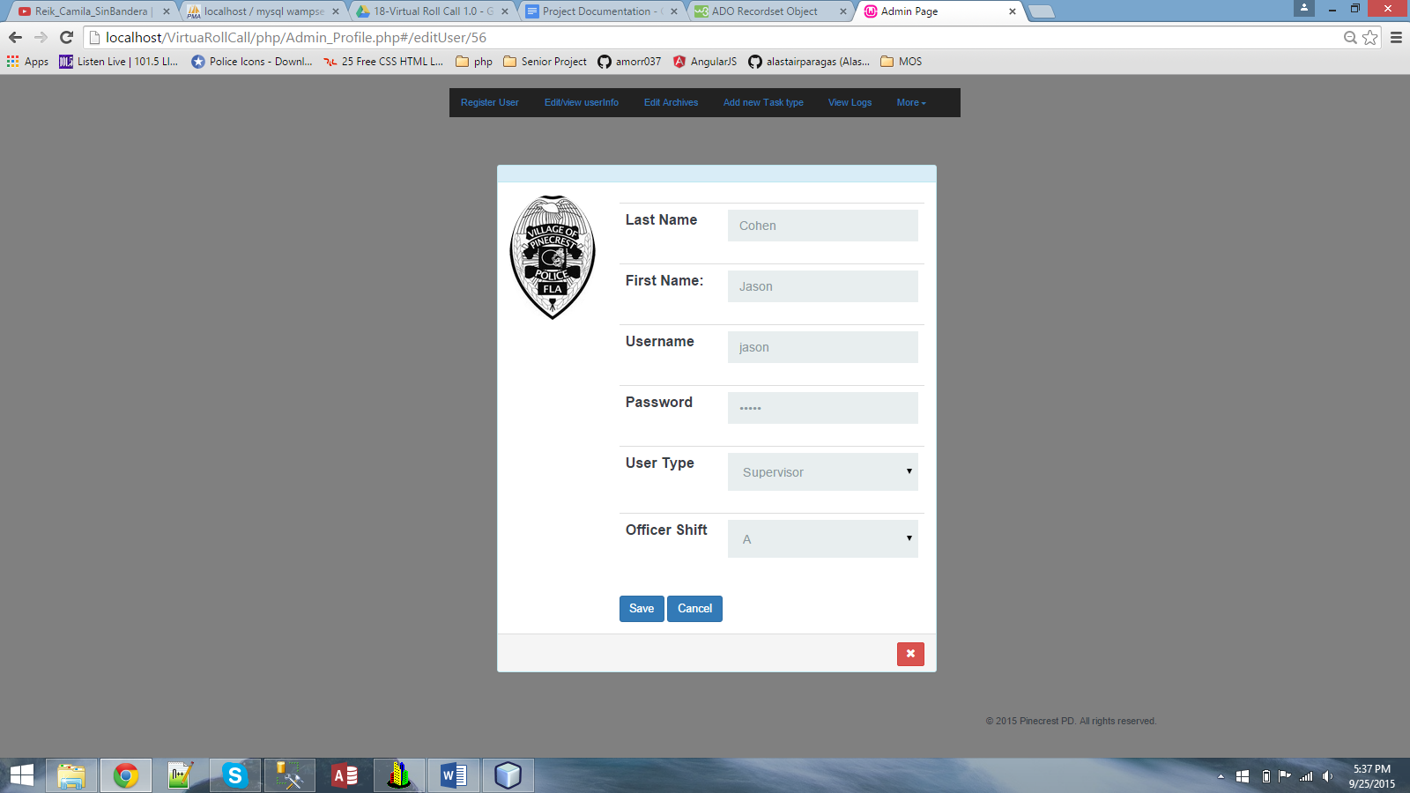

## Figure 29. Editing User Information

## 

## 

## 

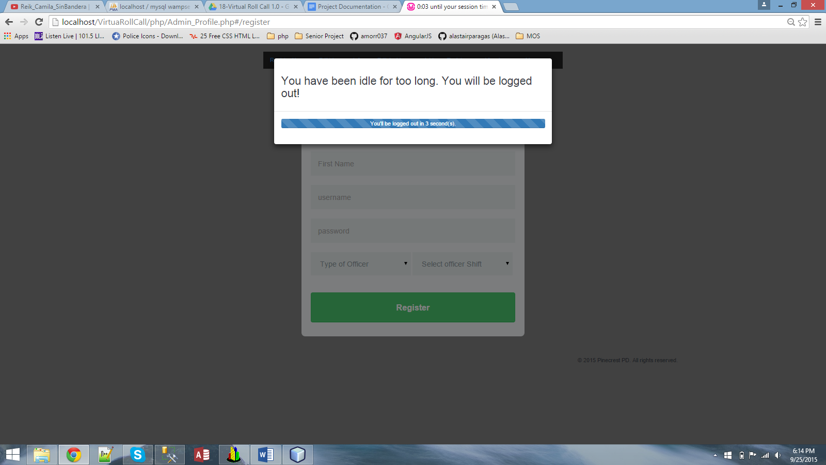

## Figure 30 . Idle Timeout

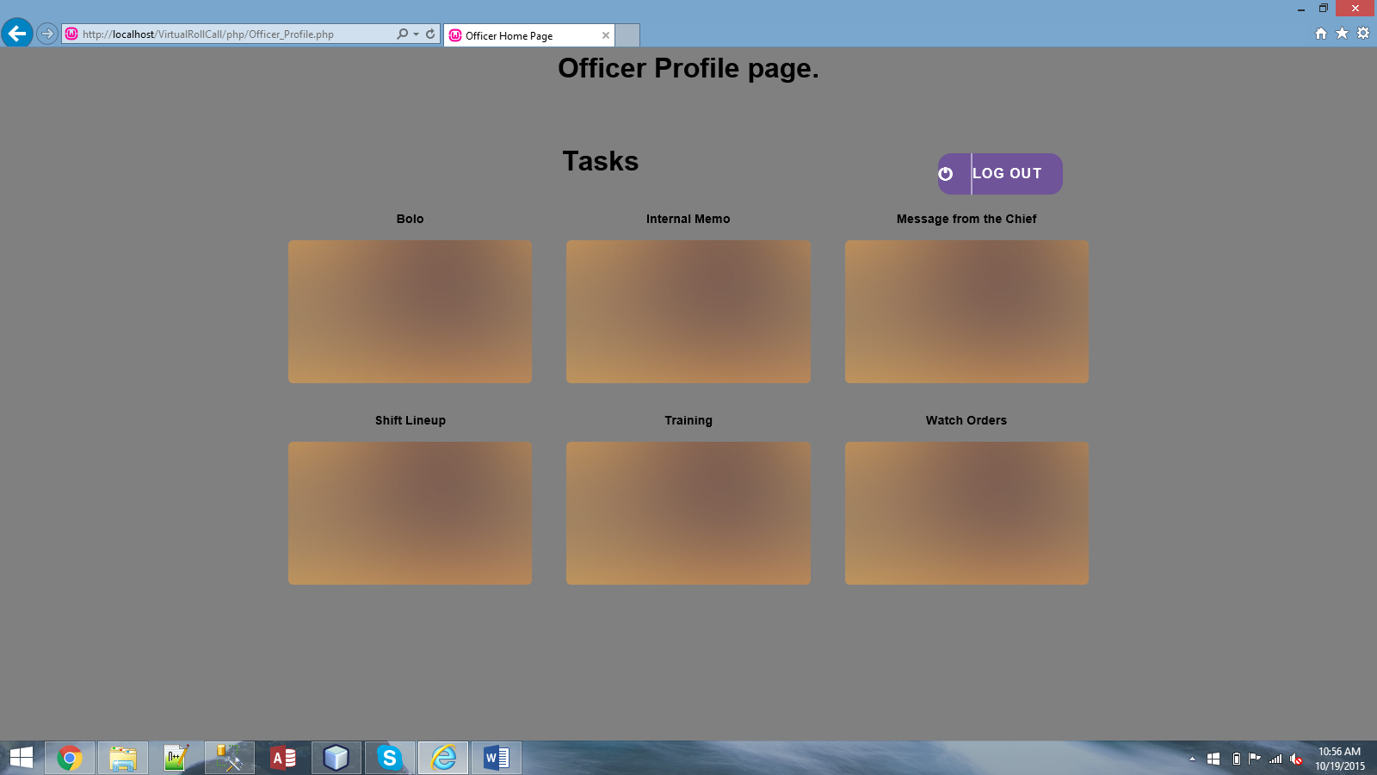

**Figure 31. Categories.**

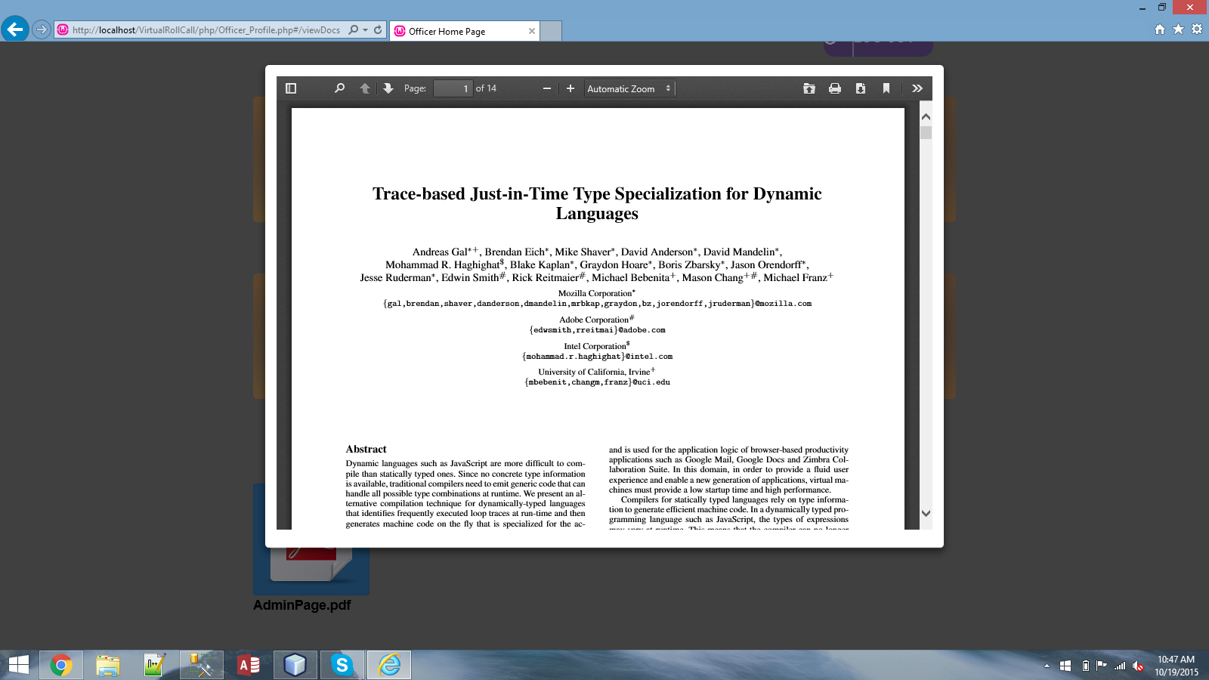

**Figure 32. PDf Document Viewer**

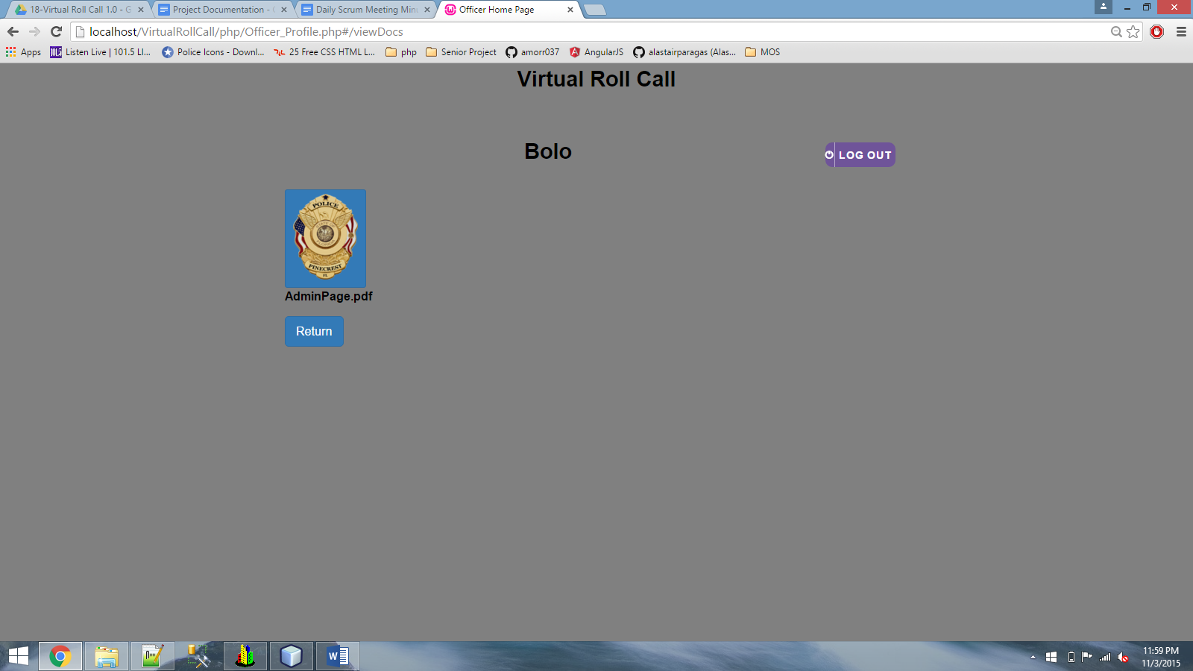

**Figure 33. Document List**

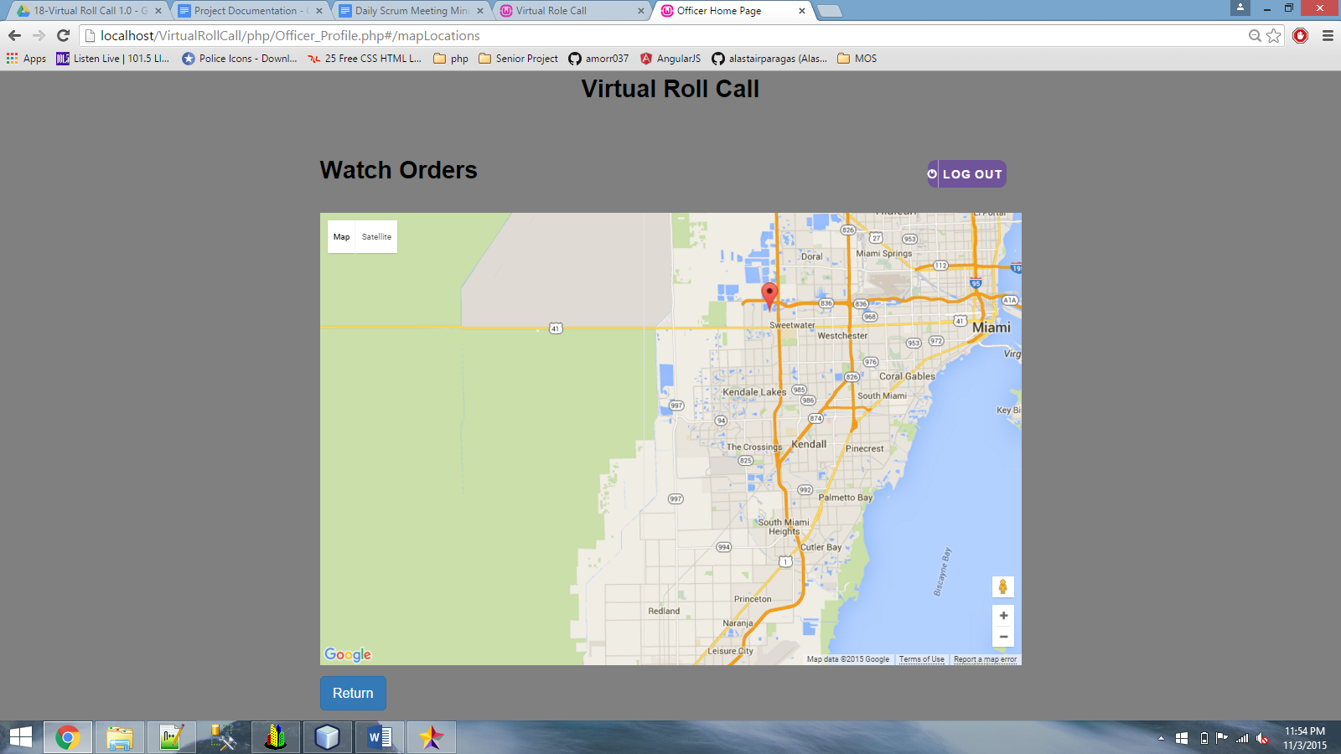

**Figure 34. Watch Orders**

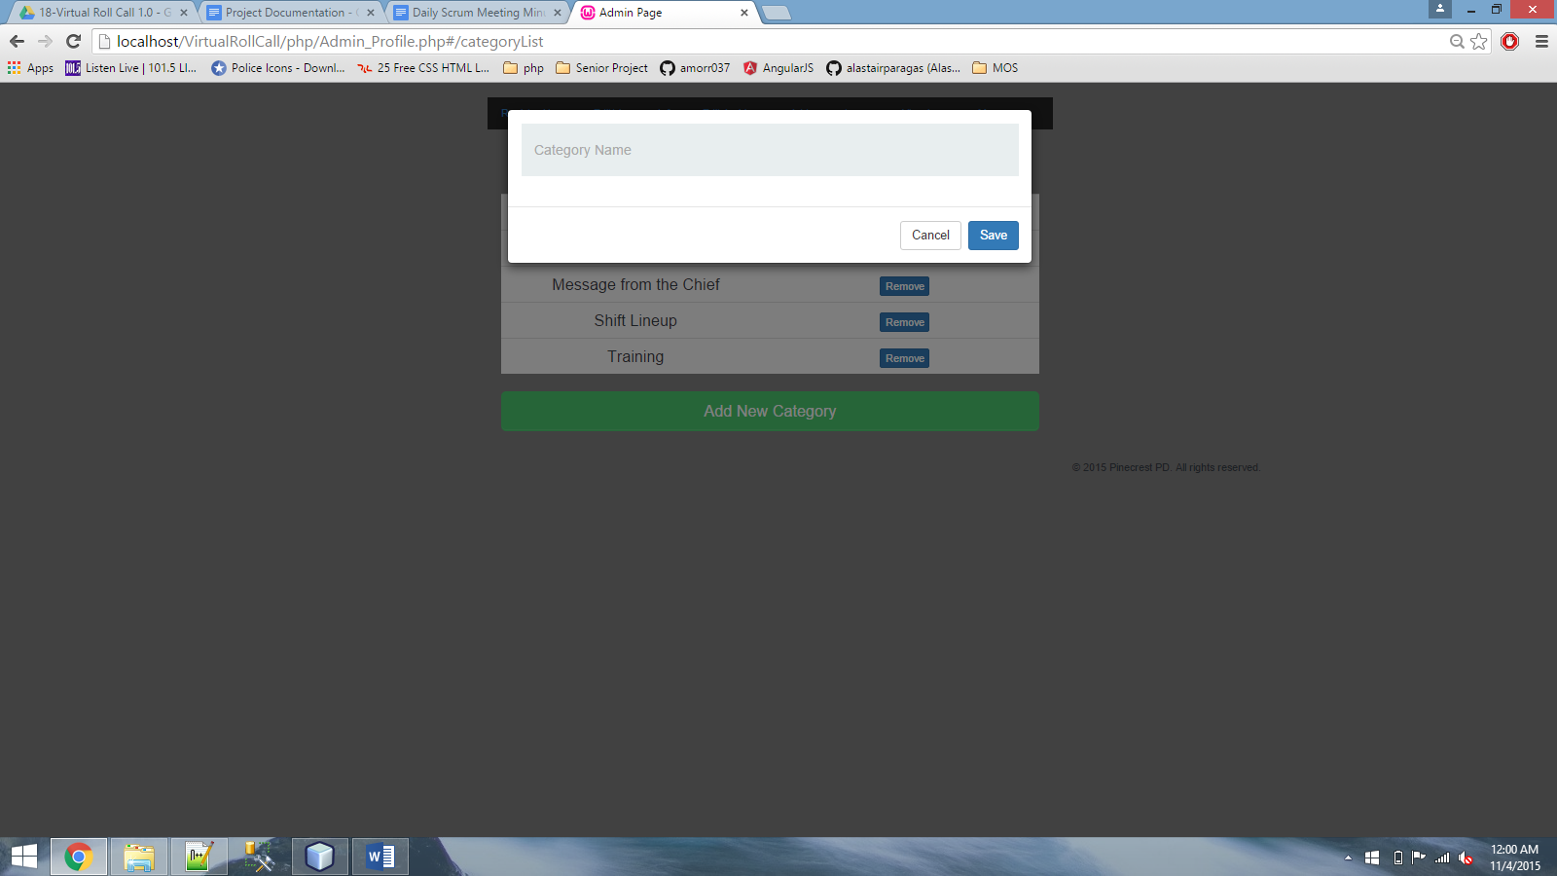

**Figure 35. Add New Category**

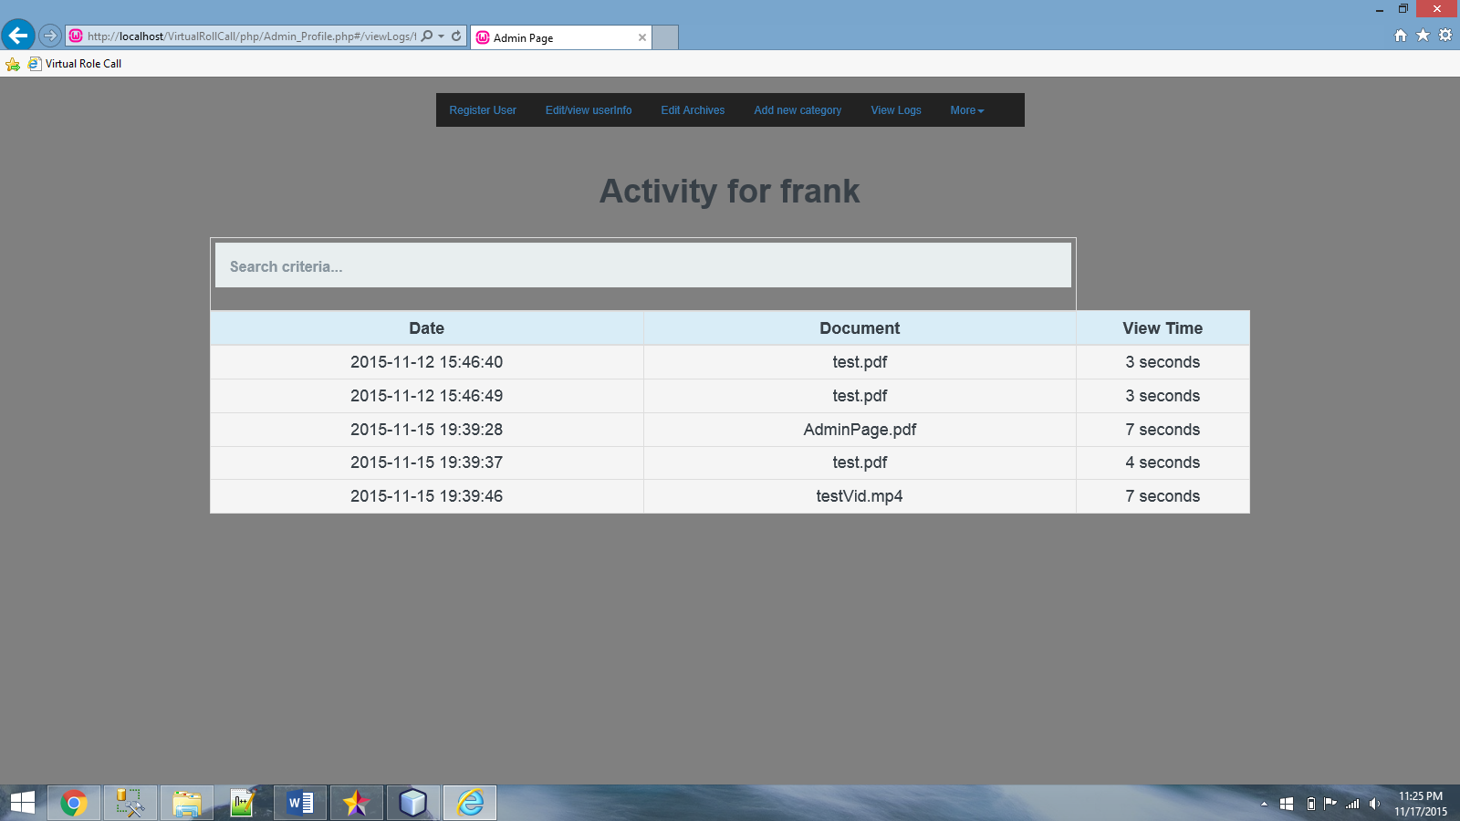

**Figure 36. Viewing Logs**

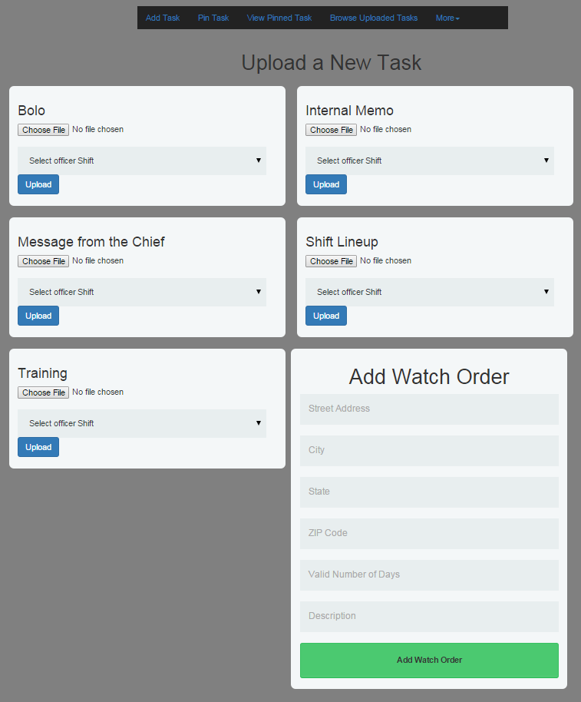

**Figure 37. Upload task UI**

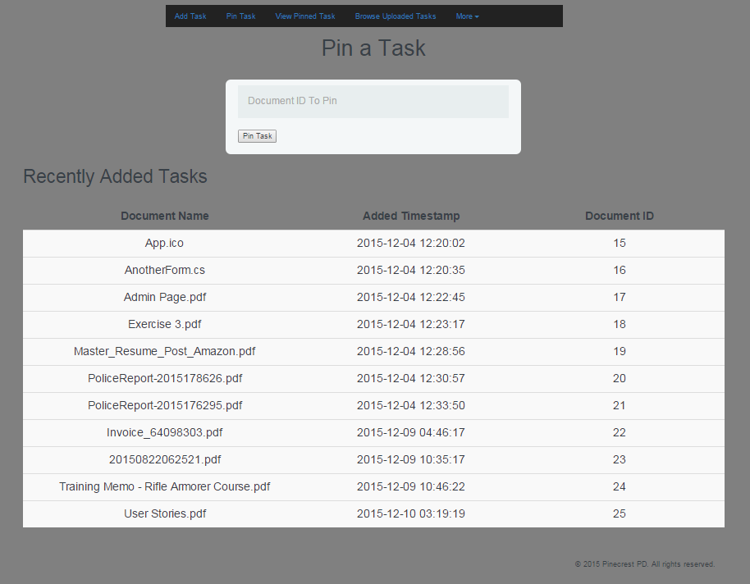

**Figure 38. Pin a task UI**

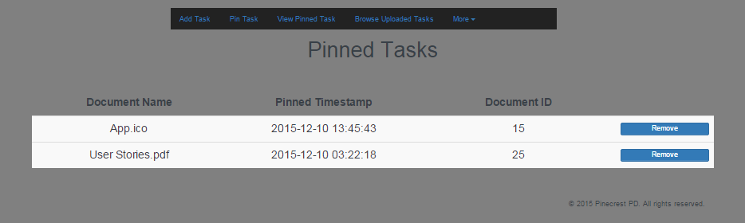

**Figure 39. Viewing Pinned Tasks**

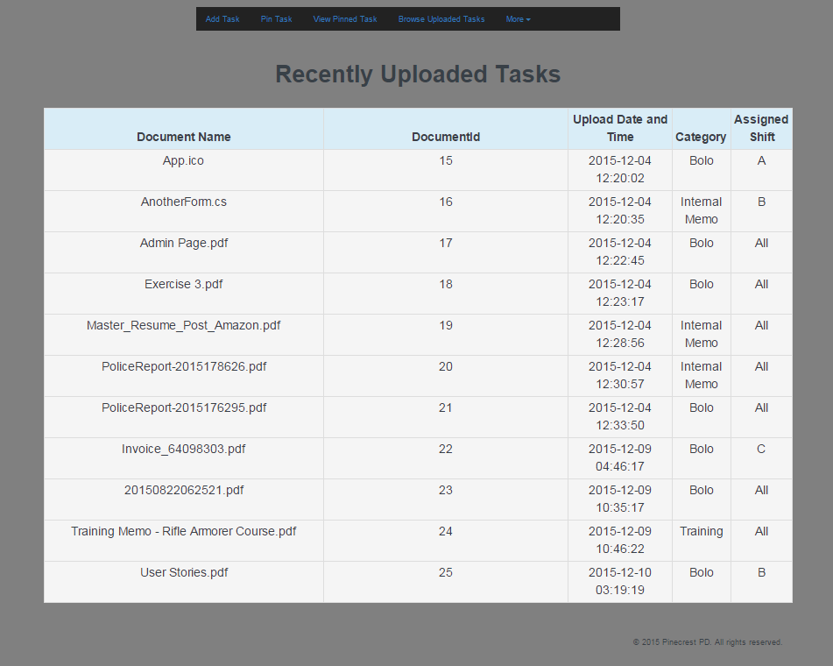

**Figure 40. Recently uploaded tasks UI**

## 

## 

## Appendix C - Sprint Review Reports

**Sprint 1 Report**

**Date:** Month Day, Year

**Attendees:** Frank Vincench, Peter Reidy

**Discussed Topics:**

During Sprint 1, we met up with the product owner to discuss the specifics of the system. The initial design was set up and we begun implementing features. Most of the time however was spent on researching on technologies that could possibly be used, as well as learning how to apply it into the system.

**Sprint 2 Report**

**Date:** September 25,2015

**Attendees:** Frank Vincench, Peter Reidy

**Discussed Topics:**

During Sprint 2, we met up with the product owner to discuss more specific details about the project. Some doubts were also clarified which led to a smooth development phase. During this time, the system gained the ability for admins to register new users and to redirect users to their page according to their user type and shift. Also, it gained functionalities for administrator type users to view and update user information.

**Sprint 3 Report**

**Date: October 8th, 2015**

**Attendees:** Frank Vincench, Peter Reidy

**Discussed Topics:** Admin module & Officer Module.

During Sprint 3, the system gained the functionality of login users out when they are idle.

The client was very satisfied with the results so far. Also, the officers module began taking shape. They are now able to view the tasks and view the documents related to that specific task. During this spring, Administrators now have the ability of removing users from the system. Though other things were discuss, the main focus during this sprint was to have officers view the documents, since the product owner seemed to have greater interest on this.

**Sprint 4 Report**

**Date: October 22nd, 2015**

**Attendees:** Frank Vincench, Peter Reidy

**Discussed Topics:** Officer Module.

During Sprint 4, the system gained the functionality of displaying PDF documents and mp4 videos to officers. Also, officers will be logged out after being idle for a certain amount of time, 15 minutes to be exact as requested by the product owner.

The client was very satisfied with the results so far. During our previous meeting, the client emphasized a lot on the officer module, being able to display the documents, etc. It was successfully done and the officer module is now almost complete.

**Sprint 5 Report**

**Date:November 5th, 2015**

**Attendees:** Frank Vincench, Peter Reidy

**Discussed Topics:** Officer Module.

During Sprint 5, the system gained full functionality of the officer Module. Officers will be able to log in and have access to everything they need to see as prepared by their supervisor(s).

The client was very satisfied with the results so far. During our previous meeting, the client emphasized a lot on the officer module, being able to display the documents, etc. It was successfully done and the officer module is now finally complete.

## 

**Sprint 6 Report**

**Date:November 19th, 2015**

**Attendees:** Frank Vincench, Peter Reidy

**Discussed Topics:** Officer Module & Admin Module

During Sprint 6, the system got some modifications to the already completed officer Module from the previous Sprint. Administrators will now have the ability to view the logs created by the officers implicitly as they view the documents assigned by their supervisors. The system also received tests to ensure the proper and consistent functions of the system across all the use cases.

The client was very satisfied with the results so far. During our previous meeting, the client emphasized a lot on the administrator module, being able to keep track of how long the officers are viewing the documents, etc. It was successfully done and the administrator module is almost complete.

**Sprint 7 Report**

**Date:December 2nd, 2015**

**Attendees:** Frank Vincench, Peter Reidy

**Discussed Topics:** System tests.

During Sprint 7, The system was tested with all the functionalities added during the semester. Everything was running smooth. The most updated version was also updated on the FIU server for client to view.

## Appendix D - Sprint Retrospective Reports

**Sprint 1 Retrospective**

**Date:** Month Day, Year

**Attendees:** First Name Last Name, First Name Last Name, …

**Discussed Topics:**

Explain what went well and not so well in this sprint. Include any agreed-upon actions to mitigate any issues for the next sprint.

**Sprint 2 Retrospective**

**Date:**

**Attendees:**

**Discussed Topics:**

**Sprint 3 Retrospective**

**Date:** 09 Oct,2015

**Attendees:** Frank Vicench

**Discussed Topics:**

**Sprint 4 Retrospective**

**Date:** Oct 22**,**2015

**Attendees:** Frank Vincench

**Discussed Topics: Progress Report for the sprint**

This Sprint I think went very well for me. I was able to get a lot done and meet all of the Project owner's expectation for the system’s progress. My partner was also able to get the system up running on the FIU server which was a huge relief, turned out to be an issue with one letter that was supposed to be lower case in a file name, so when we tried to reference that file it wouldn't find it. I also learned that windows is not as picky when it comes to these things, however linux is, which is the environment the FIU server is running on. Overall, great work, progress and a lot of satisfaction for both me and the client.

**Sprint 5 Retrospective**

**Date:** Nov 5th**,**2015

**Attendees:** Frank Vincench

**Discussed Topics: Progress Report for the sprint**

This Sprint I think went very well for me. I was able to get a lot done and meet all of the Project owner's expectation for the system’s progress.I was able to complete the officer Module completely with everything the client requested. I was also able to make some additions to the Administrator module, getting it closer to completion. Overall, great work, progress and a lot of satisfaction for both me and the client.

**Sprint 6 Retrospective**

**Date:** Nov 19th**,**2015

**Attendees:** Frank Vincench

**Discussed Topics: Progress Report for the sprint**

This Sprint I think went very well for me. I was able to get a lot done and meet all of the Project owner's expectation for the system’s progress. I had to make some modification to the already completed officer module, in order to add a new implementation for administrators, this being viewing how long officers are viewing a specific document.

**Sprint 7 Retrospective**

**Date:** Dec 2nd**,**2015

**Attendees:** Frank Vincench

**Discussed Topics: Progress Report for the sprint**

This Sprint I think went very well for me. I was able to test the system with all the functionalities I added during the semester. I also completed the missing parts on the system document.

# 

# References

1-. The system encrypts information using crypto js.

CryptoJS v3.1.2

code.google.com/p/crypto-js

(c) 2009-2013 by Jeff Mott. All rights reserved.

code.google.com/p/crypto-js/wiki/License

2. The system monitors idle users with the help of a script written by Mike Grabski known as ng-idle.

Directives and services for responding to idle users in AngularJS

author Mike Grabski <me@mikegrabski.com>

version v1.1.0

link https://github.com/HackedByChinese/ng-idle.git

license MIT