**Medications Update**

Every Tuesday, you will receive a CD from First Data Bank delivered by UPS. This CD contains the last medications update, such data you will upload.

Step 1

* Make sure you are logged in to the VPN (Watch Guard)
* <Https://216.21.82.230:4100/>

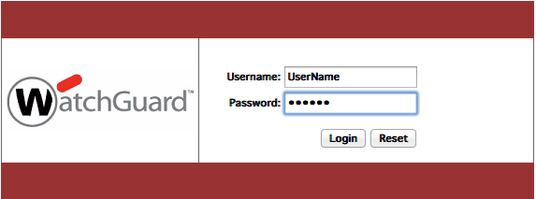

If you are already logging you will receive a message saying

“*You have been successfully authenticated*”

Once you have logged you will have access to the server through any SFTP (SSH file transfer protocol) software.

In our case we are going to use the Cyberduck that is an open source FTP and SFTP tool that can be used either in Mac or windows.

You can download the site <http://cyberduck.io/> or from the APP STORE in Mac

Step 2

Open Cyberduck, Click on the icon that say Open Connection  and enter the information that you need for access the server, Remember we will be using the protocol **SFTP**

Server: gateway.vipahealth.com

UserName: Will be provided

Password: Will be provided

Path: /var/www/html/meds/files_full_data

And click connect

SmartEMR – Dashboard Message

Creation of messages for posting in the dashboard

Please See Step 1

**Creation of the message to post in the dashboard**

1. Access devemr.vipahealth.com:/usr/local/apache2/htdocs_emr/admin_emr
2. Create a new file, the name convention is mess_razon_of_the_message.htm remember o put the extension htm to the file
3. Once the file is created open mess_sample_message.htm and copy the content into your new file.
4. Replace “Message goes here” with the information that you want to transmit
5. If you also want to add images upload it/them to the images folder.
6. Once you have everything, you can go to <http://devemr.vipahealth.com/admin_emr/mess_razon_of_the_message.htm> and see how the users are going to see the message, if there is something wrong go back to the 4 and continue from there.