*Florida International University*

*School of Computing and Information Sciences*

Software Engineering Focus

Feature Document

#779 WebVR Integration to 3D Scenes

**Name: Daniel Khawand**

**Team Member(s): Bernardo Pla, Daniel Rivero, Pachev Joseph, Hamilton Chevez**

**Project: WebVR 1.0**

**Product Owner(s)**: Francisco Ortega

**Mentor(s)**: Francisco Ortega

**Instructor**: Masoud Sadjadi

**User Story Name: integrate WEBVR to 3d scenes**

* As a user, I would like to see the WebVR representation of the Three.js dynamic structures so that I can get the learning experience through the VR device.

Acceptance Criteria

* User may switch to VR mode at any time in a scene
* The VR and webpage view must be identical

**Use Case**

* Name: 3D View in VR
* Actor: User
* Preconditions:
  + WebGL Loaded
  + Scene Rendered
  + In VR-Compatible browser
  + WebVR Enabled
* Description: The user accesses the visual demo and then gets to click to access the same visual in VR.

**Use Case Diagram**

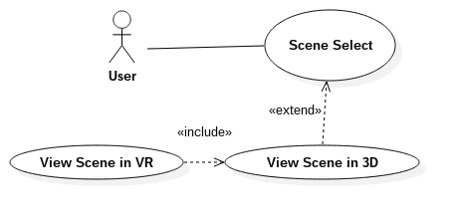

**Sequence Diagram**

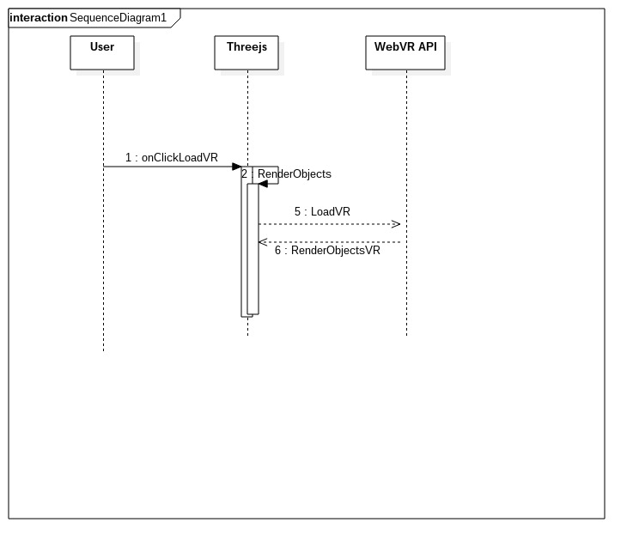

**Class Diagram**

**Unit Test**

* Test case ID: VR Capability
* Description/Summary of Test: User accesses a WebGL Demo and is able to observe that demo using a VR headset
* Pre-condition:
  + animate() is called
  + WebVR Flag is enabled in browser
* Expected Results: Same exact scene from non-VR is visible through a VR headset
* Actual Result: Same exact scene from non-VR is visible through a VR headset
* Status (Fail/Pass): Pass

**Integration Test**

**Visual User Guide**

This is without VR mode activated; notice the URL at the top.

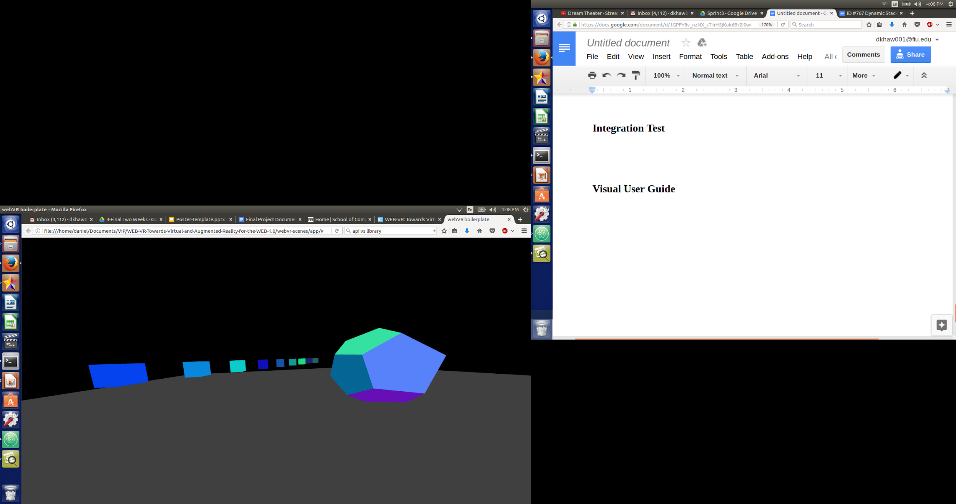

VR mode enabled:

