*Florida International University*

*School of Computing and Information Sciences*

Software Engineering Focus

Feature Document

User Story ID #752 Video Game Controller

**Name: Pachev Joseph**

**Team Member(s): Bernardo Pla, Daniel Rivero, Daniel Khawand,**

**Project: WebVR 1.0**

**Product Owner(s)**:

**Mentor(s)**: Francisco Ortega

**Instructor**: Masoud Sadjadi

**User Story Name: #752 Design Connection For Mouse**

* As a developer, I would like a modular interface to connect Touch device to any computer and have it be usable.

Acceptance Criteria

* Touch input device can be registered and read by device that it is connected to
* Developers are able to provide input and receive correct output via transition function
* Output for interactions are sent via universal JSON format for developers to use

**Use Case**

* Name: Touch Input
* Actor: Developer, User, Device Controller
* Preconditions: Webvr-input has started and is listening for devices
* Description :
  + Developer connects Touch Input
  + Developer provides which inputs and functions are needed
  + Device controller reads and adds touch input device
  + User provides input
  + Device controller receives input and provides appropriate output to developer.

**Use Case Diagram**

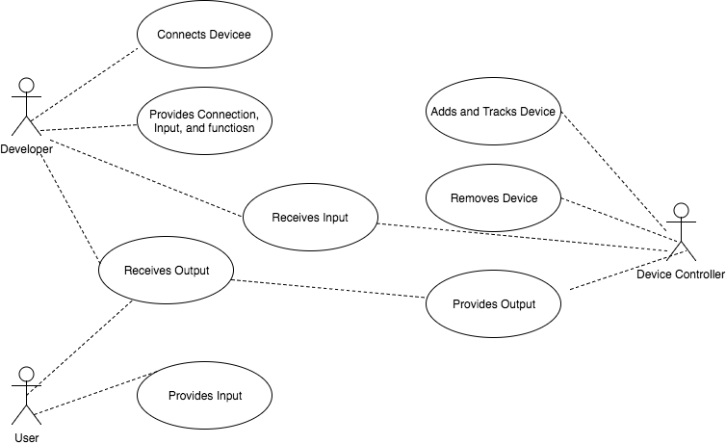

**Sequence Diagram**

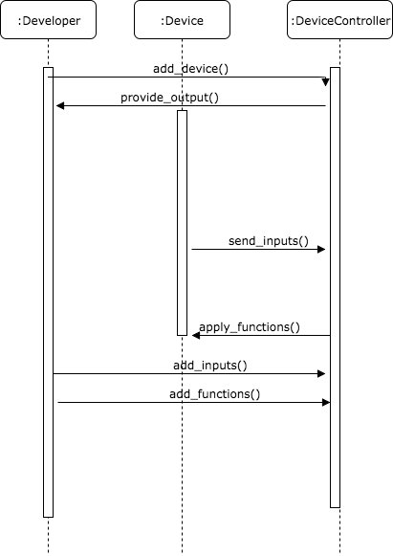

**Class Diagram**

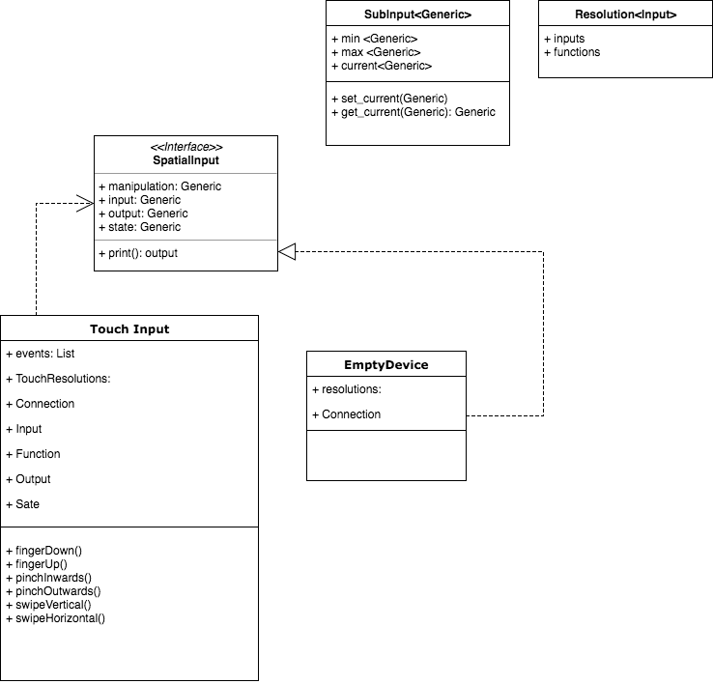

**Test case ID: WV-TI-IN002: Sunny**

* **Description/Summary of Test:** The developer will launch the demo class and only provide  
  Inputs that require 3 or more fingers
* **Pre-condition:** The main class in the rust library is running. A touch input device must be connected to the machine and is fully operational
* **Expected Results:** Once binary is running, only the 3 fingers or more will be read by the device
* **Actual Result:** the developer received results for 2 fingers as well
* **Status (Fail/Pass):** Fail

**Visual User Guide** <like one or two screenshots of the feature. For the hardware project, a photo of device is required>