*Florida International University*

*School of Computing and Information Sciences*

Software Engineering Focus

Feature Document

User Story ID #674 Robot Inventory

**Name: Daniel Rivero**

**Team Member(s):** Pachev Joseph, Hamilton Chevez, Bernardo Pla, Daniel Khawand

**Project: WebVR 1.0**

**Product Owner(s)**:

**Mentor(s)**: Francisco Ortega

**Instructor**: Masoud Sadjadi

**User Story Name:**

* As a user who plays this game, I want both the programmable robot to have an inventory so that I can choose what modules the robot can/cannot attach

Acceptance Criteria

* Inventory should start small and increase as the levels get more difficult
* Inventory dictates how many modules the robot can have at once on its board

**Use Case**

* Name: Access robot Inventory
* Actor: Player, Robot
* Preconditions: The game is running and the robot is not executing.
* Description:
* Player opens the menu items of the left vive controllers
* Player presses down on the trackpad
* Robot inventory HUD gets displayed to the user

**Use Case Diagram <**you can use draw.io**>**

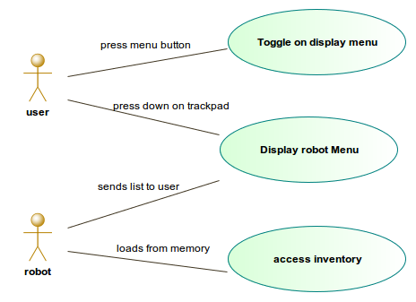

**Sequence Diagram**

**Class Diagram**

**Unit Test**

* Test case ID:
* Description/Summary of Test:
* Pre-condition:
* Expected Results:
* Actual Result:
* Status (Fail/Pass):

**Integration Test**

**Visual User Guide** <like one or two screenshots of the feature. For the hardware project, a photo of device is required>