Instructions for AmpliQué
AmpliQué
AmpliQué is a program used to predict the results of PCR using 16S rRNA primers.
Instructions
1. Download the last release from the ribosomal database project web page. http://rdp.cme.msu.edu/misc/resources.jsp
- Choose “Combined”, “unaligned” in fasta format
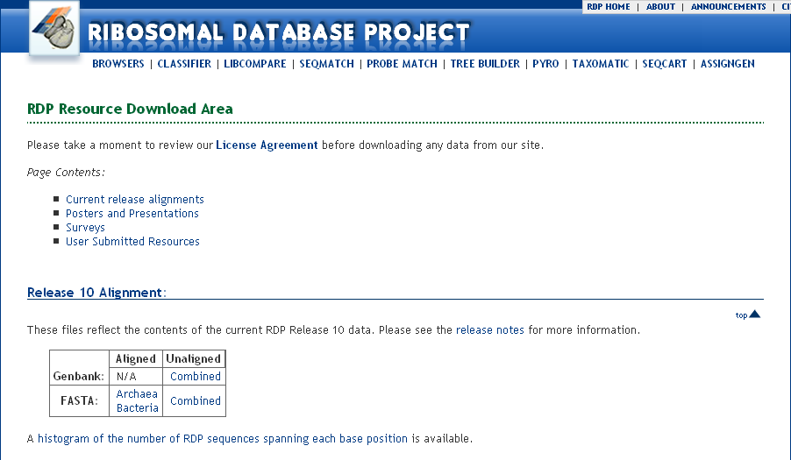
1.1. Run ChopUp.pl to break down the main database file into smaller pieces. The program is set up to place 50,000 sequences in each file. The Database is chopped into smaller pieces for BlastParser.pl (Step 2.3)
2. For each set of primers create a fasta file containing the name and sequences. The following is an example of a file with pairs of primers “V1P1F41F” and “V1P2R130R”:
>V1P1F41F
GCGGCGTGCCTAATACATGC
>V1P2R130R
TTCCCCACGCGTTACTCACC

2.1. Run Blast with the primer file against each of the database files with the command :
Blastall -p blastn -d <database_file>
-I <primer_file> -o <output_file.out>
-v 50000 -e 50
-b 50000 -F F
2.2. Run BlastParser.pl for all the ouput files obtained in the previous step
2.3. Run HitsReader.pl for all the output files obtained in the previous step
3. Concatenate all the output files from the previous step

