# CS 255 System Design Document Template

## UML Diagrams

### UML Use Case Diagram

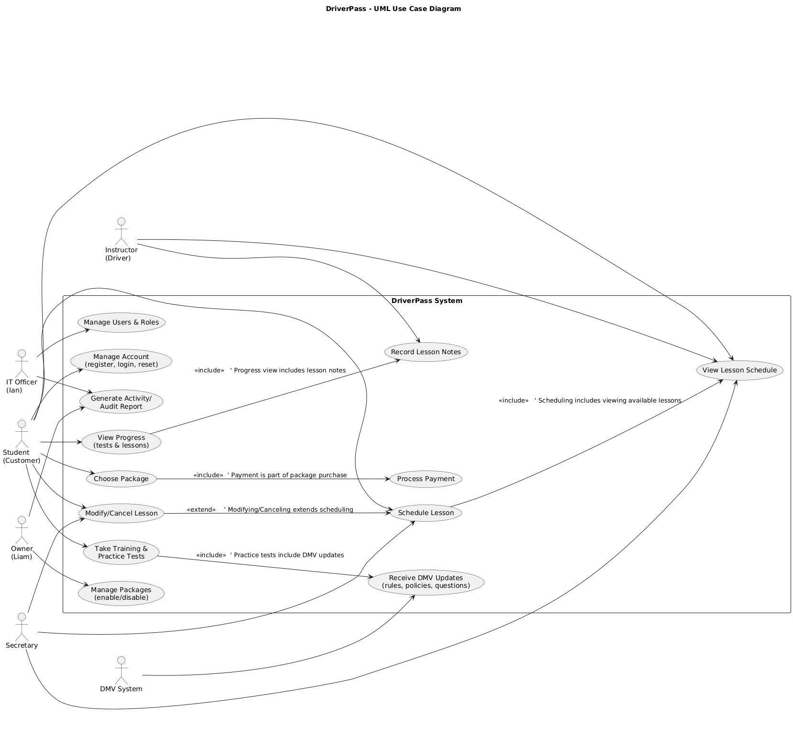

### UML Activity Diagrams

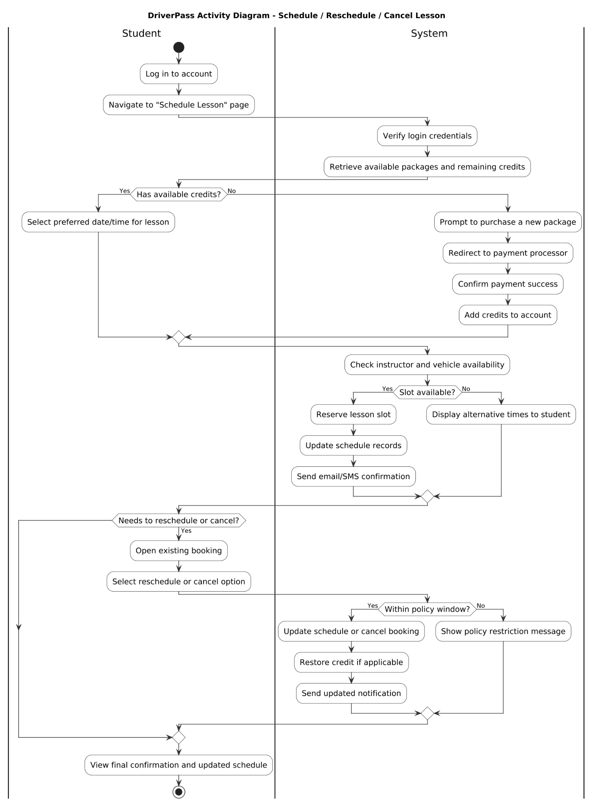

### UML Sequence Diagram

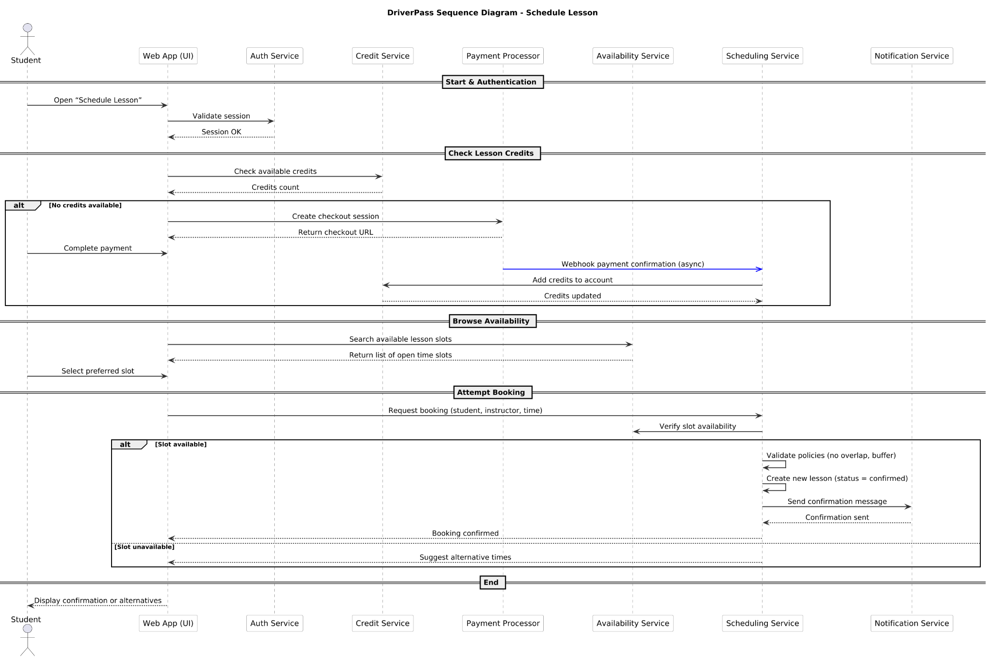

### UML Class Diagram

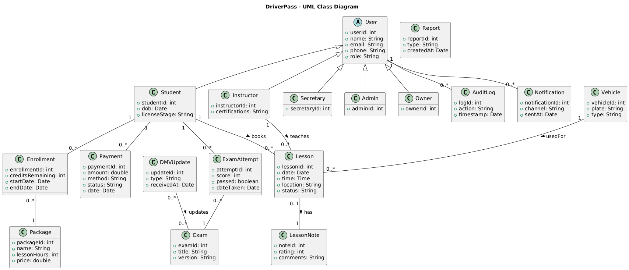

## Technical Requirements

The DriverPass system will operate as a secure, web-based platform that can be accessed from any modern browser on a computer or mobile device. Because the system supports multiple user roles—students, instructors, and administrators—it requires reliable internet connectivity and sufficient cloud-based resources to manage traffic and data storage.

***Hardware and Infrastructure:***

The system will run on hosted cloud servers to reduce maintenance and ensure availability. Basic computing resources such as CPU, memory, and scalable storage will support concurrent users during high-traffic times. Routine data backups and recovery options will protect user information and lesson schedules.

***Software and Tools:***

The application will use a standard three-tier architecture with a web interface, an application layer, and a relational database. Web technologies such as HTML, CSS, and JavaScript will provide a responsive interface. The backend will use a programming framework such as Java, Python, or Node.js, while a relational database (MySQL or PostgreSQL) will store data about users, lessons, exams, and payments. The system will communicate over secure HTTPS connections to protect user privacy.

***Supporting Services:***

Integrated tools will handle authentication, payment processing, and email or text notifications. Administrators will access reports and account management features through secure logins with role-based permissions. Logging and monitoring tools will track performance and help with troubleshooting and maintenance.

***Security and Maintenance:***

All data transfers will be encrypted, and passwords will be stored securely. Only authorized staff will have administrative access, and the system will follow standard security and accessibility practices to ensure reliability and ease of use for all users.