Vehicle Detection Project

Vehicle Detection Project
The goals / steps of this project are the following:
Perform a Histogram of Oriented Gradients (HOG) feature extraction on a labeled training set of images and train a classifier Linear SVM classifier
Optionally, you can also apply a color transform and append binned color features, as well as histograms of color, to your HOG feature vector.
Note: for those first two steps don't forget to normalize your features and randomize a selection for training and testing.
Implement a sliding-window technique and use your trained classifier to search for vehicles in images.
Run your pipeline on a video stream (start with the test_video.mp4 and later implement on full project_video.mp4) and create a heat map of recurring detections frame by frame to reject outliers and follow detected vehicles.
Estimate a bounding box for vehicles detected.

I will consider the rubric points individually and describe how I addressed each point in my implement

Histogram of Oriented Gradients (HOG)

1. Explain how (and identify where in your code) you extracted HOG features from the training images.

The code to read car and noncar image is contained in paragraph [142]. I started by reading in all the “vehicle” and “non-vehicle” images. Here is an example of some random picked vehicle and non-vehicle classes:

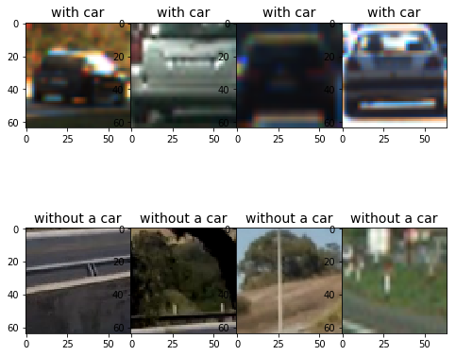

Then I define functions for HOG feature extraction (In paragraph [143]) from skimage.feature import hog function. The comparison between car image, car HOG, non car image, non car HOG are shown below:

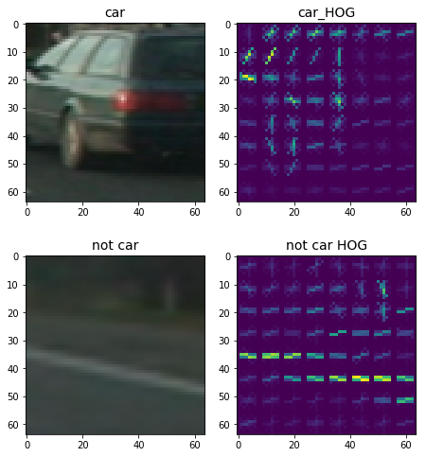

Since the total vehicle samples (8792) and non vehicles samples (8968) are almost same, so we do not need to balance the number of images. The paragraph [169] shows how to create classifier. Those codes creates the feature lists for the training data. All data is split to training dataset (80%) and test datasets (20%). I tried different feature combinations and my final results are processed with parameters listed below:
orient = 11 # HOG orientations
pix_per_cell = 16 # HOG pixels per cell
cell_per_block = 2 # HOG cells per block
hog_channel = 'ALL' # Can be 0, 1, 2, or "ALL"
color_space = 'YUV' # Can be RGB, HSV, LUV, HLS, YUV, YCrCb
spatial_size = (16, 16) # Spatial binning dimensions
hist_bins = 32 # Number of histogram bins
hist_feat = True # Histogram features on or off
hog_feat = True # HOG features on or off
y_start_stop = [400, 600] # Min and max in y to search in slide_window()

I then applied a linear SVM ([147]) and the accuracy of SVC is as high as 0.9899.

Sliding Window Search

Next step is to apply a sliding windows search technology and use trained classifier to search for vehicles in images. The parameters used to find cars are same with previous defined. The result is:

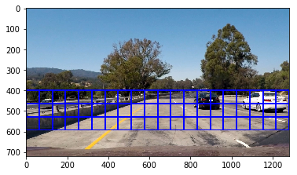

Then a function called ‘find_cars’ was used to extract HOG features and was sub-sampled to get all of its overlaying windows. A single scale search scheme was applied and the result is shown below:

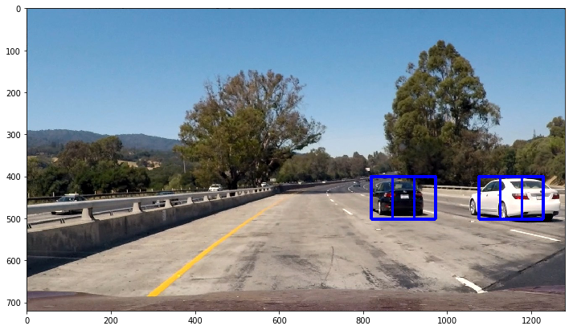

Apply this method multiple time to form multi-scale window searching. The differences between multi-scale are the range of searching area and searching scale (In [172]). The result is shown below:

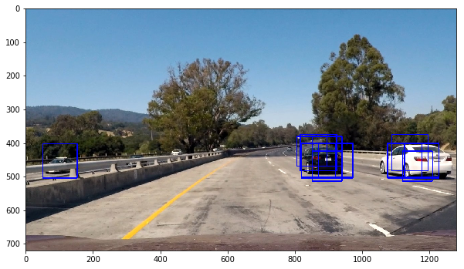

Two cars are successfully found. However, it shows a false positive result. I will apply a multiple detection methods to eliminate false positive and apply heat map to refine my result (In [173]).

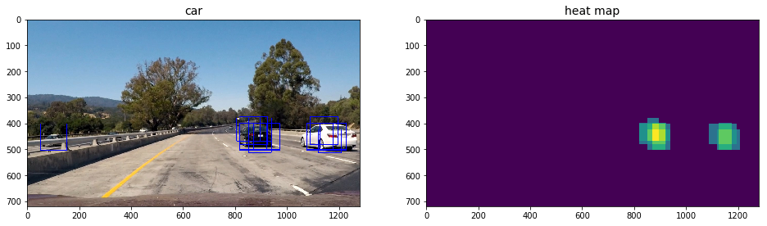

From heat map we can obtain label information based on “scipy.ndimage.measurements import label”. The label will draw a single color box which contains all information from heat map:

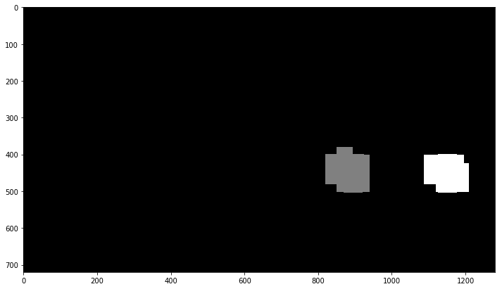

Then to draw bounding box based on label information (In [175]) on original image:

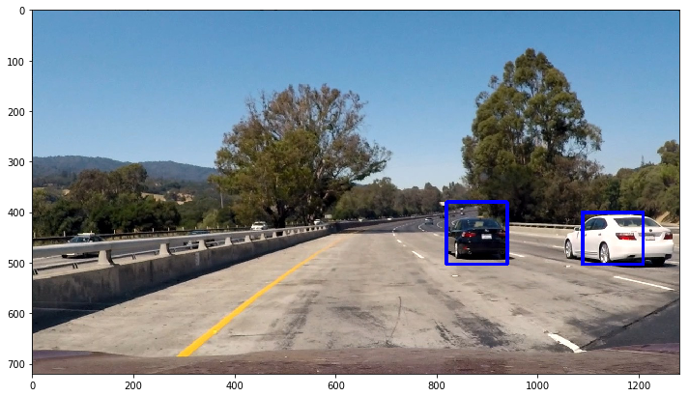

Video Implementation

To apply such methods to video frame, I defined a function called ‘process_line’ for processing workflow. This function was formed with four different scale search windows and will return image with colored box.

The video link of my vehicle detection project is https://youtu.be/5i7Bz6RKBHA

Discussion

Vehicle detection is the most important step during self-driving car project. Some erroneous codes will cause serious accident. One has to pay more attention on this project. With correct car detection, we are able to avoid collision and protect passenger’s life. Combine vehicle detection technology with advanced lane detection technology will provide more confidence with self-driving car. But I have not combined those two projects together but this is a definitely worth-to-try project.

