API:

What is API:

What is Web Service:

What is REST Api.

What si SOAP based API?

API :

S1(java) and S2(.Net) are two different independent systems but they both interacts with the help of API in form of JSON/XML format

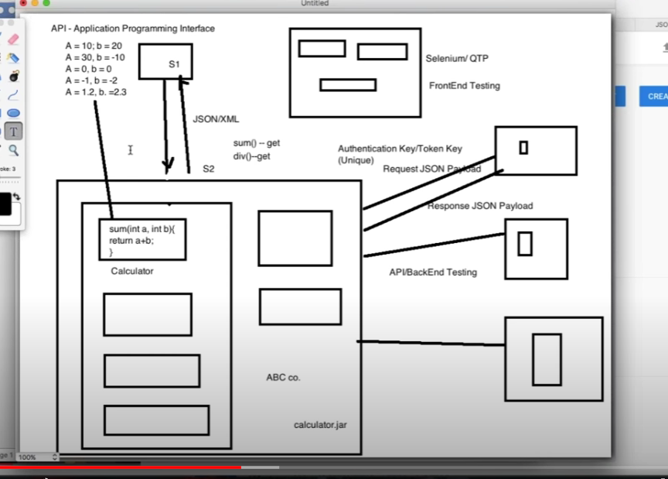

Web Service :

Ex: goibibo.com, makeMyTRip.com

These web site will have services from diff airline sites like indigo,soice jet, air india, eitehas, qata etc

All these websites dont provide their vendor make my trip directly their business logic but the communicate with help of API’s in the form of JSON fomat.

They send the request in form of JSON and also get the response back in form of JSON.

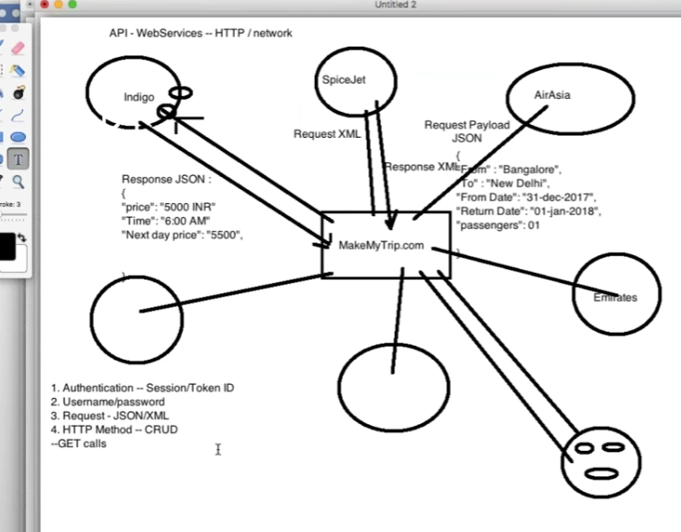

Its very imp for the web services to be secure

Now while paying the tickets the website is redirected to the icici bank or wallets to make the payment

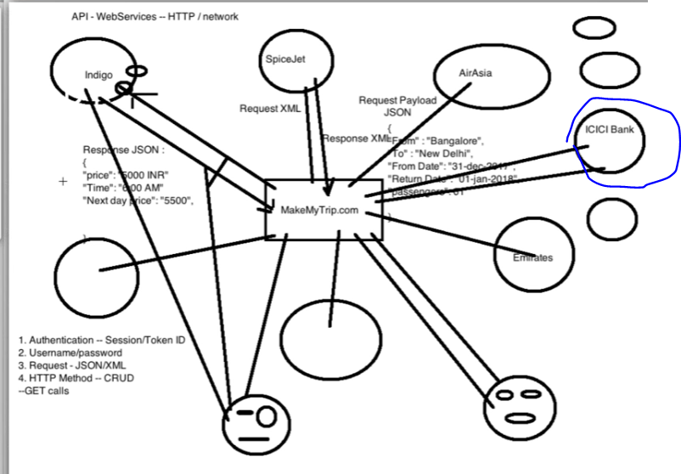

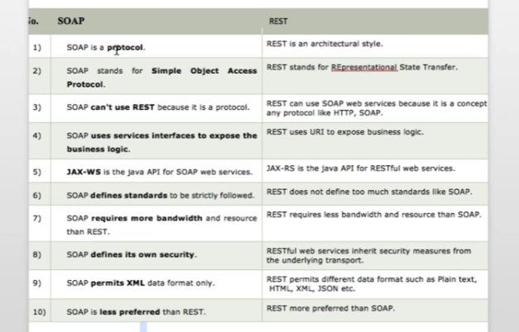

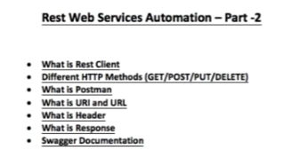

Here S1 I the client which is interacting with the server S2

S1 request are being passed as an URI, Headers and payload in form of JSON/XML to the server and then the server S2 gets the response back with the status 200 , response payload, String message if it’s a success or failure.

We have 4 operstions called CRUD.

C-create , R-retrieve , U-update, D-delete

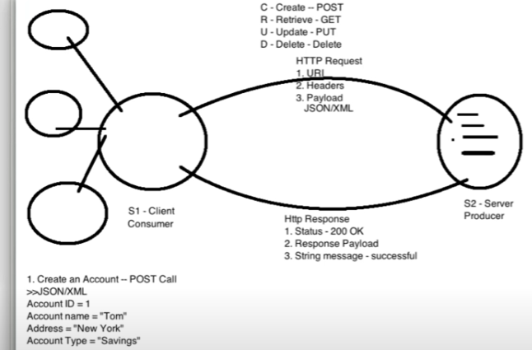

Here post call is always used to create an entity.

Now we want to fetch what ever we created .For this we need the GET command

PuT is used if we want to create as well as update

DELETE is used to delete the account.

So with each and every request we get an equal response.

Status Response Code

200- OK (api is responding properly)

201 – Created successfully

400- wrong payload-incporrect end URL – BAD request

401 – Authentication error

404- if account not found and trying to delete - NOT FOUND

500- if server is down or any internet issue- Server intenal error.

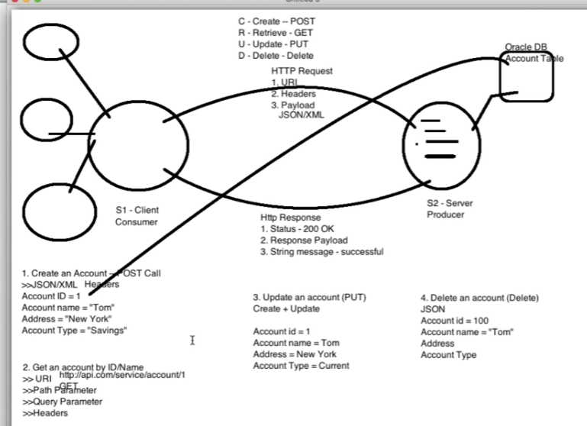

Now to test these API’s, if the API is available with UI, then we can test but if its not available , then we need tools suh as Rest client like postman,SOAP UI ,advanced REST client,JMeter, Browser.

Post man is the most famous tool available to test the APIS.

URL+Service API URL= URI

So for tetsinh , we need to ask the end point URI to developers.

We also have a link where we can find the aPI ‘s to worl on :

<https://reqres.in/>

So in postman we need to use URI which is the combination of URL + request API’s

<https://www.youtube.com/watch?v=Vnx2uBtn_bQ&list=PLFGoYjJG_fqp891lruz5fCRPWsDtEXJky&index=2> Intro to Restful API

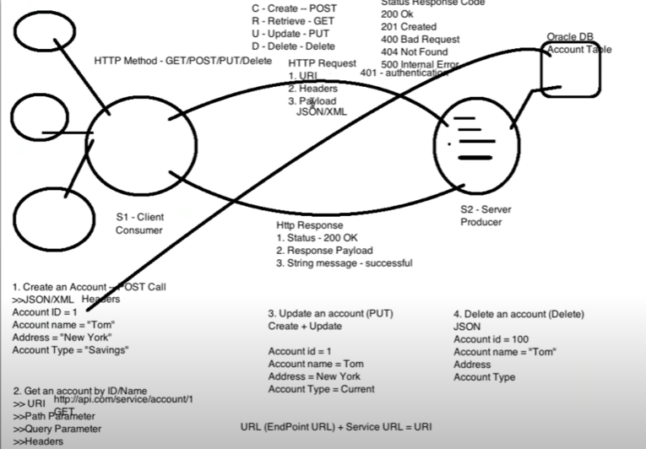

<https://fakerestapi.azurewebsites.net/swagger/ui/index#/Activities>

Swagger : is the API technical documentation tool where we can hit or test the API’s

swagger is same as postman. Swagger is created by developer .Its a server where developers implement their code with help of annotations.

JSON : java script object notation :

Purpose: To transfer the ihnfo frpom one system to another.

OR

Communication from client to server. Client is sending the request to the server and then the server is sending the response to the client in form of JSON.

JSON is very light weight object and is available in form of basic key value pair.

There are many different API which can convert from Object to JSON(Server side) to the JSON to object(Client side):

Obj to JSON (Marshelling)

* Google GSON
* Jackson
* Simple JSON
* JSON Soup

JSON to Object (Unmarshelling).

POJO – Plain old java object

POJO -JSON (Marshelling)

JSON-POJO(unmarshelling)

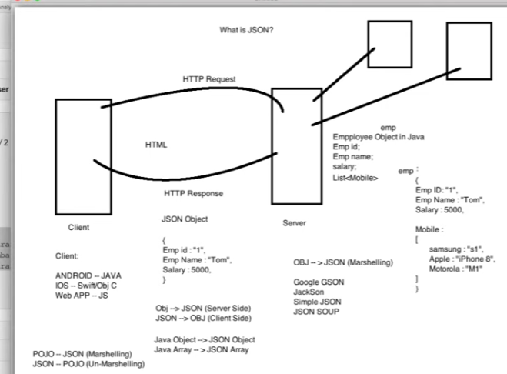

Automate rest GET call using http client:

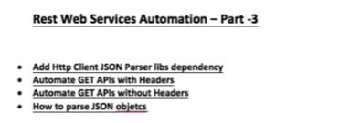

Now the coding point :

Create a maven project in the eclipse called RestApiTest and add few dependencies in the pom.xml file :

<dependencies>

<!-- https://mvnrepository.com/artifact/org.apache.httpcomponents/httpclient -->

<dependency>

<groupId>org.apache.httpcomponents</groupId>

<artifactId>httpclient</artifactId>

<version>4.5.12</version>

</dependency>

<!-- https://mvnrepository.com/artifact/org.apache.httpcomponents/httpcore -->

<dependency>

<groupId>org.apache.httpcomponents</groupId>

<artifactId>httpcore</artifactId>

<version>4.4.13</version>

</dependency>

<!-- https://mvnrepository.com/artifact/org.json/json -->

<dependency>

<groupId>org.json</groupId>

<artifactId>json</artifactId>

<version>20200518</version>

</dependency>

<!-- https://mvnrepository.com/artifact/org.testng/testng -->

<dependency>

<groupId>org.testng</groupId>

<artifactId>testng</artifactId>

<version>7.3.0</version>

<scope>compile</scope>

</dependency>

Created code for the get API and also for the post API

In post APi we need the URL +request URL = URI

Then we need to pass the URL,post, JSON payload , headers .

In eclipse we are creating users clss but for the post we need to convert the User class into the JSON format which means marshalling

For converting , we need to add jacson dependency : and save

<dependency>

<groupId>com.fasterxml.jackson.core</groupId>

<artifactId>jackson-databind</artifactId>

<version>2.11.2</version>

</dependency>