NAvinReddy:

<https://www.youtube.com/watch?v=NpCEjtKAa20>

agilemanifesto.org

MVP-minimum viable Product from which we start building

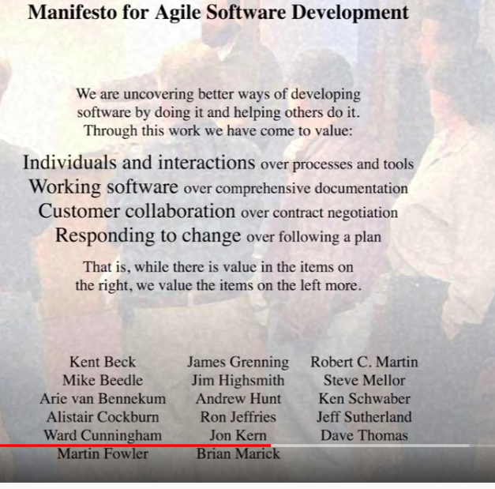

**Principles behind the Agile Manifesto**

*We follow these principles:*

Our highest priority is to satisfy the customer  
through early and continuous delivery  
of valuable software.

Welcome changing requirements, even late in  
development. Agile processes harness change for  
the customer's competitive advantage.

Deliver working software frequently, from a  
couple of weeks to a couple of months, with a  
preference to the shorter timescale.

Scrum is a framework used in agile .There is a term called sprint which is about a period of 2 – 4 weeks timespan to deliver a product.After every sprint we should be able to give a customer potentially shippable product

Business people and developers must work  
together daily throughout the project.

Build projects around motivated individuals.  
Give them the environment and support they need,  
and trust them to get the job done.

The most efficient and effective method of  
conveying information to and within a development  
team is face-to-face conversation.

Working software is the primary measure of progress.

Agile processes promote sustainable development.  
The sponsors, developers, and users should be able  
to maintain a constant pace indefinitely.

Continuous attention to technical excellence  
and good design enhances agility.

Simplicity--the art of maximizing the amount  
of work not done--is essential.

The best architectures, requirements, and designs  
emerge from self-organizing teams.

At regular intervals, the team reflects on how  
to become more effective, then tunes and adjusts  
its behavior accordingly.