Agiile Interview Questions:

Agile is a practice’s. Its a kind of methodology of a SDLC where we follow a of of activities like scrum , iteration, stand up calls,retrospectives,backlog grouping , sprint planning.We define a particular sprint which is ad uration of 2-3 weeks in which we have to complete the set of requirements coded,tested and deployed.

**Q #1) What is Agile Testing?**

**Answer:** Agile Testing is a practice that a QA follows in a dynamic environment where testing requirements keep changing according to customer needs. It is done parallel to the development activity where the testing team receives frequent small codes from the development team for testing.

**Q #2) What is the difference between burn-up and burn-down charts?**

**Answer:** Burn-up and burn-down charts are used to keep track of the progress of the project.

Burn-up charts represent how much work has been completed in any project whereas Burn-down chart represents the remaining work in a project.

**Q #3) Define the roles in**[**Scrum**](https://www.softwaretestinghelp.com/agile-scrum-methodology-for-development-and-testing/)**?**

**Answer:**

**There are mainly three roles that a Scrum team have:**

1. **Project Owner** has the responsibility of managing the product backlog. Works with end-users and customers and provides proper requirements to the team to build the proper product.
2. **Scrum Master**works with the scrum team to make sure each sprint gets completed on time. Scrum master ensures proper workflow for the team.
3. **Scrum Team:** Each member of the team should be self-organized, dedicated and responsible for the high quality of the work. ( Scrum team consist of Dev ,QA,release,Product manager,Scrum master,Engineer manager,Product Manager)

**Q #4) What is Product Backlog & Sprint Backlog?**

**Answer:** The **Product backlog** is maintained by the project owner which contains every feature and requirement of the product.

**Sprint backlog** can be treated as the subset of product backlog which contains features and requirements related to that particular sprint only.

All the requirements are referred as to the product backlogs.When the backlogs comes in small sprints its called as user stories (also called as sprint backlogs).Acceptance criteria(AC)is defined by product manager..Once the aceptane criteria is made , the dev team starts writing the code and the QA team starts testing

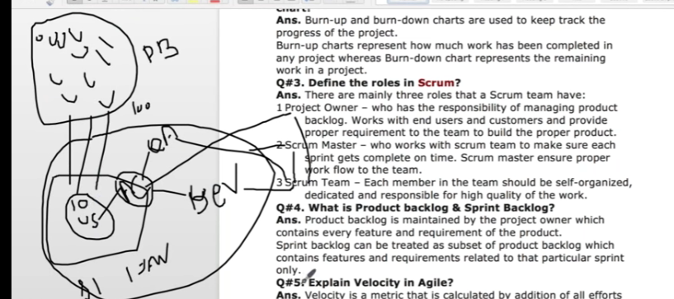

**Q #5) Explain Velocity in Agile.**

**Answer:** Velocity is a metric that is calculated by the addition of all efforts estimates associated with user stories completed in an iteration. It predicts how much work Agile can complete in a sprint and how much time will it require to complete a project.

**Q #6) Explain the difference between a**[**traditional Waterfall model**](https://www.softwaretestinghelp.com/what-is-sdlc-waterfall-model/)**and Agile testing?**

**Answer:**Agile testing is done parallel to the development activity whereas a traditional waterfall model testing is done at the end of the development.

As done in parallel, agile testing is done on small features whereas, in a waterfall model, testing is performed on the whole application.

**Q #7) Explain Pair Programming and its benefits?**

**Answer:** Pair programming is a technique in which two programmer works as a team in which one programmer writes code and other one reviews that code. They both can switch their roles.

**Benefits:**

* **Improved code quality:** As the second partner reviews the code simultaneously, it reduces the chances of mistake.
* **Knowledge transfer is easy:** One experienced partner can teach another partner about the techniques and codes.

**Q #8) What is Re-factoring?**

**Answer:** Modification of the code without changing its functionality to improve the performance is called Re-factoring.(ex: companies like Uber and flipkart they change their GUI look n feel)

**Q #9) Explain the Iterative and Incremental Development in Agile?**

**Answer:**

**Iterative Development:**Software is developed and delivered to the customer and based on the feedback again developed in cycles or releases and sprints. **Example:** Release 1 software is developed in 5 sprints and delivered to the customer. Now, the customer wants some changes, then the development team plan for 2nd release which can be completed in some sprints and so on.

**Incremental Development:**Software is developed in parts or increments. In each increment, a portion of the complete requirement is delivered.

**Q #10) How do you deal when requirements change frequently?**

**Answer:** This question is to test the analytical capability of the candidate.

The answer can be: Work with PO to understand the exact requirement to update test cases. Also, understand the risk of changing the requirement. Apart from this, one should be able to write a generic test plan and test cases. Don’t go for the automation until requirements are finalized.(until all the test cases are signed off)

**Q #11) What is a test stub?**

**Answer:**Test stub is a small code that mimics a specific component in the system and can replace it. Its output is the same as the component it replaces.

**Q #12) What qualities should a good Agile tester have?**

**Answer:**

* He should be able to understand the requirements quickly.
* He should know Agile concepts and principals.
* As requirements keep changing, he should understand the risk involved in it.
* The agile tester should be able to prioritize the work based on the requirements.
* Communication is a must for an Agile tester as it requires a lot of communication with developers and business associates.

**Q #13) What is the difference between Epic, User stories & Tasks?**

**Answer:**

**User Stories:**It defines the actual business requirement. Generally created by the business owner.  
**Task:**To accomplish the business requirements development team create tasks.  
**Epic:** A group of related user stories is called an Epic.

**Q #14) What is a Taskboard in Agile?**

**Answer:** Taskboard is a dashboard that shows the progress of the project.

**It contains:**

* **User Story:** It has the actual business requirement.
* **To Do:** Tasks that can be worked on.
* **In Progress:** Tasks in progress.
* **To Verify:** Tasks pending for verification or testing
* **Done:** Completed tasks.

**Q #15) What is Test Driven Development (TDD)?**

**Answer:** It is a Test-first development technique in which we add a test first before we write the complete production code. Next, we run the test and based on the result refactor the code to fulfill the test requirement.

**Q #16) How QA can add value to an agile team?**

**Answer:** QA can provide value addition by think outside the box about the various scenarios to test a story. They can provide quick feedback to the developers about whether new functionality is working fine or not.

**Q #17) What is Scrum ban?**

**Answer:** It is a software development model that is a combination of Scrum and Kanban. Scrumban is considered for maintaining projects in which there are frequent changes or unexpected user stories. It can reduce the minimum completion time for user stories.

**Q #18) What is the Application Binary Interface?**

**Answer:** Application Binary Interface or ABI is defined as an interface for complied application programs or we can say it describes the low-level interface between an application and the operating system.

**Q #19) What is the Zero sprint in Agile?**

**Answer:** It can be defined as a pre-preparation step to the first sprint. Activities like setting development environment, preparing backlog, etc need to be done before starting the first sprint and can be treated as Sprint zero.

**Q #20) What is Spike?**

**Answer:** There may be some technical issues or design problem in the project which needs to be resolved first. To provide the solution to this problem “Spikes” are created.

**Spikes are of two types-** Functional and Technical.(ex: like do we need the docker ,Jenkins, something we need to discuss with the business, clear with the Product owner,to discuss with thetechnical architect, design issues etc).

**Q #21) Name some Agile quality strategies.**

**Answer:** **Some Agile quality strategies are-**

1. Re-factoring
2. Small feedback cycles
3. Dynamic code analysis
4. Iteration
5. Bug Bash(creating more bugs for the testing)

**Q #22) What is the importance of daily stand up meetings?**

**Answer:** Daily stand up meeting is essential for any team in which team discuss,

1. How much work has been completed?
2. What are the plans to resolve technical issues?
3. What steps need to done to complete the projects etc?

Whatever work has been done in last 24 hours and what exactly r u doing in next 24 hrs.If any blocker then how can we unblock it.

**Q #23) What is a tracer bullet?**

**Answer:**It can be defined as a spike with the current architecture or the current set of best practices. The purpose of a tracer bullet is to examine how an end-to-end process will work and examine feasibility. (This is a task of the scrum master)

**Q #24) How the velocity of the sprint is measured?**

**Answer:** If capacity is measured as a percentage of a 40 hours weeks then, completed story points * team capacity

If capacity is measured in man-hours then Completed story points/team capacity.

(The higher the velocity mean steam is very much progressing)

**Q #25) What is Agile manifesto?**

**Answer:** Agile manifesto defines an iterative and people-centric approach to software development. It has 4 key values and 12 principals.

*I Hope, these questions will help you in preparing for the****Agile testing and methodology interview.***